This is a digital copy of a book that was preserved for generations on library shelves before it was carefully scanned by Google as part of a project to make the world’s books discoverable online.
It has survived long enough for the copyright to expire and the book to enter the public domain. A public domain book is one that was never subject to copyright or whose legal copyright term has expired. Whether a book is in the public domain may vary country to country. Public domain books are our gateways to the past, representing a wealth of history, culture and knowledge that’s often difficult to discover.
Marks, notations and other marginalia present in the original volume will appear in this file - a reminder of this book’s long journey from the publisher to a library and finally to you.

Usage guidelines

Google is proud to partner with libraries to digitize public domain materials and make them widely accessible. Public domain books belong to the public and we are merely their custodians. Nevertheless, this work is expensive, so in order to keep providing this resource, we have taken steps to prevent abuse by commercial parties, including placing technical restrictions on automated querying.
We also ask that you:

+ Make non-commercial use of the files We designed Google Book Search for use by individuals, and we request that you use these files for personal, non-commercial purposes.
+ Refrain from automated querying Do not send automated queries of any sort to Google’s system: If you are conducting research on machine translation, optical character recognition or other areas where access to a large amount of text is helpful, please contact us. We encourage the use of public domain materials for these purposes and may be able to help.
+ Maintain attribution The Google “watermark” you see on each file is essential for informing people about this project and helping them find additional materials through Google Book Search. Please do not remove it.
+ Keep it legal Whatever your use, remember that you are responsible for ensuring that what you are doing is legal. Do not assume that just because we believe a book is in the public domain for users in the United States, that the work is also in the public domain for users in other countries. Whether a book is still in copyright varies from country to country, and we can’t offer guidance on whether any specific use of any specific book is allowed. Please do not assume that a book’s appearance in Google Book Search means it can be used in any manner anywhere in the world. Copyright infringement liability can be quite severe.

About Google Book Search

Google’s mission is to organize the world’s information and to make it universally accessible and useful. Google Book Search helps readers discover the world’s books while helping authors and publishers reach new audiences. You can search through the full text of this book on the web at

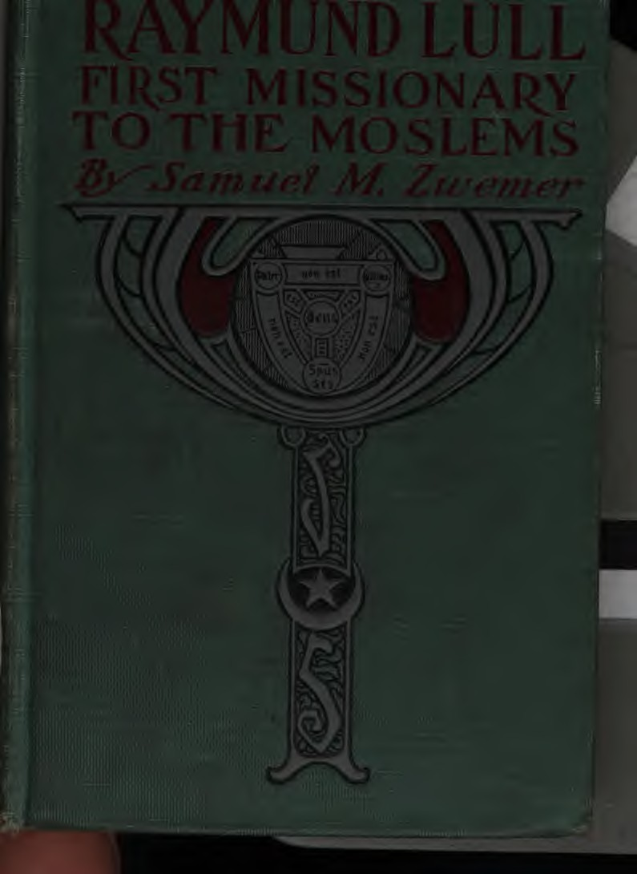

I 9. 5
L 9 53 z

•

....,.

ST | TUE | OF | RAYMU | D | LULL | AT | PALMA, | MAJORCA,
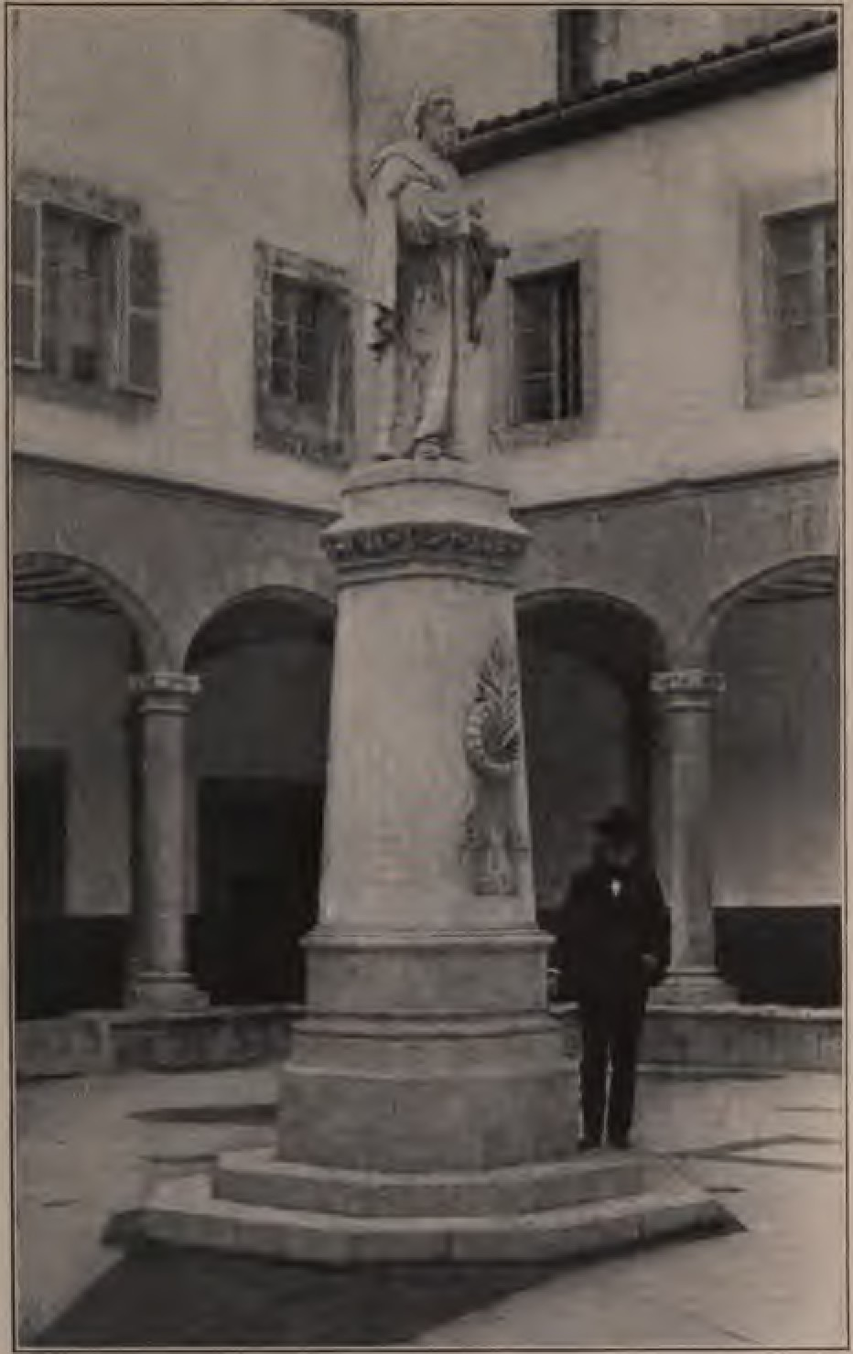

-··-····
i
r-··..
I R iJ1{1T f't If··.
!
j-"," '... :
1·.
,)..•: ':.,L
J
;- -· i ..
i
:.-..;::.·.- . ::. ;:_-..·· ·. ·.... --=·-·.-

:·;
- .. ,:;-. ,.
..... f ,t, :... • • .... • • • .- : .,1 -. •.

I' roHr.., '-" •,!- 1 , -. ,.;.,m••,.1r-•1v• I
I 1 ..... "N,_w ·; ,!, :;...', '.,•n::, - JI II
L. --------- -·•··-··-··-
----·-----·- ---- ---- ,
..,J

:
.. ..
:
lllB I:WAGR.ill.S COJll'ART
1'cw York aDl Loadoll
c.>>
: •• : : • ; • ... : • • ... : "'i,
., .. ., ..:
. •· ..
: ! ., .... :
..
-
Br
SAllUEL IL D.D., F. R. G. S.
AUTHOR OW
"Arabia, The Cradle of Ialam," "TOJIIY•TllnJ Land," e1c.
RAYMUND LULL
First Missionary to the lloslems

.........._,....
"1Nlt a WAGNALLS COIIPANY
...........SlatlaMN'BaD. I--.......
..................
-•U...,.SW.9'.il_..
295900
-...-:....::-.. ··...: .
. . .... .. ..

...

Contents

INT .. ODUCTION BY ROBllT E. Sns..
PUFACJt,
P.lGS
. ix
. :c:ci

CHAPTER
- Europe and the Saracens in the Thirteenth Century, I
- Raymund Lull's Birthplace and Early Life, 19
- The Vision and Call to Service, ₃₂
- Preparation for the Conflict, . 47
- At Montpellier, Paris, and Rome, 63
- His First Missionary Journey to Tunis, Bo
- Other Missionary Journeys, . 97
- Raymund Lull as Philosopher and Author, n3
- His Last Missionary Journey and His Mar- tyrdom, • ₁₃₂
- "Who being Dead yet Speaketh," • • 147

BIBLIOGL\PHY:
- Books written by Raymund Lull,
- Books about Raymund Lull,
V

157
169

INTRODUCTION

IT would be difficult to find another so competent as Dr. Zwemer to write a life of the first great missionary to the Moham­ medans. For twelve years he has been working with his associates of the Arabian Mission of the Reformed Church on the eastern coast of the Arabian peninsula and in the Turkish region northwest of the Persian Gulf. To an almost perfect com­ mand of Arabic, an accurate knowledge of the Koran, untiring zeal and indomitable courage, he has added an absorbing love for the Mohammedans, and a desire to make known to them in truth that Savior whom in their belief their prophet annuls and supersedes.
ix

lntaudton
aratiOn their visions, their untiring toil, their passion for Christ, their sufferings and shipwrecks, their intellectual activity and power, their martyrdoms, the rule of Christ supreme thus in death, supreme also in life, its thought, its purpose, its taste, its use, its friends, its sacrifice. But the essence of all such comparison-the real essence of all true missionary char­ acter-is the possession by the life of Christ as life, and the ability thus to give, not a new doctrine only, not a new truth to men, but a new life. The work of mis­ Slone is Just this: the going out from the Church over the world of a body of men and women knowing Christ, and, therefore, having life in themselves; their quiet resi­ dence among the dead peoples; and the iesurrection from among these peoples of fint one, then a few, then more and more,
ho feel the life and receive it and live.
Lull sought in every way to fit himself
svi

lntr uctton

for contact with men so that he might reach them in the deepest intimacies of their life, and be able thus to plant the seed of the divine life which he bore. Therefore he learned Arabic, became a master of the Moslem philosophy, studied geography and the heart of man. And, therefore, he became also a student of com­ parative religion, as we would call him to­ day. There was a great difference between his view, however, and that of a large school of modern students of comparative religion. Lull had no idea that Christian­ ity was not a complete and sufficient re­ ligion. He did not study other religions with the purpose of providing from them ideals which Christianity was supposed to lack. Nor did he propose to reduce out of all religions a common fund of general prin­ ciples more or less to be found in all and regard these as the ultimate religion. He
studied other religions to find out how bet-
xvii

ter to reach e hearts of their adherents the Gospel, itself perfect and com­ plete, lacking nothing, needing nothing from any other doctrine. With him there was a difference between Chnstianity and other religions, not in degree only, but in kind. It possesses what they lack, which desirable. It lacks what they possess, hich is unworthy. It alone satisfies. It alone ts life. They are systems of society or politics, religions of books, methods, oipnizations. It and it alone is life, eternal life Lull studied other religions, Dot to discover what they have to give to Christianity for they have nothing, but to find how he might give to those who follow them the true life, which is life, and which no man shall ever find until he finds it in
Christ.
Blessed as the influence of Lull should be upon the Christian life and experience of all ho feel it in reading this sketch, it
xviii

f ntrot,uctton
will fall short of its full purpose if they are not led to desire to make amends for the neglect of the centuries. It is six centuries since Lull fell at Bugia. Is that martyr­ dom never to have its fruitage? Shall we not now at last wake from the sleep of the generations and give the Savior His place above the Prophet, and the crescent its
place beneath the cross?
·"' ROBERT E. SPEER•

.tix

1

To the Reader
"'lllllbo faultetb not, Uuetb not ; wbo men etb faults ts commen : be Printer batb faulte a little: it mav be tbe autbor o"er•sigbte more. bl? paine (llea er) ts tbe least ; tben erre not tbou most bi mtsc:onstruing or sbarpe censuring ; least tbou be more onc:barttable, tben ettber of tbem batb been bee lesse: Go amen an gut e "s alL"
-W..obutes on f' thu, Camb. 1613.

xx

PREFACE

THE subject of this biography is ac­ knowledged by all writers on the history of missions to be the one connecting link be­ tween the apostles of Northern Europe and the leaders who followed the Reformation. Eugene Stock, the editorial secretary of the, Church Missionary Society, declares" there is no more heroic figure in the history of Christendom than that of Raymund Lull, the first and perhaps the greatest mission­ ary to Mohammedans."
No complete biography of Lull exists in the English language ; and since the twen­ tieth century is to be preeminently a cen­ tury of missions to Moslems, we should
xxi

reface
rescue the memory of the pioneer from oblivion.
His philosophical speculations and his many books· have vanished away, for he knew only in part. But his self-sacrificing love never faileth and its memory can not perish. His biography emphasizes his own motto:
" He who lt"ves by the Life can not die."
It is this part of Lull's life that has a mes­ sage for us to-day, and calls us to win back the Mohammedan world to Christ.
SAMUEL M. ZwEMER.
BAHllKIN, ARABIA, March, 1902.

xxii

--. :_.·2,··...'.
. ..
...-­
"......_..:.·:• ....
. :
......
..

.. .

"'. ..... .
1Sfo1t1Pb!' of lta!'fflunb i lt'\-:.
. . .
·: _.::- ..
. ; ....

CHAPTER I
BUROPE AND THE SARACENS IN THE THIRTEENTH CENTURY
(A.D. 1aoo-1300)
"Altho the history of an age is goinr on all at once, it can not be written all at once. Missionaries are proceedinr on their errands of Ion, theologians are constructinr their sys­ tems, persecutors are slaying the believers, prelates are seelt­ inr the snpremacy, kings are checking the advance of the churchman-all this and an infinitude of detail is goinr on in the very same period of time."-S.tedd'.r "Hi.rtor,Y (If D«lrir,e."
WE can not understand a man unless we know his environment. Biography is a thread, but history is a web in which time is broad as well as long. To unravel the
I

-- Digitized by Google

thread DI itwe must I001eD the we• °To understand Raymund Lull, put ourselves back seven hundred
•t
_ ._,_.·... and see Europe and the Saracens as
•.• ·::.• ffieywere before the dawn of the lleDaJSoo
- ::··f· sa.nce and the daybreak of the Reformation.
Altho the shadow of the dark ages still fell
heavily upon it, the thirteenth century was aneventful epoch, at least for Europe. The colossal power of the empire was waning, and separate states were springing up in Italy and Germany. The growth of civil liberty, altho only in itsinfancy, was already bringing fruit in the enlargement of ideas and the founding of universities. In Eng­ land, Norman and Saxon were at last one people, the Magna Charta was signed, and the first Parliament summoned. About the time when Lull was bom, the Tatars mvaded Russia and sacked Moscow; Su. cens and Christians were disputing not only the possession of the Holy Land, but the

Europe ant, tbe Saracens

rulership of the world. Altho in the East the long struggle for the Hply City had ended in the discomfiture of the Christians, the spirit of the Crusades lived on. The same century that saw the fall of Acre also witnessed the fall of Bagdad and the extinc­ tion of the califate. In Spain, Ferdi­ nand of Castile was winning city after city from the Moors, who were entrenching their last stronghold, Granada. The year 1240 marks the rise of the Ottoman Turks; Lull was then five years old. Before he was twenty, Louis IX. had failed in his crusade and been taken prisoner by the Sultan of Egypt; emperors had deposed popes and popes emperors; and the Inqui­ sition had begun in Spain to torture Jews and heretics. At Cologne the foundations of the great cathedral were being laid, and at Paris men were experimenting with the new giant, gunpowder.
All Europe was heated with the strong
3

1ntr uctton
ter to reach the hearts of their adherents with the Gospel, itself perfect and com­ plete, lacking nothing, needing nothing from any other doctrine. With him there was a difference between Christianity and other religions, not in degree only, but in kind. It possesses what they lack, which is desirable. It lacks what they possess, which is unworthy. It alone satisfies. It alone is life. They are systems of society or politics, religions of books, methods, organizations. It and it alone is life, eternal life. Lull studied other religions, not to discover what they have to give to Christianity, for they have nothing, but to find how he might give to those who follow them the true life, which is life, and which no man shall ever find until he finds it in Christ.
Blessed as the influence of Lull should be upon the Christian life and experience of all who feel it in reading this sketch, it
xviii

tnttot,uctton
will fall short of its full purpose if they are not led to desire to make amends for the neglect of the centuries. It is six centuries since Lull fell at Bugia. Is that martyr­ dom never to have its fruitage? Shall we not now at last wake from the sleep of the generations and give the Savior His place above the Prophet, and the crescent its place eath the cross?
ROBERT E. SPEER.

l)reface
rescue the memory of the pioneer from oblivion.
His philosophical speculations and his many books· have vanished away, for he knew only in part. But his self-sacrificing love never faileth and its memory can not perish. His biography emphasizes his own motto:
" He who /£ves by the Life can not die."
It is this part of Lull's life that has a mes­ sage for us to-day, and calls us to win back the Mohammedan world to Christ.
SAMUEL M. ZwEMER.
BAHII.KIN, ARABIA, March, 1902.

:u:ii

.-. ..: ,;.,
··

...
. .·.,:.., ...........,
-->=·:•.·.
.
.....·.: ..

.. .

.. .. . ..
35tograpbJ! of lta1!fflunb i ff\-:· .
...... ....•.:. :-.... .
.. ; ...

CHAPTER I
EUROPE AND THE SARACENS IN THE THIRTEENTH CENTURY
(A,D. 1200-1300)

"Altbo the history of an age is going on all at once, it can not be written all at once. Missionaries are proceeding on their errands of lo-.e, theologians are constructing their sys­ tans, persecutors are slaying the believers, prelates are seek· ing the supremacy, kings are checking the advance of the churchman-all this and an infinitude of detail is Ing on in the very same period of time."-S4edd'.t "Hi.ttwy of D«lritu."
WE can not understand a man unless we know his environment. Biography is a thread, but history is a web in which time is broad as well as long. To unravel the
l

i

...

thread b ng it we must looaen
the-welt,:·." o understand Raymund Lull,
" ri;_ut put ourselves back seven hundred
: • ·•··. and see Ewope and the Saracens aa
.•.•. .- they were before the dawn of R.enm.
:. ·:·•• sance and the daybreak of the Reformation.
  - Altho the shadow of the dark ages still fell heavily upon it, the thirteenth century was aneventful epoch, at least forEUl'Qpe The colossal power of the empue was waning, and separate states were springing up in ltaly and Germany The growth of civil liberty,altho only in its infancy, wasalready bringing fruit in the enlargement of ideas and the founding of universities. In Eng­ land, Norman and Saxon were at last one people; the Magna Cbarta was signed, and the first Parliament summoned About the time when Lull was bom, the Tatars invaded Russia and sacked Moscow; Sara­ cens and Christians weredisputing not only
the possession of the Holy Land, but the

•

:Europe ant, tbe Saracens

rulership of the world. Altho in the East the long struggle for the Hply City had ended in the discomfiture of the Christians, the spirit of the Crusades lived on. The same century that saw the fall of Acre also witnessed the fall of Bagdad and the extinc­ tion of the califate. In Spain, Ferdi­ nand of Castile was winning city after city from the Moors, who were entrenching their last stronghold, Granada. The year 1240 marks the rise of the Ottoman Turks; Lull was then five years old. Before he was twenty, Louis IX. had failed in his crusade and been taken prisoner by the Sultan of Egypt; emperors had deposed popes and popes emperors; and the Inqui­ sition had begun in Spain to torture Jews and heretics. At Cologne the foundations of the great cathedral were being laid, and at Paris men were experimenting with the new giant, gunpowder.
All Europe was heated with the strong
3

1ntrot,uctton
will fall short of its full purpose if they are not led to desire to make amends for the neglect of the centuries. It is six centuries since Lull fell at Bugia. Is that martyr­ dom never to have its fruitage ? Shall we not now at last wake from the sleep of the generations and give the Savior His place above the Prophet, and the crescent its place b_,,e. neath the cross?
ROBERT E. SPEER•

.tix

l)reface
rescue the memory of the pioneer from oblivion.
His philosophical speculations and his many books· have vanished away, for he knew only in part. But his self-sacrificing love never faileth and its memory can not perish. His biography emphasizes his own motto:
" He who lives by the Life can not die."
It is this part of Lull's life that has a mes­ sage for us to-day, and calls us to win back the Mohammedan world to Christ.
SAMUEL M. ZwEMER.
BAHIUUN, ARABIA, March, 1902.

xxli

.·...·.."
·.·. ..
... '

..·:·:
thread 'Yitb<Nt breaking it we must loosen the..weli;:•.·rto understand Raymund Lull,
e. n:i,-ist put ourselves back seven hundred
:::- and see Europe and the Saracens as
.·.:::-.:they were before the dawn of the Renais-
:··.·. sance and the daybreak of the Reformation. Altho the shadow of the dark ages still fell heavily upon it, the thirteenth century was an eventful epoch, at least for Europe. The colossal· power of the empire was waning, and separate states were springing up in Italy and Germany. The growth of civil liberty, altho only in its infancy, was already bringing fruit in the enlargement of ideas and the founding of universities. In Eng­ land, Norman and Saxon were at last one people; the Magna Charta was signed, and the first Parliament summoned. About the time when Lull was born, the Tatars invaded Russia and sacked Moscow; Sara­
cens and Christians were disputing not only the possession of the Holy Land, but the
a

Europe ant, tbe Saracens

rulership of the world. Altho in the East the long struggle for the Hply City had ended in the discomfiture of the Christians, the spirit of the Crusades lived on. The same century that saw the fall of Acre also witnessed the fall of Bagdad and the extinc­ tion of the califate. In Spain, Ferdi­ nand of Castile was winning city after city from the Moors, who were entrenching their last stronghold, Granada. The year I 240 marks the rise of the Ottoman Turks; Lull was then five years old. Before he was twenty, Louis IX. had failed in his crusade and been taken prisoner by the Sultan of Egypt; emperors had deposed popes and popes emperors; and the Inqui­ sition had begun in Spain to torture Jews and heretics. At Cologne the foundations of the great cathedral were being laid, and at Paris men were experimenting with the new giant, gunpowder.
All Europe was heated with the strong
3

1ntrot,uctton
ter to reach the hearts of their adherents with the Gospel, itself perfect and com­ plete, lacking nothing, needing nothing from any other doctrine. With him there was a difference between Christianity and other religions, not in degree only, but in kind. It possesses what they lack, which is desirable. It lacks what they possess, which is unworthy. It alone satisfies. It alone is life. They are systems of society or politics, religions of books, methods, organizations. It and it alone is life, eternal life. Lull studied other religions, not to discover what they have to give to Christianity, for they have nothing, but to find how he might give to those who follow them the true life, which is life, and which no man shall ever find until he finds it in Christ.
Blessed as the influence of Lull should
be upon the Christian life and experience of all who feel it in reading this sketch, it
xviii

1ntrot,uctton
will fall short of its full purpose if they are not led to desire to make amends for the neglect of the centuries. It is six centuries since Lull fell at Bugia. Is that martyr­ dom never to have its fruitage? Shall we not now at last wake from the sleep of the generations and give the Savior His place above the Prophet, and the crescent its place b_,,e. ,neath the cross?
ROBERT E. SPEER•

.tix

»reface
rescue the memory of the pioneer from oblivion.
His philosophical speculations and his many books· have vanished away, for he knew only in part. But his self-sacrificing love never faileth and its memory can not perish. His biography emphasizes his own motto:
"He who lives by the Life can not du."
It is this part of Lull's life that has a mes­ sage for us today, and calls us to win back the Mohammedan world to Christ.
SAMUEL M. ZwEMER.
BAHREIN, ARABIA, March, 1902.

zxii

.
-:. ..·•..•..
Jltograpbl of itamuunb iJi'\:: ·.
. . . '
.. ; ....
CHAPTER I
EUROPE AND THE SARACENS IN THE THIRTEENTH CENTURY
(A.D. 1:.100-1300)

"Altho the history of an age is going on all at once, it can not be written all at once. Missionaries are proceeding on their errands of love, theologians are constructing their sys. tans, persecutors are slaying the believers, prelates are seek­ ing the supremacy, ldngs are checking the advance of the churchman-all this and an infinitude of detail is going on in the very same period of time."-S4edd' .t "Hutor7 of D«triiu."
WE can not understand a man unless we know his environment. Biography is a thread, but history is a web in which time is broad as well as long. To unravel the
I

..... ....
JltoO'::P:!! •avnune Sllll
thread breaking it we must loosen
the-.we•i•t To understand Raymund Lull,
)1[' m_ust put ourselves back seven h\lDdlm

:•: • •••
.·....
and see Europe and the Saracens aa

•• : :·. they re before the dawn of the Renma-
··! : · sance and the daybreak of the Reformation.
  - Altho the shadow of the dark ages still fell heavily upon it, the thirteenth century was aneventful epoch,at least for Europe. The colossal power of the empire was waning, and separate tates were springing up in Italy and Germany. The growth of civil liberty, altho only in its infancy, wasalready bringing fruit in the enlargement of ideas and the founding of universities In Eng­
land. Norman and Saxon were at last one
people; the Magna Charta was signed, and the first Parliament summoned. About the time when Lull was born, the Tatars invaded Russia and sacked Moscow; Sara­ cens and Christians were disputing not only the possession of the Holy Land, but the
•

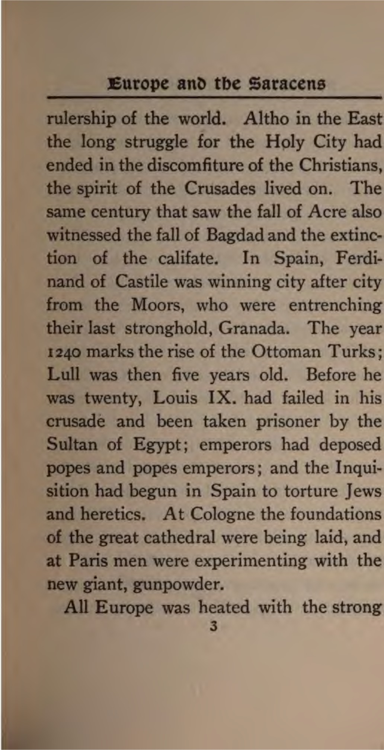

Digitized by e

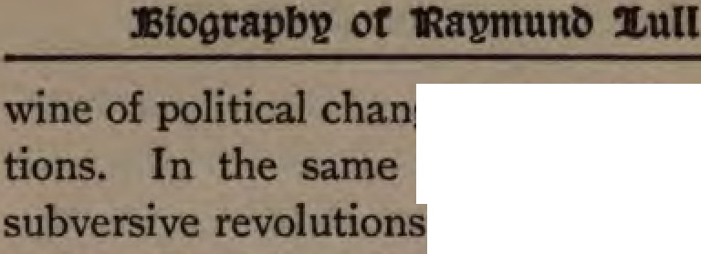

poli1tieal chaDp IOClal eKp!!ICta-
"Cenbuy &Uddell and
taking place in A The onaolian hordes under Geil­ pis Khan poured out, like long.pent -­ ten,overall the countries of theEast. The califate of 8agdad fell forever before the furious onslaught of Hulaku Khan The Seljuk empire soon advanced 1ts Moslem
rule mto the mountain ranges of Anatolia, and Turks were disputing with Mongols the sovereignty of "the roof of the world." The beneficial effects of the Cnisades
re already being felt in the breaking up
of those two colossal fabncs of the Middle Ages, the Church and the Empire, which ruled both as ideas and as realities The feudal system was disappearing The in­ vention and application of paper, the
iner s compass, and gunpowder herakled the eras of printing, exploration, and quest in the century that followed. It wu
4

:Europe ant, tbe Saracens

not dark as midnight, altho not yet dawn. The cocks were crowing. In 1249 the Uni­ versity of Oxford was founded. In 1265 Dante was born at Florence. The pursuit of truth by philosophers was still a game of wordy dialectics, but Thomas Aquinas and Bonaventura and Albertus Magnus left a legacy of thought as well. The two former died the same year that Raymund Lull wrote his "Ars Demonstrava." It was in the thirteenth century that physical science struggled into feeble life in the cells of Gerbert and Roger Bacon. But these men were accounted magicians by the vul­ gar and heretics by the clergy, and were re­ warded with the dungeon. Marco Polo the Venetian, the most famous of all travelers, belongs to the thirteenth century, and did for Asia what Columbus did for America. His work was a link in the providential chain which at last dragged the New World to light. But both Marco Polo and Roger
5

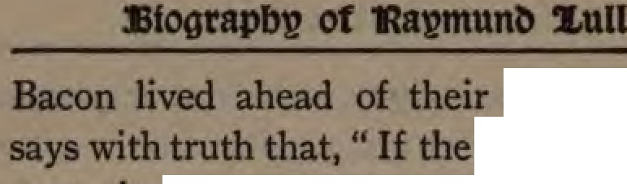

age. Gibbon
ninth and tenth cent1IU'iel were the of darkneas. the thirteenth and fourteenth were the age of. absurdity and fable ' Thought was
n tenor through dread of the doom de­
clared on heretics and rebels.
The maps of the thirteenth cen show no appreciation of Marco Polo discoveries The world as RaJmund LuU knew it was the world of medieval legend and classic lore. The earth's surface represented as aarcular disk surrounded by
the ocean. The central point the Land or Jerusalem, according to the proph­ ecy of Ezekiel. Paradise occupied the tresne east and Gog and Magog re _{OD} the north. The pillars of Hen:ules marked the boundary of farthest west, and the
ttomenclature of even Southern Europe loose and scanty. It is interesting to nom that the first great improvement of these
6

Europe ant, tbe Saracens

maps took place in Catalonia, the province of Spain where Lull's ancestors lived. The remarkable Catalan map of 1375 in the Paris Library is the first world-map that throws aside all pseudo-theological theories and incorporates India and China as part of the world. Nearly all the maps of the Middle Ages are inferior to those in our illustration. Clever artists concealed their ignorance and gave life to the disk of the world by pictures of turreted towns, walled cities, and roaring lions in imaginary forests. Swift has satirized their modern descend­ ants as-
.. Geographers who in Afric's maps With savage pictures fill their gaps ; And o'er unhabitable downs
Place elephants for want of towns."
Regarding the general attitude of the masses toward intellectual progress, a writer• justly remarks: " There were by no
J. A. SymODds: "The Renaissance," Encyc. Brit., u.,
383.
7

Of
mea:ns Jackmg e1emen of natne vigor ready to burst forth But the cowaae that born of knowledge, the calm strength be­ got1en by a positive attitude of mind face to face with the dominant overshadowing sphinx of theology, were lacking We may fairly say that natural and untaught people had more of the Just intuition that needed than learned folk trained m
the schools. Man and the actual universe kept on reasserting their rights and cluma in one way or another; but they were al­ ways being thrust back again into Cun­ merian regions of abstractions, fictions, VJSions, spectral hopes and fears, in the midst of which the intellect somnambulis­ tically moved upon an unknown way."
The morality of the Middle Ages pre­ sentsstartling contrasts. Over against each other, and not only in the same land but often in the same individual, we witness sublime faith and degrading superstition,
8

:Europe an tbe Saraceu

angelic purity and signs ofgross sensuality. It was an age of self-denying charity to suf­ fering Christians, and of barbarous cruelty to infidels, Jews, and heretics. The wealthy paid immense sums to redeem Christian slaves captured by the Saracens; and the Church took immense sums to persecute those who erred from the faith. When the Crusaders under Godfrey of Bouillon (who refused to wear a crown of gold where his Savior had worn a crown of thorns) came in sight of Jerusalem, they kissed the earth and advanced on their knees, in penitential prayer; but after the capture of the city they massacred seventy thousand Moslems, burned the Jews in their synagogs, and waded in blood to the Holy Sepulcher to offer up thanks I The general state of morals even among popes and the clergy was low. Gregory VII. and Innocent III. were great popes and mighty reformers of a corrupt priesthood, but they were excep-
9

OI
tions in the long list. One of the popes deposed _{OD} charges of incest, perjury, murder, and blasphemy. Many were in power through simony Concubinage and unnatural vices re rife in Rome among the clergy. Innocent IV., who became
pope the very year Lull was born, was an outrageous tyrant. Nicholas Ill and Mai,. tin IV., who were popes toward the doee of the thirteenth century, rivaled each other in infamy. The pontificate of the former so marked by rapacity and nepotism
that he was consigned by Dante to his In­ ferno. The latter was the murderous in­ stiptor of the terrible " Sicilian Vespers "
Martensen says that " the ethics of this period often exhibit a mixture of the morals of Christianity with those of Aristotle." And this is natural if we remember that Thomas Aquinas represents the height of medieval morals as well as of dogmatics. Sins were divided into cama1 and spiritual,
10

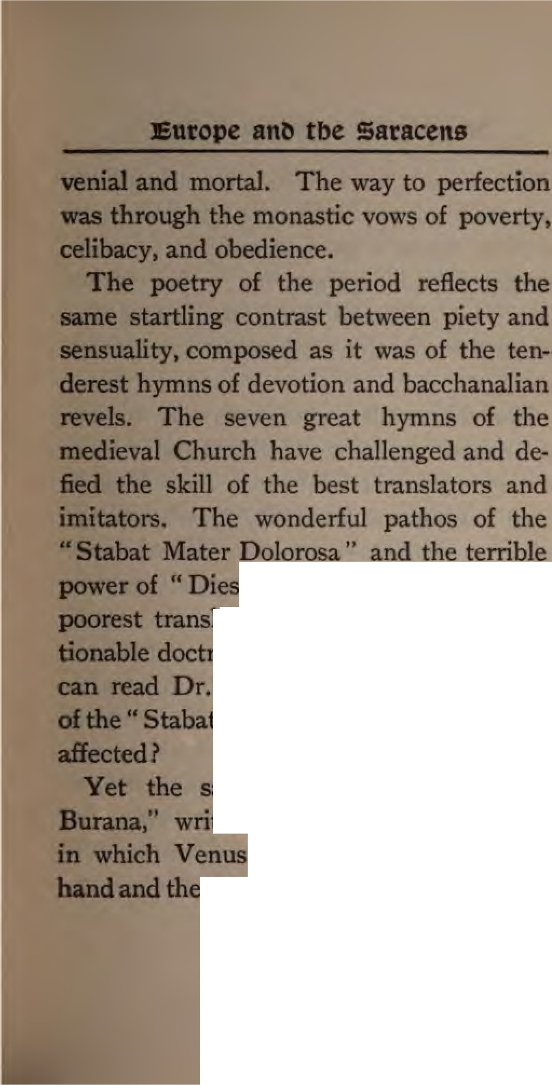

l12" appear even in their
,tlaJ.ia tions In spite of its objec­ doctrinal features, what Protestant Cole's admirable translation
- tabld Mater" without being deeply

aame age had its "Carmina mtten by Goliardi and others, and Bacchus go hand-in­
!illlil,jil tJilll!eensual element predominates.
II

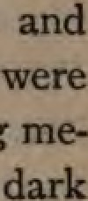
e do not to be reminded Beatrice adorer had a wife and chikbm, or that Laura s poet owned a son dauihter by a concubine." or
Dante and Petrarch exceptiODS mnonc
dieval poets in this respect. It was a
world.
The thirteenth century was also an ace
of 1upentition1 an age of ghosts and visions and miracles and fanatiCISlll. The "Flagel­ Jan •• wandered from city to city calling on the people to repent. Girded with
ropes, in acant clothing or entirely naked, they scourged themselves in the open stree The sect spread like contagion from Italy to Poland, propagating extrava­ gant doctrines and often causing sedition and murder. Catherine of Sienna and Francis of Assisi in the fervor of their love saw visions. The latter bore the stip,alt, and died of the wounds of Christ, which
are said to have impressed themselva on
u

Europe an tbe Saracens

his hands and side through an imagination dtunk with the contemplation and love of the crucified Redeemer. The author of the two most beautiful hymns of the medi­ eval period went to fanatical extremes in self-sought torture to atone for his own sins and for the good of others. Peter No­ lasco in 1228 saw a vision of the Virgio. Mary, and devoted all his property from that day to the purchasing of freedom for Christian captives from their Moorish masters. He founded the order of the Mercedarians, whose members even gave themselves into slavery to save a fellow
. Christian from becoming an apostate to Islam. During the twelfth and thirteenth centuries the monastic orders increased in numbers and influence. They formed the standing army of the papacy and were gen­ erally promoters of learning, science, and art. The Franciscans were one of the strongest orders, altho one of the latest.
13

In 1264 this order had eight thousand cloisters and two hundred thousand monks. Some of these monks were saints, some scienti ts, and some sensualists; alongside of unmeasured superstition and ignorance in the mass of the priesthood we meet with genius of intellect and wonderful displays of self-forgetting love in the few.
Yet the most sacred solemnities were parodied. On " Fools' Festival," which was held in France on New Year's day, mock popes, bishops, and abbots were in­ troduced and all their holy actions mim­ icked in a blasphemous manner.
Practical mysticism, which concerned itself not with philosophy but with per­ sonal salvation, was common in the thir­ teenth century, especially among the women of the Rhine provinces. St. Hilde­ gard, Mechthild, and Gertrude the Great are striking examples. There were also at­ tempts at a reformation of the Church and
14

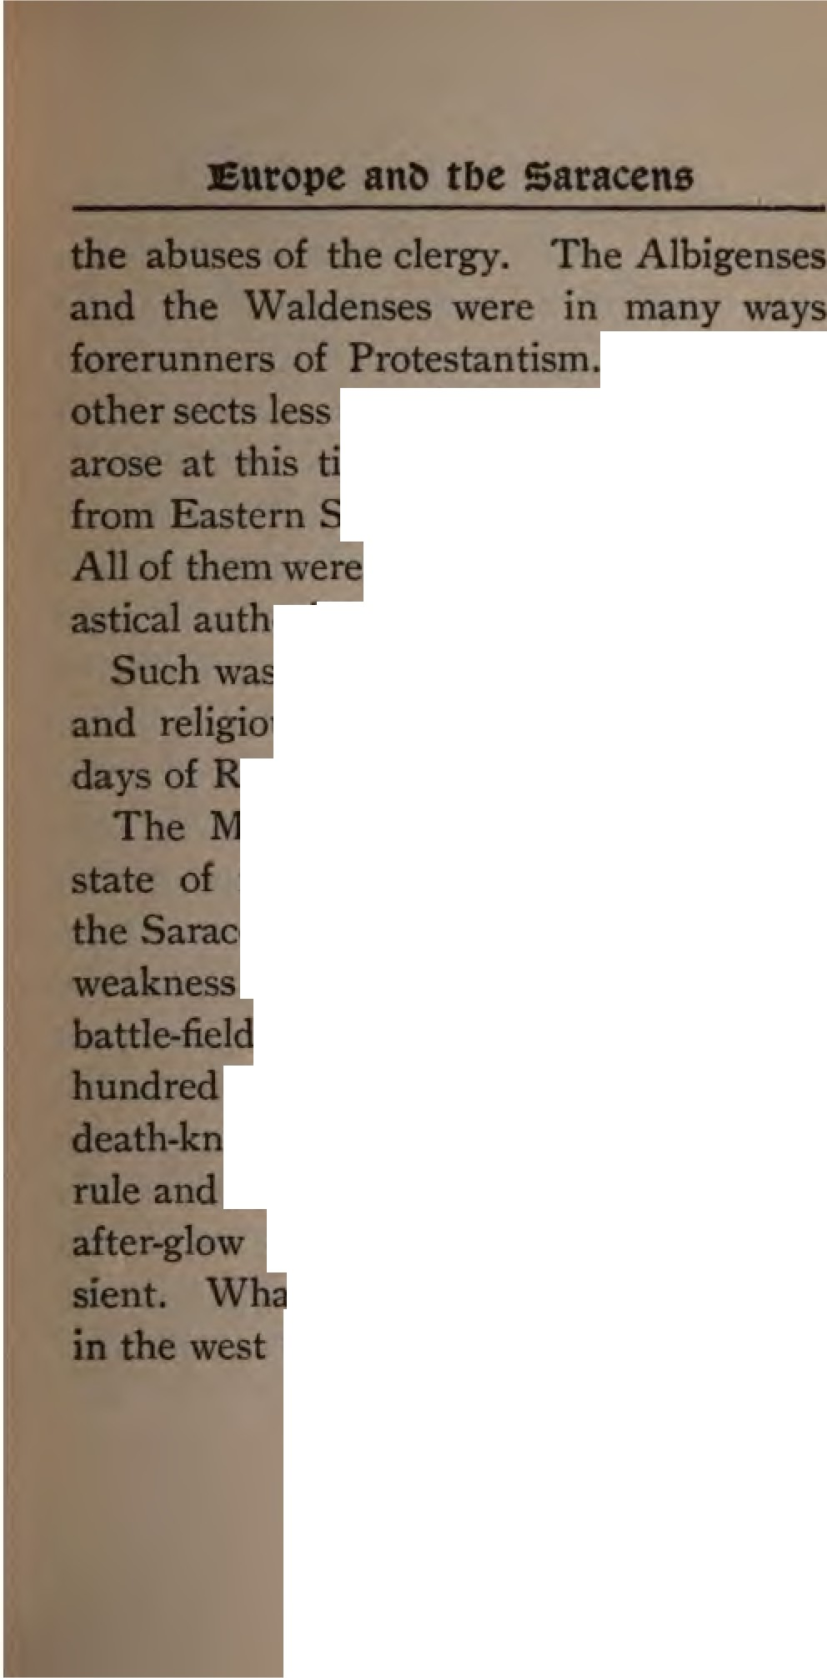

umerous 1S1111u-1ira; pure in doctrine and morals time and spread everywhere
pun to Northern Germany. agreed in opposing ecclesi­
- 51t.11U10rt·ty, and often that of the state.
- 11- • thepolitical 1ntellectual, moral, condition of Europe in the
tW·;Ka'fmund Lull.
ohamrnP.dan orld was also in a ferment. The Crusades taught r.uacen at once the strength and the of medieval Christianity. The
of Tolosa, strewed with two thousand slain Moslems, was the ltlallell of Islam in Spain. Saracen culture at Granada were only the
of • unset, glorious but tran­ t dominions the Saracens lost they regained in Syria and the
15

Digitized by le

East. In ₁₂₅₀ the Mameluke sultans be­
gan to reign in Egypt, and under Beybars
    - Moslem Egypt reached the zenith of its fame. Islam was a power in the thirteenth century not so much by its conquests with the sword as by its conquests with the pen. Moslem philosophy, as interpreted by Alkindi, Alfarabi, Avicenna, and Al­ gazel, but most of all the philosophy of Averroes, was taught in all the universi­ ties. Aristotle spoke Arabic before he was retranslated into the languages of Europe. "The Saracens," says Mye , "were during the Middle Ages almost the sole reposi­ tories of the scientific knowledge of the world. While the Western nations were too ignorant to know the value of the treasures of antiquity, the Saracens pre­ served them by translating into Arabic the scientific works of the Greeks." Part of this learning came to Europe through the Cru­ saders, but it came earlier and more largely
16

Europe an tbe Saracens

through the Arabian schools of Spain. No other country in Europe was in such close touch with Islam for good and ill as the kingdoms of Castile, Navarre, and Aragon in the north of what we now call Spain. There the conflict was one of mind as well as of the sword. There for three centuries waged a crusade for truth as well as a con­ flict on the battle-field between Christian and Moslem. In this conflict Raymund Lull's ancestors played their part. During all the years of Lull's life the Moslem pow­ er held out at Granada against the united Spanish kingdoms. Not until 1492 was the Saracen expelled from Southern Europe.
Regarding missions in the thirteenth century, little can be said. There were a few choice souls whom the Spirit of God enlightened to see the spiritual needs of the Saracen and Mongol and to preach to them the Gospel. In 1256 William de Ru­ bruquis was sent by Louis IX., partly as a
17

diplomat, partly as a missionary, to the Great Khan. In ₁₂₁₉ Francis of Assisi with mad courage went into the Sultan's presence at Damietta and proclaimed the way of salvation, offering to undergo the ordeal of fire to prove the truth of the Gospel. The Dominican general Raimund de Pennaforti, who died in ₁₂₇ 3, also de­ voted himself to missions for the Saracens, but with no success.
The only missionary spirit of the twelfth
and thirteenth centuries was that of the Cru­ saders. They took up the sword and per­ ished by the sword. But " Raymund Lull was raised up as if to prove in one startling case, to which the eyes of all Christendom were turned for many a day, what the Cru­ sades might have become and might have done for the world, had they been fought for thecross with the weapons of Him whose last
woms from it were forgiveness and peace.''•
•<..p Smida: '' A Sbort History of Mlalou."
18

Digitized by e

CHAPTER II
RAYMUND LULL'S BIRTHPLACE AND EARLY LIFE
(A.D. 1235-1265)
"I think that I better understand the proud, hardy, frural Spaniard and his manly defiance of hardships since I have seen the country he Inhabits. • . . The country, the habit■, the Tery looks of the people, have something of the Arabian
character."- Wasl,ington Irving's " Tlie A /1,am!Jra."
RAYMUND LULL was born of an illustri­ ous family at Palma in the island of Majorca of the Balearic group in 1235.* His father had been born at Barcelona and belonged to a distinguished Catalonian family. When the island of Majorca was taken from the Saracens by James I., king of
  - Some authorities give the date 1234, and one 1236, but most agree on the year 1235. See Baring-Gould : "Lives of tbe Saints," vol. vi., p. 48g.

Angon, Lull's father served in the army
conquest. For his distingwshed ,.,.,. he was rewarded with a gift of land in the conquered territory and the tatea grew in value under the new govermntnt
Southern Europe between Atlantic and the Adriatic is almost a duplicate m climate and scenery of Northern Africa. When the Moors crossed over into Spain and occupied the islands of the Western Mediterranean they felt at home. Not only in the names of rivers and mountains and on the architecture of Spain did they leave the impress of their conquest, but on the manners of the people, their literature, and their social life.
Catalonia, the eastern province of Spain, which was the home of Lull's ancestors and for a time of Lull himself, is about one hundred and thirty mil..-s bread and one hundred and eighty-five miles long, with a coast of two hundred and forty
20

JHrtbptace an Earl» Stfe

miles. It has mountain ranges on the north, three considerable rivers, and wood­ land as well as meadow. The climate is healthy in spite of frequent mists and rains, sudden changes of temperature, and great midday heat. Mountains and climate and history have left their impress on its peo­ ple. The Catalonians are distinct in origin from the other inhabitants of Spain, and differ from them to this day in dialect, dress, and character. About 470 A.D., this part of the peninsula was occupied by the Goths, whence it was called Gothalonia, and later Catalonia. It was taken possession of by the Berbers in 712, who in turn were dispossessed by the Spaniards and the troops of Charlemagne. In 1137 Catalonia was annexed to Aragon. The. Catalonians are therefore a mixed race. They have al­ ways been distinguished for frugality, wit, and industry; they have much national pride and a strong · revolutionary spirit
21

The Catalan language and its large litera­ ture are quite distinct from that of the other Spanish provinces. The poetical works of Lull are among the oldest ex­ amples of Catalan extant.
The Balearic Islands have always be­ longed to the province of Catalonia as re­ gards their people and their language. On a clear day the islands are plainly visible from the monastery of Monserrat, and by sea from Barcelona it is only one hundred and forty miles to Palma. Between these. two harbors there has always been and is now a busy traffic. Majorca has an area of fourteen hundred and thirty square miles, a delightful climate, beautiful scenery, and a splendid harbor-Palma. Some of its valleys, such as Valdemosa and Soller, are celebrated for picturesque luxuriance. The northern mountain slopes are ter­ raced _{i} the olive, the vine, and the almond­ tree are plenteous everywhere in the plains.
a:a

J3trtbptace ant, Earlv 2,tfe
According to the description of modem travelers it is an earthly paradise. During the summer there is scarcity of water, but, following a system handed down from the Arabs, the autumn rains are collected in large reservoirs. On the payment of a certain rate each landholder has his fields flooded.
Palma, Lull's birthplace and burial-place, is a pretty town with narrow streets and a sort of medieval look except where mod­ em trade has crowded out " the old-world, Moorish character of the buildings."
The cathedral is still a conspicuous building, and was commenced in ₁₂₃₀ and dedicated to the Virgin by the same King James who gave Lull's father estates near Palma. Portions of the original building still remain, and the visitor can enter the royal chapel (built in ₁₂₃₂₎ with assurance that if Lull did not worship here he at least saw the outside of the building frequently.
23

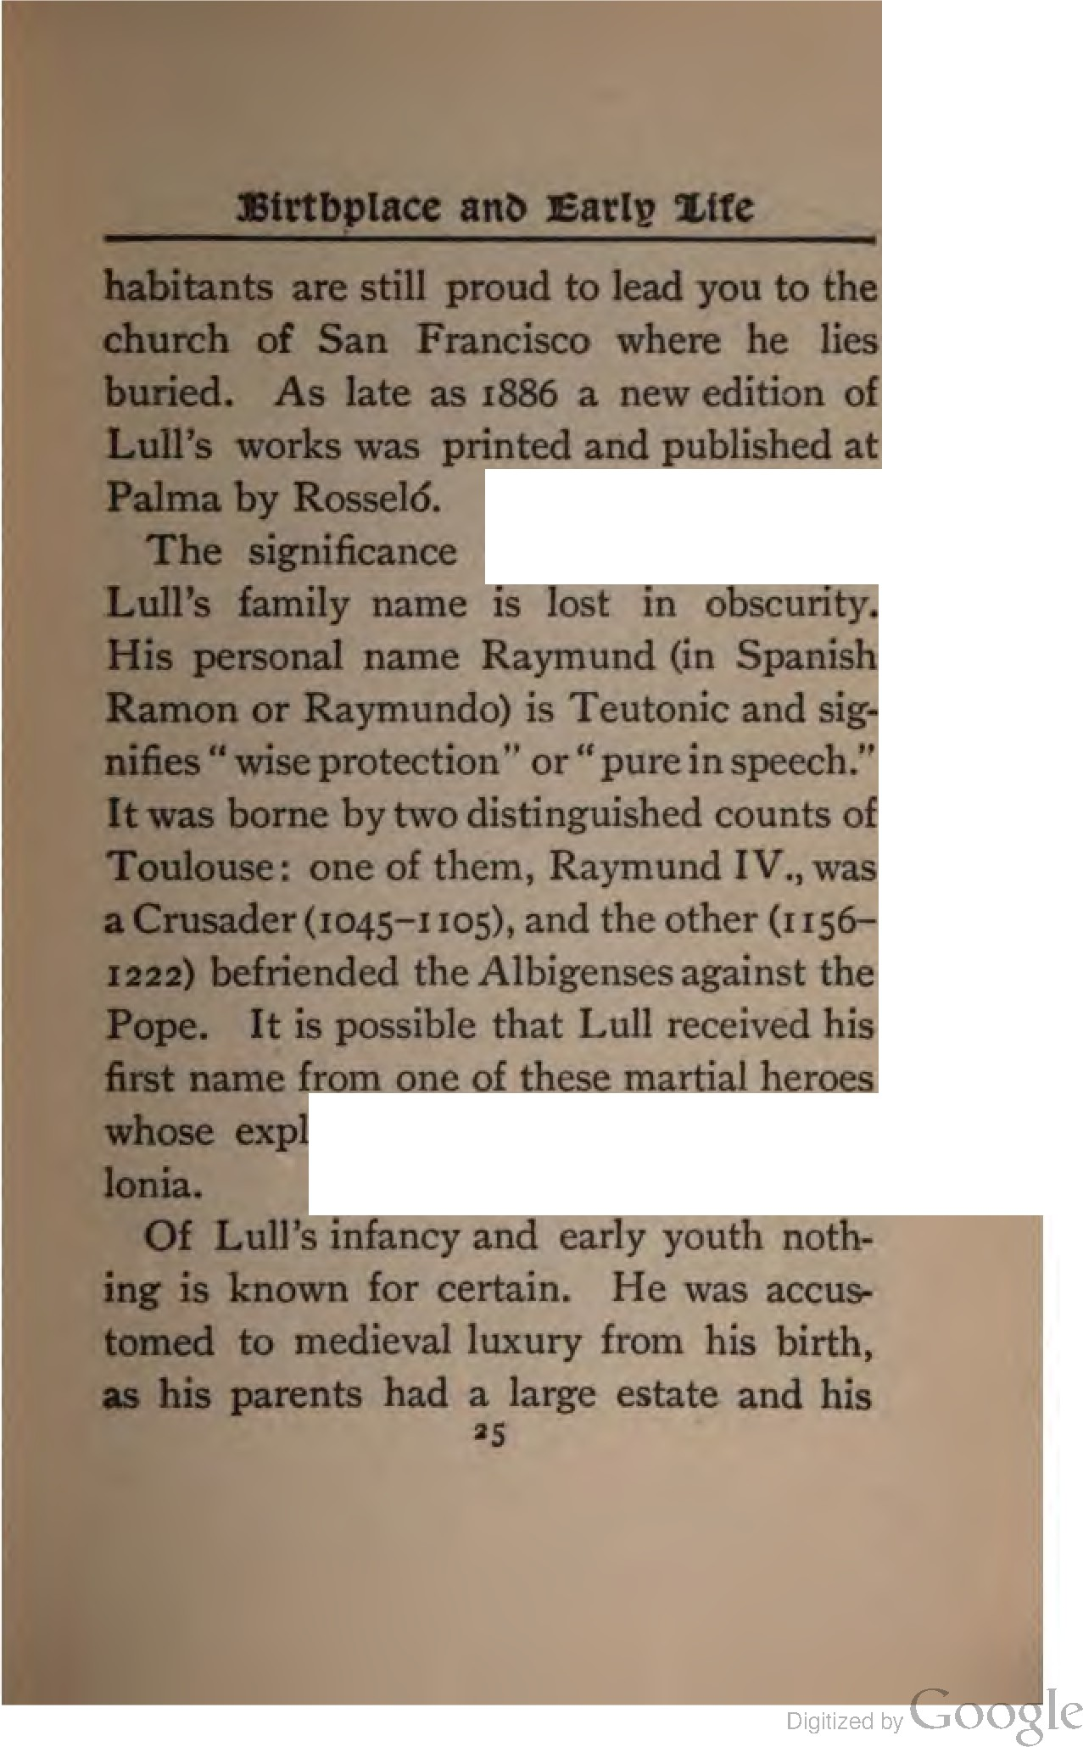

or the derivation of

oits were well known in Cata-

father was distingwshed for military seN­ ices. Lull married at an early age, and being fond of the pleasures of court life, left Palma and passed over with his bride to Spain, where be was made seneschal at the court of Ki ng. James II. of Aragon. Thus bis early manhood was spent in gaiety and even profligacy. All the enthu­ siasm and warmth of his character found exercise only in the pleasures of the court, and, by his own testimony, he lived a life of utter immorality in this corrupt age. Wine, women, and song were then, as often since, the chief pleasures of kings and princes. Notwithstanding his marriage and the blessing of children, Lull sought the reputation of a gallant and was mixed up in more than one intrigue. For this sort of life his office gave him every temp­ tation and plenty of opportunity.
A seneschal (literally, an old servant)•
    - Fnia Lada - +1Mlau, or Gothic nlldp +1ltul.
26

JHrtbplace ant, Earll? tfe
was the chief official in the household of a medieval prince or noble and had the super­ intendence of feasts and ceremonies. These must have been.frequent and luxurious at the court of James II., for Aragon, previ­ ous to the reign of Ferdinand and Isabella, enjoyed the most liberal government of Europe. According to one authority, "the genius and maxims of the court were pure­ ly republican." The kings were elective, while the real exercise of power was in the hands of the Cortes, an assembly consist­ ing of the nobility, the equestrian order, the representatives of cities, and the clergy. A succession of twenty sovereigns reigned from the year 1035 to 1516. At such a court and amid such an assemblage, prob­ ably in the capital town of Zaragoza (Sara­ gossa), Lull spent several years of his life. He was early addicted to music and played the cithern with skill. But he was yet more celebrated as a court poet. Accord-
27

Digitized by Google

ing to his own confessions, however, the theme of his poetical effusions was not seldom the joys of la less love " I see,0 Lord," he says in his Contemplations, 'that trees bring forth every year flowers and fruit, each after their kind, whence man­ kind derive pleasure and profit. But thus it was not with me, sinful man that I am; for thirty years I brought forth no fruit in this world, I cumbered the ground, nay, was noxious and hurtful to my friends and neigh­ bors. Therefore, since a mere tree, which has neither intellect nor reason, is more fruitful than I have been, I am exceedingly ashamed and count myself worthy of great blame." • In another part of the same book he returns thanks to God for the great differ­ ence he sees between the works of his after­ life and those of his youth. " Then," he says, all his "actions were sinful and he enjoyed the pleasures of sinful companionship."
- Uber Coallmaplalkmls lo Deo," h., a57, ed. 1740-
sS

e

: JHrtbplace ant, Eatlv Stfe
Raymund Lull was gifted with great mental accomplishments and enthusiastQ. He had the soul of a poet, but at first his genius groveled in the mire of sensual pleasures, like that of other poets whose passions were not under the control of religion. We do Lull injustice, however, if we judge his court life by the standards of our Christian century. His whole en­ vironment was that of medieval darkness,
.and he was a gay knight at the banquets of James II. before he became a. scholastic philosopher and a missionary. As knight he knew warfare and horsemanship so well that among his books there are several treatises on these sciences,• first written in Catalan, and afterward put into Latin. Undoubtedly these were written, as was most of his poetry, before he was thirty years old. He was the most popular poet of his age in Spain, and his influence on
•Fora list of these works see Helflerich, p. 74, note.
29

:mtograpb» of 'Rapmunt, 2.ull
Catalonian poetry is acknowledged in such terms of praise by students of SpanishHtera­ ture that he might be called the founder of the Catalonian school of poets. The philo­ logical importance of Lull's Catalonian writings, especially his poems, was shown by Adolph Helfferich in his book on" Lull and the Origin of Catalan Literature." In this volume specimens of his poetry and proverbs are given. A writer in the " En­ cyclopedia Britannica" speaks of one of his poems, " Lo Desconort " (Despair) as emi­ nently fine and composite in its diction. This poem, if it was written before his conversion, as is probable, would already show that Lull himself was dissatisfied at heart with his life of worldly pleasure. Al­ ready, perhaps, there arose within him a mighty struggle between the spirit and the flesh. Sensual pleasures never satisfy, and his lower and higher natures strove one with the other.
30

J3frtbplace ant, Earl» .Ufe

It seems that at about his thirty-second year he returned to Palma, altho there is little certainty of date among his biogra­ phers. At any rate it was at the place of his birth that Lull was born again. It was in the Franciscan church, and not at the court of Aragon, that he received his final call and made his decision to forsake all and become a preacher of righteousness. The prodigal son came to himself amid the swine, and his feet were already toward home when he saw his Father, and his Father ran out to meet him. The story of St. Augustine under the fig-tree at Milan was reenacted at Palma.

31

CHAPTER III
THE VISION AND CALL TO SERVICE
(A.D. 1366-1267)
"I will pour out my spirit upon all flesh, ••• and :,our
young men shall sec visions."-Joel ii. a8.
WHEN St. Paul told King Agrippa the story of his life, the key of it lay in the words, " I was not disobedient to the heavenly vision." The angel had come to him and called him straight away from his career as arch-persecutor. All that he had done or meant to do was now of the past. He arose from the ground and took up his life again as one who could not be dis­ obedient to his vision. It was a vision of Christ that made Paul a missionary. And his was not the last instance of the ful-
32

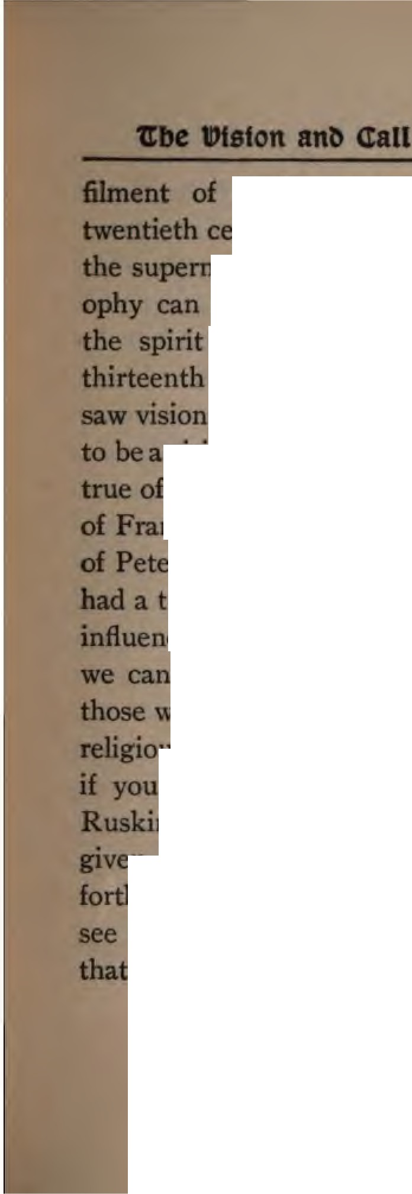

to
Joefi great prophecy The
ntury, even, dares not mock at
....'lfl!rrm•tural; and materialistic philoe­
not explain the phenomena of
spirit world. The Christians of the
,lld rtee:n·th century believed in visions and
Altho an age of visions is apt\
vaonary age, this was not altogether of the thirteenth century. The visions rancis of Assisi, of Catherine the Saint, r olasco, and of others in this age,
a tremendous effect on their lives and uence. We may doubt the vision, but not doubt its result in the lives of
ho profess to have seen it. Call it hallucination or pious imagination will but even then it has power. says that " such imagination is
.... us that we may be able to vision rth the mini try of angel beside us and the chariots of fire on the mountains cird us round." In that age of Mariol-
33

atry and angel-worship and imitation of saints, it was not suck a vision that arrested· Lull, but a vision of Jesus Himself. The story, as told in a Life• written with his consent during his lifetime, is as follows:
One evening the seneschal was sitting on a couch, with his cithem on his knees, composing a song in praise of a noble mar­ ried lady who had fascinated him but whq was insensible to his passion. Suddenly, in the midst of the erotic song, he saw on his right hand the Savior hanging on His cross, the blood trickling from His hands and feet and brow, look reproachfully at him. Raymund, conscience- struck, started up; he could sing no more; he laid aside his cithern and, deeply oved, retired to bed. Eight days after, he again at­ tempted to finish the song and again took

  - S. Baring-Gould: "Lives of the Saints," vol. vi., p. 48g. Maclear : " History of Christian Missions in the Middle es," pp. 355, 356.
34

1tbe l>tston anl) <tall to Sen,tce
up the plea of an unrequited lover. But now again, as before, the image of Divine Love incarnate appeared-the agonized form of the Man of Sorrows. The dying eyes of the Savior were fixed on him mournfully, pleadingly:
"See from His head, His hands, His feet
Sorrow and love flow mingling down :
Did ere such love and sorrow meet,
Or thorns compose so rich a crown ? "
Lull cast his lute aside, and threw himself on his bed, a prey to remorse. He had seen the highest and deepest unrequited love. But the thought that
"Love so amazing, so divine,
Demands my soul, my life, my all,"
had not yet reached him. The effect of the vision was so transitory that he was not ready to yield until it again repeated itself.• Then Lull could not resist the
•" Tertio et quarto successive d!ebus !nterpositis aliquibus, Salvator, in forma semper qua primitus, apparet."-" Acta Sanctorum,"p.66g.
35

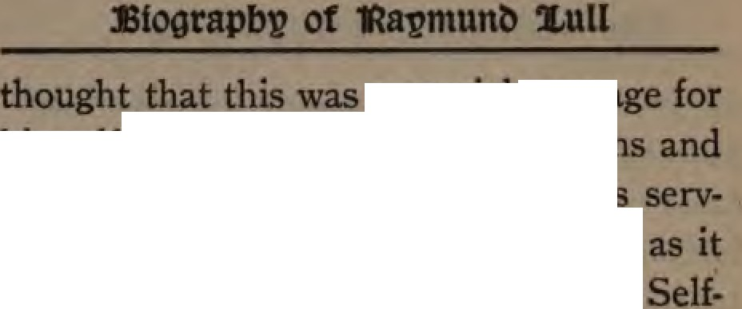

&IR"' Dlel1811'8
Jlilllllelt ID conquer bis lower PBSlllOlta.
to devote himaelf ,mtirely to
He felt engraved on · bealtt
the great pectade of divine
aacrifice. Henceforth he had only
pass1on, to love and sene Christ. But there arose the doubt, How can I, defiled with impurity, rise and enter on a
life? Night after night, we are told.
lay awake a prey to despondency doubt. He wept like Mary remembenng how much and how deeply he had sinned. At length the thought curred. Christ is meek and full of com sion· He invites all to come to Him; He will not cast me out. With that thought cameconsolation. Because be was ao much be loved the more, and concludecl that he would forsake the world and II
up all for bis Savior. How he was coo­
firmed in this resolve we shall see ahortlJ
36

1tbe l>tston ant, <tall to Sen,tce

By way of parenthesis it is necessary to give another account of Lull's conversion which the author of "Acta Sanctorum" re­ lates, and says he deems "improbable but nat impossible." According to this story Lull was one day passing the window of the house of Signora Ambrosia, the mar­ ried lady whose love he vainly sought to gain. He caught a glimpse of her ivory throat and bosom. On the spot he com­ posed and sang a song to her beauty. The lady sent for him and showed him the bosom he so much admired, eaten with hideous cancers I She then besought him to lead a better life. On his return home Christ appeared to him and said, " Ray­ mund, follow Me." He gave up his court position, sold all his property, and withdrew to the retirement of a cell on Mount Roda. This was about the year _{I} 266. When he had spent nine years in retirement he came to the conclusion that he was called
37

of God to preach the Gospel to the o­

hammedans.•
Some biographers know nothing of this nine years' retirement in a cell at Mount Roda near Barcelona, altho all of them agree that his conversion took place in July, 1266. The visions and spiritual con­
flicts and experiences at Mount Roda
gained for Lull the title of ., Doctor ruu­
minatus," the scholar enlightened from heaven. And if we look at the life that was the result of these visions, we can not deny that, in this dark age, heaven did in­ deed enlighten Lull to know the love of God and to do the will of God as no other in his day and generation.
Let us go back to the story of his con­ version as told by Lull himself in that work, " On Divine Contemplation," which may

    - See article b7 Rn, Edwin WaJJace. ol Osford Uru'Nl'­ lJ, la the Encyclopedia BritaDDlca, where oat Roda Is wtOO(ly 1pelled Randa.

Digitized by e

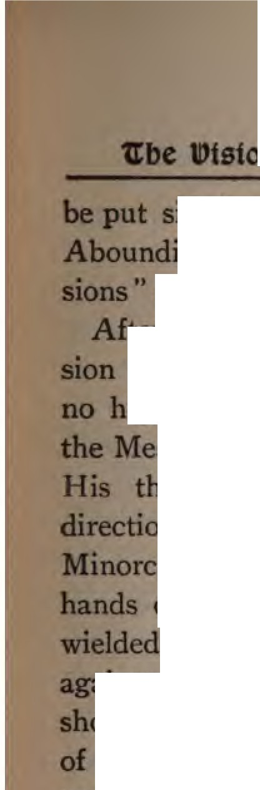

n ui, ctall to semce
side by side with Bunyan's "Grace " and Augustine's "Confes-­
as the biography of a penitent soul.
.liCI" the visions he came to the conclu­ tbat he could devote his energies to
- work than that of proclaiming of the Cross to the Saracens. thoughts would naturally take this
n. The islands of Majorca and
rca had only recently been in the of the Saracens. His father had the sword of the king of Aragon
- ••ts
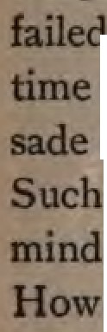
·• Mntst these enemies of the Gospel; why 1i1111u not the son now take up the sword the Spirit against them? If the carnal wn,o:ns of the crusading knights had
- - - to conquer Jerusalem, was it not to sound the bugle for a spiritual cru­ for the conversion of the Saracen? were the thoughts that filled his But then, he says, a difficulty arose. could he, a layman, in an age when
39

lUogtapb)? of 'Rapmunl) 2,ttll
the Church and the clergy were supreme, enter on such a work? Thereupon it oc­ curred to him that at least a beginning might be made by composing a volume which should demonstrate the truth of Christianity and convince the warriors of the Crescent of their errors. This book, however, would not be understood by them unless it were in Arabic, and of this lan­ guage he was ignorant; other difficulties presented themselves and almost drove him to despair. Full of such thoughts, he one day repaired to a neighboring church and poured forth his whole soul to God, beseeching Him if He did inspire these thoughts to enable him to carry them out.• This was in the month of July. But, al-
*"Vita Prima," p. 662. "Dominum Jesum Christum de­ vote, ficus largiter cxoravit, quatenus hsec prsedicta tua qua lpsc miscricorditcr inspiraverat cordi suo, ad effcctum sibi placitum pcrduccre dignaretur." Several authorities put a period of short backsliding between his conversion and the accoant of the sermon by the friar that follows in our tut.
40

U:be ll)tston an <tall to Sen,tce
tho old desires and the old life were pass­ ing away, all things had not yet become new. For three months his great design was laid aside and he struggled with old passions for the mastery. On the fourth of October, the festival of St. Francis of Assisi, Lull went to the Franciscan church at Palma and heard from the lips of the friar-preacher the tale of the " Spouse of Poverty." He learned how this son of Pie-
.tro Bernadone di Mericoni, once foremost in deeds of war and a gay worldling, was taken prisoner at Perugia and brought by disease to the very gates of death ; how he saw visions of the Christ and of the world to come; how, when he emerged from his dungeon, he exchanged his gay apparel for the garb of the mendicant, visiting the sick, tending the leprous, and preaching the Gospel; how in _{1219,} before the walls of Damietta, this missionary­ monk crossed over to the infidels and wit-
41

nessed for Christ before the Sultan, declar­ ing, " I am not sent of man, but of God, to show thee the way of salvation."
The words of the preacher rekindled the fires of love half-smothered in the heart of Lull. He now made up hismind once and forever. He sold all his property, which was considerable, gave the money to the poor, and reserved only a scanty allowance for his wife and children. This was the vow of his consecration in his own words: "To Thee, Lord God, do I now offer myself and my wife and my children and all that I possess; and since I approach Thee humbly with this gift and sacrifice, may it please Thee to condescend to accept all what I give and offer up now for Thee, that I and my wife and my children may be Thy hum­ ble slaves." • It was a covenant of com­ plete surrender, and the repeated reference to his wife and children shows that Ray-
•" Uber Coatemplationia in Deo," ui.,17,
41

U:be 11>tston ant> <tall to Ser"tce
mund Lull's wandering passions had found rest at last. It was afamt"ly covenant, and by this token we know that Lull had for­ ever said farewell to his former companions and his life of sin.
He assumed the coarse garb of a mendi­ cant, made pilgrimages to various churches in the island, and prayed for grace and as­ sistance in the work he had resolved to un­ dertake. The mantle of apostolic succes­ sion fell from Francis of Assisi, forty years dead, upon the layman of Palma, now in his thirtieth year. From the mendicant orders of the Middle Ages, their precepts and their example, Lull in part drew his passionate, ascetic, and unselfish devotion. Most of his biographers assert that he be­ came a Franciscan, but that is doubtful, especially since some of the earliest biog­ raphers were themselves of that order and would naturally seek glory in his memory.•
*See Noble: "The Redemption of Africa," TOI, I., p. uo.
43

l3tograpf>W of 'Ra)?munb 2.ull
Eymeric, a Catalonian Dominican in 1334 and the inquisitor of Aragon after 1356, expressly states that Lull was a lay mer­ chant and a heretic. In 1371 the same Ey­ meric pointed out five hundred heresies in Lull's works, and in consequence Gregory
- forbade some of the books. The Franciscans, Antonio Wadding and others, afterward warmly defended Lull and his writings, but the Jesuits have always been hostile to his memory. Therefore the Roman Catholic Church long hesitated whether to condemn Lull as a heretic or to recognize him as a martyr and a saint. He was never canonized by any pope, but in Spain and Majorca all good Catholics regard him as a saintly Franciscan. In a letter I have received from the present bishop of Majorca he speaks of Raymund Lull as "an extraordinary man with apos­ tolic virtues, and worthy of all admiration." Frederic Perry Noble, in speaking of
44

1tbe ll)tston ant, <tall to Sen,tce

Lull's conversion, says: " His new birth, be it noted, sprang from a passion for Jesus. Lull's faith was not sacramental, but personal and vital, more Catholic than Roman." Even as the Catalonians first arose in protest and revolution against the tyranny of the state in the Middle Ages, so their countryman is distinguished for daring to act apart from the tyranny of the Church and to inaugurate the rights of lay­ men. The inner life of Lull finds its key in the story of his conversion. Incarnate Love overcame carnal love, and all of the passion and the poetry of Lull's genius bowed in submission to the cross. The vision of his youth explains the motto of his old age: " He who loves not lives not; he who lives by the Life can not die." The image of the suffering Savior remained for fifty years the mainspring of his being. Love for the personal Christ filled his heart, molded his mind, inspired his pen, and
45

made his soul long for the crown of mar­ tyrdom. Long years afterward, when he sought for a reasonable proof of that great­ est mystery of revelation and the greatest stumbling-block for Moslems-the doctrine of the Trinity-he once more recalled the vision. His proof for the Trinity was the love of God in Christ as revealed to us by the Holy Spirit.

CHAPTER IV
PREPARATION FOR THE CON­ FLICT
(A.D. 1267-1274)
- Sive ergo Mahometicus error lueretlco nomlne deturpetur;
clve gentili aut pagano infametur ; agendum contra eum est, ICribendum est."-Petr11s Vmerabilis, t 1157.
- Aggredlor vos, non ut nostrl 112pe faciunt, armis, sed
verbis, non vised ratione, non odio sed amore."-Ibid.

Bv his bold decision to attack Islam with the weapons of Christian philosophy, and in his lifelong conflict with this gigantic heresy, Lull proved himself the Athanasius of the thirteenth century. The Moham­ medan missionary problem at the dawn of the twentieth century is not greater than it was then. True, Islam was not so ex­ tensive, but it was equally aggressive, and,
47

if pout"ble, more arrogant. The Moham­ medan world was more of a unit, and from Bagdad to Morocco Moslems felt that the Crusades had been a defeat for Christen­ dom. One-half of Spain was under Moa­ lem rule. In all Northern Africa Saracen power was in the ascendant. Many con­ versions to Islam took place in Georgia, and thousands of the Christian Copts in Egypt were saying farewell to the religion of their fathers and embracing the faith of the Mameluke conquerors. It was just at this time that Islam began to spread among the Mongols. In India, Moslem preachers were extending the faith in Ajmir and the Punjab. The Malay archipelago first heard of Mohammed about the time when Lull was born.• Bey­ bars I., the first and greatest of the Mame­ Juke Sultans, sat on the throne of Egypt.
Amold : " Preacblar of Islam," synchroaolorfcal table,
p.5'9, 1'96,

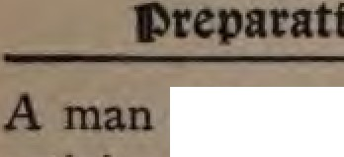
of grand achievements, unceasing admtY.and afem orthodoxy, he used every eD1111111vor to t.end and strengthen the
  - .ftli:triOD of the state.• Islam had political 11n1 and prestige. She was mistress of JJbilole)l)by and science In the beginning the thirteenth century the scientific
.....r1ra of Ari totle were translated from Arabic into Latin. Roger Bacon and lhP1 111 Magnus were so learned that the
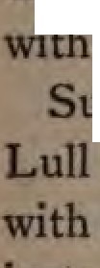
dl!!nrv accused them of being in league
    - the Saracens I
uch was the Mohammedan world which dared to defy, and planned to attack the new weapons of love and learning
.11111:eaa of the Crusaders' weapons of fa..
    - • and the sword. The Christian did not Jove Moslems in the tbir­
.teentll century nor did they understand
religion. Marco Polo, a contempt>
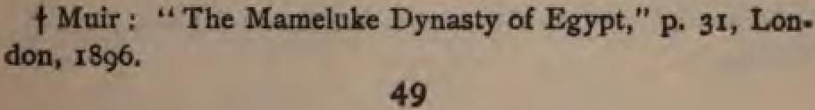

or
1911 of Lull, Wl'Ote: " Marvel not that the
:;uace1111 hate the Christians; for the ao­ cmsed la: hich Mohammed ga: them commands them to do all the mischief n1 their power to all other descripti
of people, and especially to Christians· to strip such of their goods and do them all manner of evil. In such fashion the Saracens act throughout the world." •
Dante voices the common opinion of thas age when he puts Mohammed in the deep­ est hell of his Infemo and describes his fate in such dreadful language as offends polite
ears. t But even worse things were said of the Arabian prophet in prose by other of Lull's contemporaries. Gross ignorance and great hatred were joined in nearly all
who made any attempt to describe Moham­ medanism.
"ManlO Polo's Trawels." Colonel Yule'• editiaa, yal. L.
p. 69-
t •• Hell,,. CUIO anili., I0-39, ID Dante's " Villoa."Car7'1
.Udaa.

Digitized by uUUg e

a.t,fi••
(I 114-1200) was one of
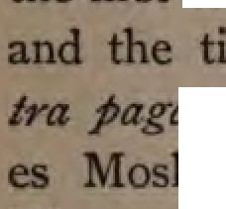
to wnte a book on Islam in Latin, tie shows his ignorance: " c.,
sn, MdnultMIJs • He class­
ems with Jews and Waldemesl

··w. rn Europe, according to Keller, wa mnt even of the century in which lloballimu was bom; and Hildebert, the of Tours, wrote a poem on
- JlaluulBDM in which he is represented as
apostate from the Christian Church I

v_..
Venerabilis, whose pregnant words at the head of this chapter, was the to translate the Koran and to study "th sympathy and scholarship. He
a plea for translating portions of the

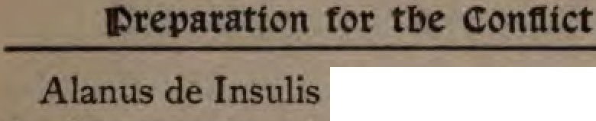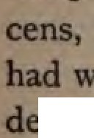5clm,t:ure mto the language of the Sara­ and affirmed that the Koran itseH eapons with which to attack the cita,.

I of
Islam But, alas I he added the plea d th scholar at his books: " I myself have time to .enter into the conflict." He
51

first distinguished the true and the false in the teaching of Mohammed, and with keen judgment pointed out the pagan and Christian elements in Islam.• Petrus Venerabilis took up the pen of controversy and approached the Moslem, as he says, "Not with arms but with words, not by force but by reason, not in hatred but in love " ; and in so far he was the first to breathe the true missionary spirit toward the Saracens. But he did not go out to them. It was reserved for the Spanish knight to take up the challenge and go out single-handed against the Saracens, " not by force but by reason, not in hatred but in love." It was Raymund Lull who wrote: "I see many knt.''ghts going to the Holy Land beyond the seas and thinking that tleey can acquire it by force of arms,·
/Jut in tlee end all are destroyed before they
  - A. Keller's " Geisteskampf des Chrlstentums geeen den
Islam bis zur Zeit der Kreuzzl\ge," pp. 41, 43, Leipsic, 18g6.
52

.,.... IAIII ••" IMY IAiu "' --.
WlauiiSMIIS to"" tl,,at 1M &Ollf"IISI of
"°'
_. Lll1lll O#gAI to 1M alm#J,l«I
iJ,.IA6 'IINlj' i,, tr1.wl, T.to# nd TMw
IIJMl/a Mpind ii, tu11M/y, low -,J
.J,wyws, Md 1M JOl6ri,,g Ol61 of lltws 11,,,J
.qf /Jl«Jtl.,,
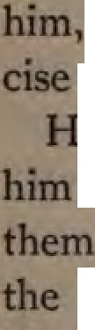
Lull was ready to pour out this sacrifice OQ the altar. The vision remained with and bis love to God demanded exel'­
lD showing forth that love to men.
e was not in doubt that God had chosen to preach to the Saracens and wm to Christ. He only hesitated as to best method to pursue. All the past
llilll'Ol'Y of ·h native land and the struggle
going on in Spain emphasized for him
greatn of the task before him.
The knight of Christ felt that he could venture into the arena unless he had
aoocl armor. The son of the soldier who
fought the Moors on many a bloody
53

JStaorapbp of 'RapmunD s.uu
battle-field felt that the Saracens were worthy foemen. The educated seneschal knew that the Arabian schools of Cordova were the center of European learning, and that it was not so easy to convince a Sara­ cen as a barbarian of Northern Europe.
At one time, we read, Lull thought·of repairing to Paris, and there by close and diligent scientific study to train himself for controversy with Moslems. At Paris in the thirteenth century was the most famous university of Christendom. And under St. Louis, Robert de Sorbon, a common priest, founded in 1253 an unpretending theo­ logical college which afterward became the celebrated faculty of the Sorbonne with authority wellnigh as great as that of Rome.
But the advice of his kinsman, the Do­ minican Raymund de Pennaforte, dis­ suaded him, and he decided to remain at Majorca and pursue his studies and prepa-
54

»reparation for tbe <ton1ltct

ration· privately. First he laid plans for a thorough mastery of the Arabic language. To secure a teacher was not an easy mat­ ter, as Majorca had years ago passed from Saracen into Christian hands, and as no earnest Moslem would teach the Koran language to one whose professed purpose was to assail Islam with the weapons of philosophy.
He therefore decided to purchase a Sara­ cen slave, and with this teacher his biog­ raphers tell us that Lull was occupied in Arabic study for a period of more than ni"ne years. Could anything prove more clearly that Lull was the greatest as well as the first missionary to Moslems?
After this long, and we may believe suc­ cessful, apprenticeship with the Saracen slave, a tragic incident interrupted his studies. Lull had learned the language of the Moslem, but the Moslem slave had not yet learned the love of Christ; nor had his
55

pupil. In the midst of their studies, on one occasion the Saracen blasphemed Christ. Ho , we are not told; but those ho work among Moslems know what cruel, vulgar words can come from Moslem lips against the Son of God. When Lull
heard the blasphemy, he struck his sla violently on the face in his strong illCiign. tion. The Moslem, stung to the quick, drew a weapon, attempted Lull's life, and wounded him severely. He was seized and imprisoned. Perhaps fearing the death­ penalty for attempted murder, the Saracen slave committed suicide. It was a sad be­ ginning for Lull in his work of preparation. Patience had not yet had its perfect work. Lull felt more than ever before, " He that loves not lives not." The vision of the thorn-crowned Head came back to him; he could not forget his covenant.
Altho he retired for eight days to a
mountain to engage in prayer and medita-
56

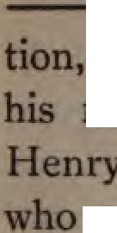

be did not falter, but pe:ae1ircn in resolution Even as in the case of Nartyn with his munshi, Sabat, made life a burden to him, so Lull's rience with his Saracen slave was a
school of faith and patience.
Besides his Arabic studies, Lull spent theae nine years in spiritual meditation. in what be calls contemplating God.

"Tbe awakened pn Taraecl whoUJ from the earth, _{OD} thmp of lNaftll
lie dwelt botJa day ud 11fcht. The thaqbt al. Goel
blm wlda ID&lllte joy ; his ClllffllC ma!
Dwelt Oil mm u a feast ; u did the IIOlll
Of apt Frucaeo ID Ida holy cell
h 1llat Aalal; and he 1mew the pabl,
- deep despoadace of the uhlt, the doabt,
,,. camcloaam ol dark -- the joy Of fta1I IIIIIU'IIICe lut, wbea heaftll ltMlf Studs apea to the OClfalJ of faith."

ile thus employed the idea occurred to him of composing a work which should oontain a strict and formal demonstration of all the Christian doctrines, of such co-
57

:Etograpbv of 'Rapmunt> 1ull
gency that the Moslems could not fail to acknowledge its logic and in consequence embrace the truth. Perhaps the idea was suggested to him by Raymund de Penna­ forte, for he it was who, a few years previ­ ous, had persuaded Thomas Aquinas to compose his work in four volumes, " On the Catholic Faith, or Summary against the Gentiles."•
In Lull's introduction to his" Necessaria Demonstratio Articulorum Fidei " he re­ fers to the time when the idea of a contro­ versial book for Moslems first took posses­ sion of him, and asks " the clergy and the wise men of the laity to examine his argu­ ments against the Saracens in commending the Christian faith." He pleads earnestly that any weak points in his attempt to con­ vince the Moslem be pointed out to him before the book is sent on its errand.
  - Maclear : " History of Missions," p. 358, where authori­
ties are cited.

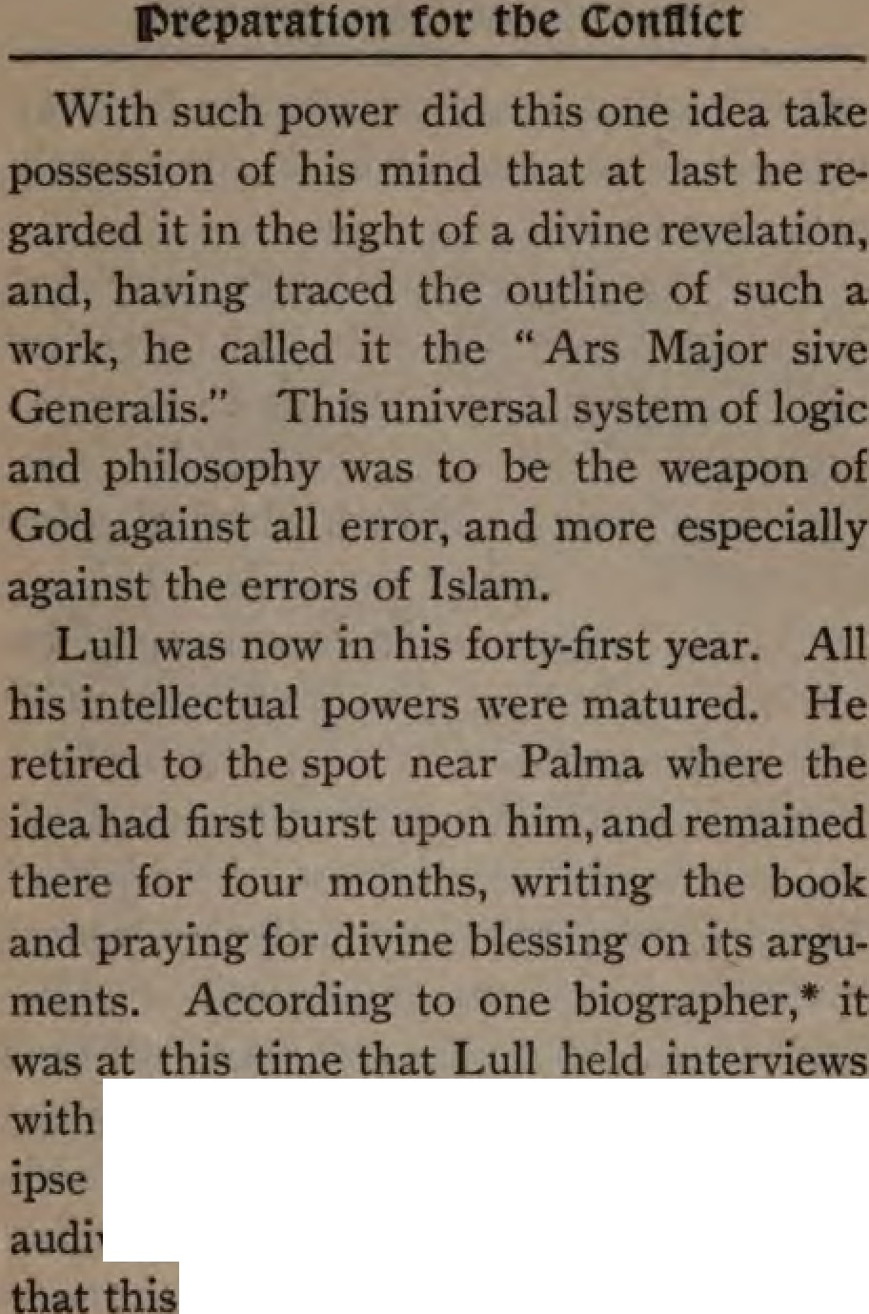

a certain mysterious shepherd, "q m nunquam viderat alias, neque de 1pao verat quenquam loqui." Is st poll8ib
refers only to the Great Shepheni
.. Vita Prima." Acta SIDc:lonaD," -
59

of
L 'spiritualeJQJel'HllQl·h••--

from &iends and family, m
spot near Palma?
The "Ars Major" was finally COllllPM._
in the year 1275. Lull had an j,nt.PUU..
th the king of Majorca, and ..._.....
patronage the first book of h 11 Method" was published. Lull pn to lecture upon it in public. markable treatise, while in one
tended for the special work of CODWIC:i)iS
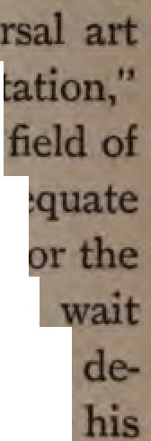
Moslems, was to include "a unive
of acquisition, demonstration, confutad
and was meant "to cover the hole
owledge and to supersede the inadeq methods of previous schoolmen." Fi ##IW of Lull's philosophy we will
ntil we reach the chapter specially voted to an account of his teaching and boo A few words, however, rep.rding the ,W,tH,u of the Lullian method are­ place.
6o

»reparatton tor tbe <tontltct

In the age of scholasticism, when all sorts of puerile questions were seriously debated in the schools, and philosophy was anything but practical, it was Lull who proposed to use the great weapon of this
- age, dialectics, in the service of the Gospel and for the practical end of converting the Saracens. Let us admit that he was a scholastic, but he was also a missionary. His scholastic philosophy is ennobled by its fiery zeal for the propagation of the Gospel, and by the love for Christ which purifies all its dross in the flame of passion for souls.
We may smile at Lull's dialectic, and his " circles and tables for finding out the dif­ ferent ways in which categories apply to things " ; but no one can help admiring the spirit that inspired the method. " In his assertion of the place of reason in re­ ligion, in his demand that a rational Chris­
tianity should be presented to heathendom,
61

:Etograpbp of 1blpmun 1uu
Lull goes far beyond the ideas and the as­ pirations of the century in which he lived." • In judgingthecharacterof Lull'smethod and his long period of preparation, one thing must not be forgotten. The strength of Islam in the age of scholasticism was its philosophy. Having thoroughly entered into the spirit of Arabian philosophical writings and seen its errors, there was noth­ ing left for a man of Lull's intellect but to meet these Saracen philosophers on their own ground. Avicenna, Algazel, and Averroes sat on the throne of Moslem learning and ruled Moslem thought. Lull's object was to undermine their influence and so reach the Moslem heart with the message of salvation. For such a conflict and in such an age his weapons were well
chosen.
*" Enc:yclopedia Britannica," voL n., p. 64-

62

CHAPTER V
AT MONTPELLIER, PARIS, AND
ROME
(A.D. 1275-1298)
"I have but one passion and it is He - He only." -
Zi111mtiiw f.
- ID his assertion of the function of reason in religion and his demand that a rational Christianity be placed before Islam, this Don Quixote of his times belongs to our day."-Fredwie Perry No le.

IT is difficult to follow the story of Lull's life in exact chronological order because the sources at our disposal do not always agree in their dates. However, by group­ ing the events of his life, order comes out of confusion. Lull's lifework was three­ fold: he devised a philosophical or educa­ tional system for persuading non-Christians of the truth of Christianity; he established
63

missionary colleges; and he himself went and preached to the Moslems, sealing his witness with martyrdom. The story of his life is best told and best remembered if we foHow this clue to its many years of loving service. Lull himself, when he was about sixty years old, reviews his life in these words: " I had a wife and children; I was tolerably rich; I led a secular life. All these things I cheerfully resigned for the sake of promoting the common good and diffusing abroad the holy faith. I learned Arabic. I have several times gone abroad to preach the Gospel to the Saracens. I have for the sake of the faith been cast into prison and scourged. I !lave la6ond foriy­ fiw years to gain wer th sl,epnenis of 1M eAwn.4 and th pniues of Europe to 1/u """"""' good qf Cl,risuntio,,,. Now I am
old and poor, but still I am intent on the
same object. I will persevere in it till
, if the Lord permits it:'
64

e

, . a IIOme
The sentence italicized is the subject
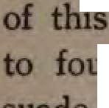
  - chapter: the story of Lull's effort found missionary schools and to per­
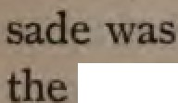
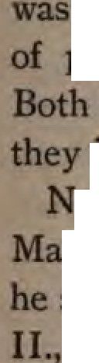
-- popes and princes that the true Cru­ to be with the pen and not with sword It was a grand idea, and it startlingly novel in the age of Lull. It an idea that, next to hi favorite scheme
philosophy possessed his hole ul. ideas were thoroughly missionary and interacted the one on the othe
o sooner had Lull completed his "Ars jor," nd lectured on it in public, than set to ork to persuade the king, James who had heard of his zeal, to found and
endow a monastery in Majorca where
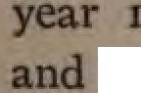
ranciscan mon should be instructed in Arabic language and trained to be­ able disputants among the Moslems. king welcomed the idea, and 1n the 276 such a monastery was o ned
thirteen monks began to study Lull'
65

:Etograpbp of 'Rapmunt, 1uu
method and imbibe Lull's spirit. He aimed not at a mere school of theology or philosophy: his ideal training for the for­ eign field was ahead of many theological colleges of our century. It included in its curriculum the geography of missions and the language of the Saracens I " Knowl­ edge of the regions of the world," he wrote, "is strongly necessary for the republic of believers and the conversion of unbelievers, and for withstanding infidels and Anti­ christ. The man unacquainted with geog­ raphy is not only ignorant where he walks, but whither he leads. Whether he at­ tempts the conversion of infidels or works for other interests of the Church, it is indis­ pensable that he know the religions and the environments of all nations." This is high-water mark for the dark ages I The pioneer for Africa, six centuries before Livingstone, felt what the latter expressed more concisely but not more forcibly:
66

Bt ll)ontpellter, arts, an 'Rome
- The end of the geographical feat is the beginning of the missionary enterprise."
Authorities disagree whether this mis­ sionary training-school of Lull was opened under the patronage of the .ing, at Palma, or at Montpellier. From the fact that in 1297 Lull received letters at Montpellier from the general of the Franciscans recom­ mending him to the superiors of all Fran­ ciscan houses, it seems that he must have formed connections with the brotherhood there at an early period.
Montpellier, now a town of considerable importance in the south of France near the Gulf of Lyons, dates its prosperity from the beginning of the twelfth century. In 1204 it became a dependency of the house of Aragon through marriage, and remained so until _{1350.} Several Church councils were held there during the thirteenth cen­ tury, and in ₁₂₉₂ Pope Nicholas IV., prob­ ably at the suggestion of Lull, founded a
67

:Etograpb,i of 'Ra,imun 2iull
university at Montpellier. Its medical school was famous in the Middle Ages, and had in its faculty learned Jews who were educated in the Moorish schools of Spain.
At Montpellier Lull spent three or four years in study and in teaching. Here, most probably, he wrote his medical works, and some of his books appealing for help to open other missionary schools. In one place he thus pleads with words of fire for consecration to this cause: " I find scarcely any one,0 Lord, who out of love to Thee is ready to suffer martyrdom as Thou hast suffered for us. It appears to me agree­ able to reason, if an ordinance to that effect could be obtained, that the monks should learn various languages that they might be able to go out and surrender their lives in love to Thee.•..0 Lord of glory, if that blessed day should ever be in which I might see Thy holy monks so influenced by zeal to glorify Thee as to go to foreign
68

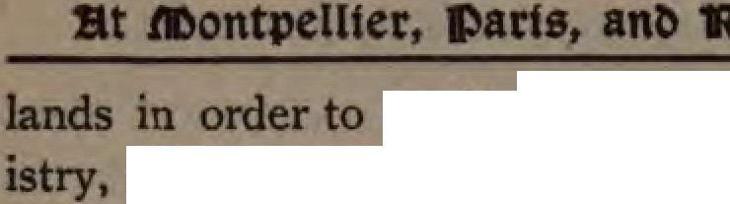

.....fvof n, holy
of Thy bleSled incarnatioD. and of Thy bitter sufferings, _{1111n11,M} a glorious day a day in which that glow devotion would return "th • the y apos met death for their Loni J
Chriat.,..
Lull longed "th all his soul for
Pentecost and for world-wide milliellia.
ontpe]lier was too small to be his lllll'llft.
altho be but a layman. H. ambi
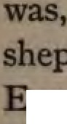
m own words. "to pin over
herds of the Church and the pnncea of
un:,pe,. to become mi&stonary enth1111ialltl 1i hnmelf Where ould he place · fulcrum to exert leverage to this end :ve
the very center of Christendom? P.
had inaugurated and promoted thecru:llldl
blood, they held the keys of sp1rimal
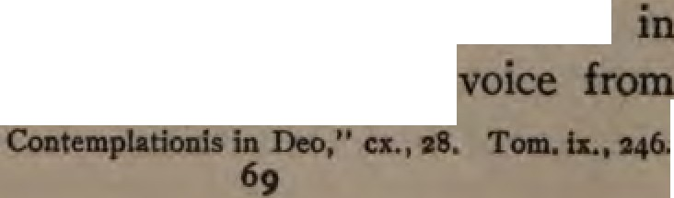
ancl temporal power their command Middle Ages as a
.It

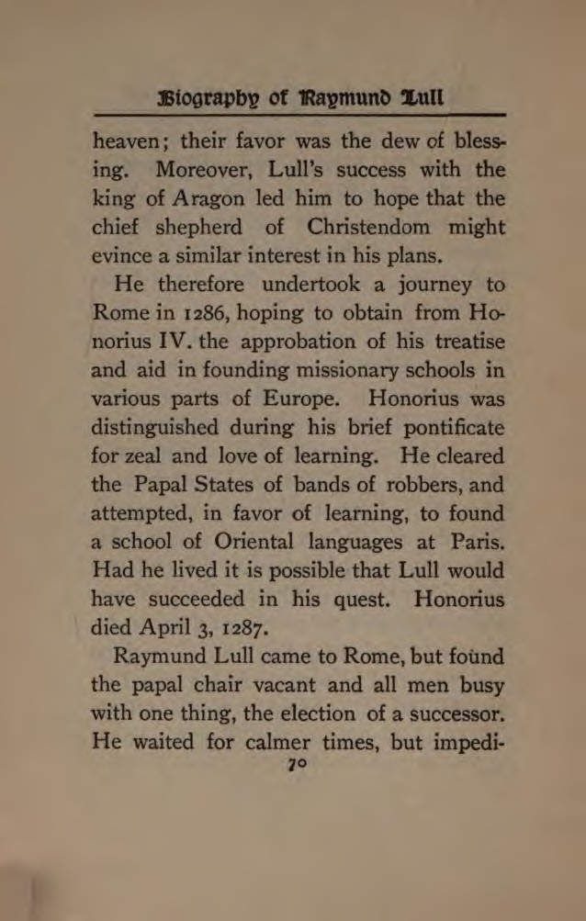

Bt .tmontpellter, arts, ant, 'Rome

ments were always thrown in his way. His plans met with some ridicule and with little encouragement. The cardinals cared for their own ambitions more than for the con­ version of the world.
Nicholas IV. succeeded to the papal throne, and his character was such that we do not wonder that Lull gave up the idea of persuading him to become a mis­ sionary. He was a man without faith; and his monstrous disregard of treaties and oaths in the controversy with the king of Aragon, Alphonso, struck at the root of all honor.• He believed in fighting the Sara­ cens with the sword only, and sought ac­ tively but vainly to organize another Cru­ sade. Not until ten years after did Lull again.venture to appeal to a pope.
Disappointed at Rome, Lull repaired to Paris, and there lectured in the university on his " Ars Generalis," composing other
  - Milmau: 11 History of Latin Christianity," Ti., 175.
71

Digitized by Google

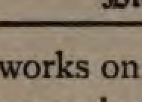
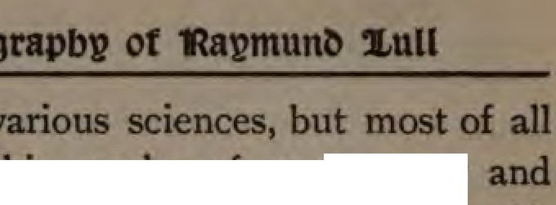p1ep11m1g

con1tnwelft'
aeeklng to propapte hJS ideas of W01rld-.
In one of .........:,_ he
fervently that """""'8 of IM,l,y &I# -. ognn,,lIwflJlUoM,I_I s,".",","r1Hform,,, litJ,slIilUllliM-$-;. 111'6 lo jlntd ID _.'""'1n"
were Dot npe.
At length tired of seeking aid for
m which no one took m· teJ:elt. determined to tat the power of m:mDJe. Altho m his fifty-sixth year, he c1etennined to set out alone and single-handed peach Christ in orth Africa. Of
milll0 ionary voyage our next cbaiDlet

contains an account.
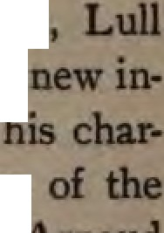
On h' return from Tunis • found bia way to aples. Here a 8uence wu bro\18ht to bear cm • actei He made the acquaintance
alchemist and ·ous nobleman, no1a1i111
7•

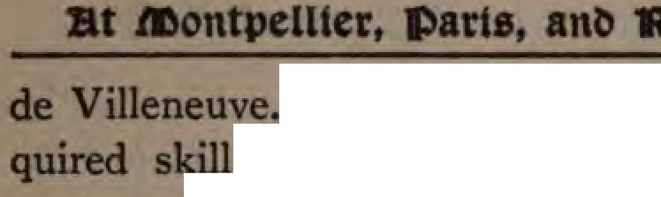

Whether Lull actually ac-
. m transmuting metals and IM'!Nt.aome of the many works on alchemy attn"buted to JilmJ will perhaps
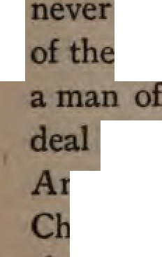
be decided. I rather think this part
storyis medieval legend. But mely Lull's affections imbibed a great
of that spirit which broUght down on An lOld. of Villeneuve the censure of the mch for holding that "medicine and dlaritY were more pleasing to God than twip,ue services." A mold taught that the a iu 'wi had corrupted the doctrine of Christ, that saying masses is useless; and
the papacy is a work of man. His
np were condemned by the lnquisi­ as were also the works of Lull. Per­ these brothers in heresy were really Pn:,teatants at heart, and their friendship
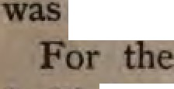
like that of the friends of God.
next few years the scene of
- D Iil,. labors changed continually. He first
73

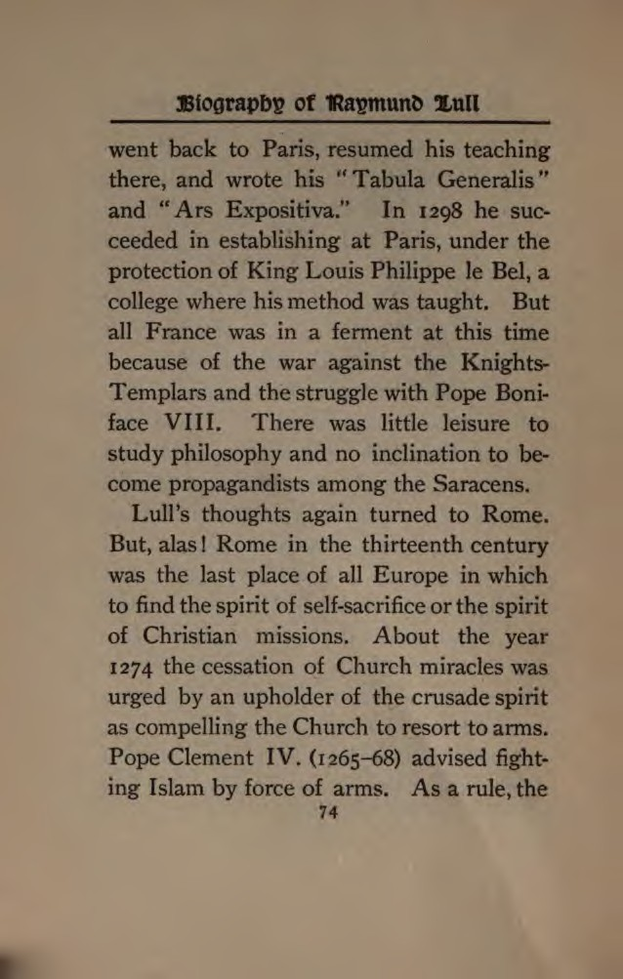

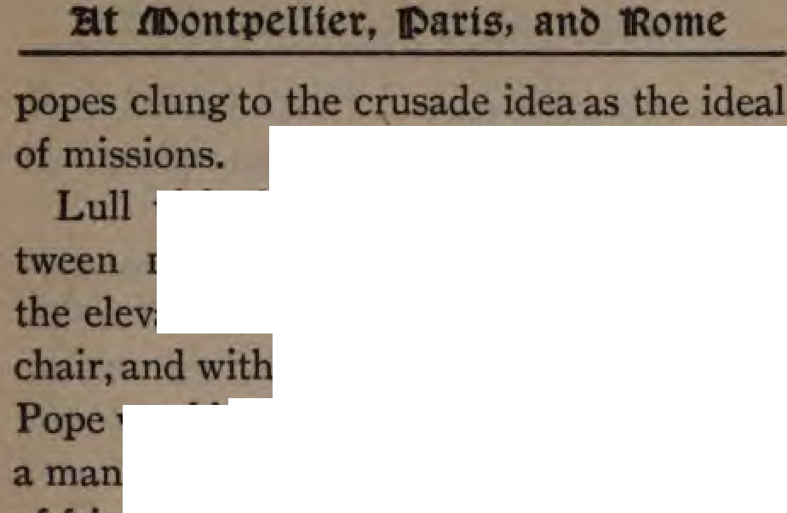;QIJ111111:S. and zealous for the faith On the

Vtsited Rome the second time be­
'94 and Hg6 He bad hean1 of
- .e, ratiem of Celestine V. to the papal
some reason hoped
'WOUkl favo his cause. Celestine
of austerity, the founder of an ord
111eentb of July, 1294, he was elected, but,
•llPelled by the machinations of his suo­
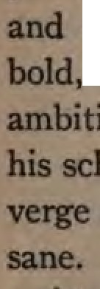
••• resigned his office on December of the same yeat He was cruelly im­ MIOIM by the new Pope, Boniface VIII., died two years later Boniface was avancious, and domineering. His
tiOna centered 1n himself. He carried
ICben::a for self-eggn.ndizement to th of frenzy, and afterward became in­ Lull found neither sympathy nor
•111aace n this quarter•
. .. ....., 1299 to 13()6, when he made his
75

Digitized by

or
eecond great JOumeJ to North Africa, Lull preached and taught m various places, we aba11 see Jatet
In ₁₃₁₀ the teran hero now sevent,'­ fiw years old, attempted once more to m­ fluence the heart of Christendom and to persuade the pope to make the Church tnle to its great mission.
Full of his old ardor, since he himseJf was unable to attempt the great plans of apintual conquest that consumed his ftl'J' heart, he conceived the idea of founding an order of spiritual knights who should be ready to preach to the Saracens and so recover the tomb of Christ by a crusade of love.• Pious noblemen and ladies of rank at Genoa offered to contnoute for this ob­ ject the um of thirty thousand guilders. Much encouraged by this proof of interest,
Wot. •....,ltllaed In - articles &boat Lall, a,-.
'°""
,...a to ae of --. Cf, Noble, p. uei. ad lhdlar,
,,
wltb,...
.. 566. la lllttlr from .. Libs CcMatempledoDh
laDao,"CIIIL 11.

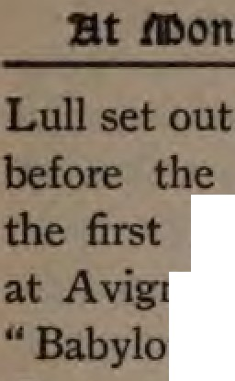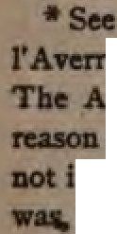

for VlgDOD to Jay acheme
Clement V He
pope _{O} fixed his teSidence
:Jl -.illrlKln. thus besinning the so,called
Capti'Vlty • of the iltellll>Onmeo1us tem accuae him of
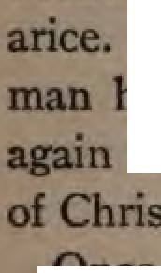
-$UOWIIDelillt nepotism, lllllODy, and &V­
lt i no wonder that, with such a holding the keys of authority, Lull lmCM:Kf!::U at the door of "the vicar
t" all _{ID} 'Vain.
•m«
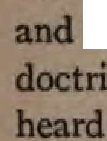
- va more Lull returned to Paris, and, in nund altho feeble in frame, at­ the Arabian philosophy of Averroes wrote ID defense of the faith and the of ievelation.• At Paris he
- • ked
that a general conference was to be

dll .......,.,aDCI GDlllll1t lllllUl's '' AftffllDIS
, ... I« partlcalars of bis IDIIIM,d wl .....
,Awafflllllll fllllll dw ddrlseDtb CIIDtmy GDwrd oppMII
IDfallla. Lall'• tulc was 110sbow tut t-, ...
.... • ...- mataUJ _{related} ud la ur m■DJ• Jt
la fad, 1la&da al falda aplDat apoedcftm
77

V1C1111ic, ree bmldnd •
away the IOUth of France. on Ud gc)IJl!!r ·
16, 1311 A general council migb
popes had scarcely deigned to no
SQ retraced the long journey he
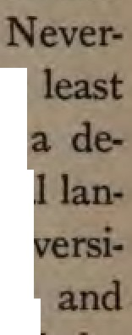
J t taken. Nearly three hundred Dmlatllei were present at the council. The coa:ll8t of heresies, the abrogation of the Older Templars, proposals for new crusades. discussions to legitimacy-Of Bmaa
  - occupied the most attention. tbeless the council gave heed to at one of Lulls proposals, and passed cree that professorships of the Oriental guages should be endowed in the um ties of Paris, Salamanca, and Oxford,
m all cities where the papal court ns lde!L·
Thus, at last, he had lived to see one portion of bis lifelong pleadings broupt to fruition Who is able to follow out result for Dl18810ns of these first 0 1rieldal

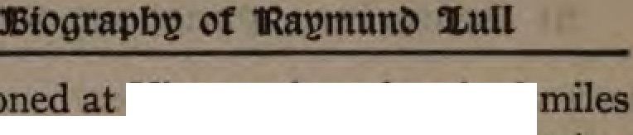language chairs in European
78
Uini0iwi 11CU•

at .montpellter, arts, ant, 'Rome

even asfar as saintly Martyn and Ion Keith Falconer, Arabic professor at Cambridge? For this great idea of missionary prepara­ tion in the schools Lull fought single­ handed from early manhood to old age, until he stood on the threshold of success. He anticipated Loyola, Zinzendorf, and Duff in linking schools to missions ; and his fire of passion for this object equaled, if not surpassed their zeal.

79

CHAPTER VI
HIS FIRST MISSIONARY JOURNEY TO TUNIS
(A.D. 1291-1293)
" In that brlrht sunny land
ACl'OIS the tideless sea, where lonr ago
Proud Carthage reared its walls, beauteous and fair, And large Phenician galleys laden deep
With richest stores, sailed bravely to and fro­ Where Gospel light in measure not unmixed With superstitions vain, burned for a time,
And spread her peaceful conquests far and wide, And gave her martyrs to the scorching fire­ There dwells to-day a darkness to be felt ;
Each ray of that once rising, growinr lirht
Faded and gone." -A-.
WHEN Raymund Lull met with disap­ pointment on his first visit to Rome, he re­ turned for a short time to Paris, as we have seen, and then determined to set out as a m1ss1onary indeed to propagate the faith
80

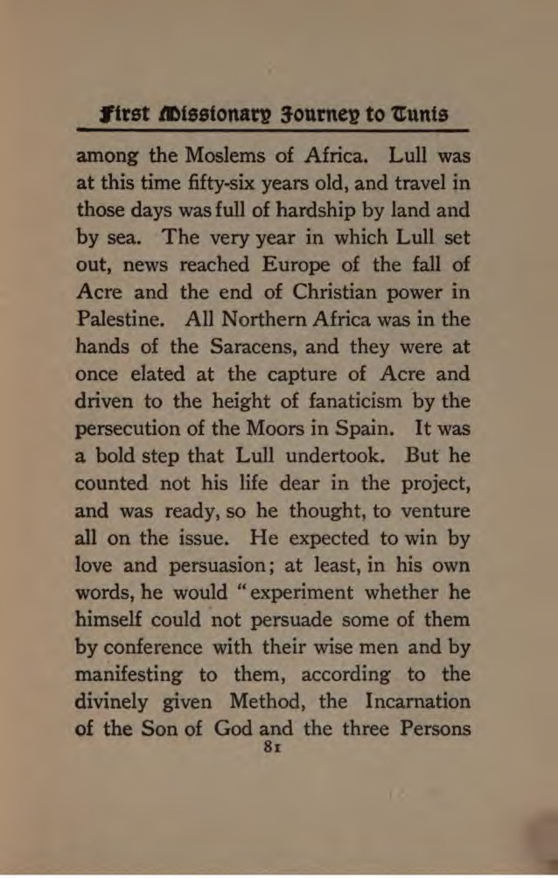

JHograpb,i of 'Ra,imun.t, 2'ull
of the Blessed Trinity in the Divine _Unity of Essence."• Lull proposed a parliament of religions, and desired to meet the bald
  - monotheism of Islam face to face with the revelation of the Father, the Son, and the Holy Spirit.
Lull left Paris for Genoa, which was then the rival of Venice and contended with her for the supremacy of the Mediter­ ranean. In the thirteenth century Genoa was at the height of its prosperity, and the superb palaces of that date still witness to the genius of her artists and the wealth of her merchant princes.
At Genoa the story of Lull's life was not unknown. Men had heard with wonder of the miraculous conversion of the gay and dissolute seneschal; and now it was whis­ pered that he had devised a new and cer­ tain method for converting the " infidel " and was setting out all alone for the shores
•"Vita Prima," in "Acta Sanctorum," p. 633.
82

•ar.t atutoaac» 50ltmcl to11:alde
Africa. The expectations of the people raised to a high pitch. A vesae1 was found ready to sail for Africa and Lull's passage was engaged. The ship was lying m the harbor; the missionary's books, even. bad been conveyed on board. All
was ready for the wyage and the venture.
But at this juncture a change came over him Lull says that he was"overwhelmed with terror at the thought of what might befall him in the country whither he was 10ing. The idea of enduring torture or lifelong imprisonment presented itseH with such force that he could not control his emotions." • Such a strong reaction after his act of faith in leaving Paris must not urprise us. Similar experiences are not rare in the lives of missionaries. Henry Martyn wrote in his journal as the shores of Cornwall were disappearing: "Would I IO back? Oh, no. But how can I be sup-
    - •• VIia Prima,.. In •• Acta Sactonam, .. p. 664,
83

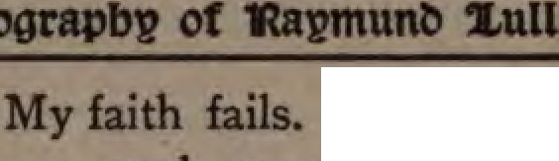
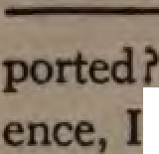I find by e&INlll'i-

am
u ter. 0 my friends m Eng)and, hen we spc,ke with ezaltation of the missions to the heathen. what an unperfect idea did we form of the sufferings by which it must be accom­ plished I"' Lull had to face a darker ancl more uncertain future than did Martyn. His faith failed. His boob were taken back on shore and the ship sailed without him.
However, no sooner did he receive • dings of the vessel's departure than he was seized with bitter remorse. His passionate love for Christ could not bear the though that he had proved a traitor to the cause for which God had specially fitted and called him. He felt that he had given opportu­ nity for those who scoff at Christ's religion to mock Him and His great mission. So keen was his sorrow that he was thrown into a violent fever. While yet suffering
84

wealtneu of body and prostration of
... uu.he that another ship was ready harbor and loaded to 8llil for the of _{U1U1.} Weak tho wu, he
becPd his friends to put his books OD
boud and asked them to permit him to at,.
tempt the voyage He was taken to the p,but hisfriends,convinced that hecould · outlive the voyage, insisted on his being
apin landed. Lull returned to bis bed, but did not find rest or recuperation. His passion consmned him; he felt the contrition of Jonah and cried with Paul, o is me if I preach not." Another
amp offering fit opportunity, he determined
at all nsks to be put on board.
It _{JS} heroic reading to follow Lull in his autobiography as he tells how "from this moment he was a new man." The
had hardly lost sight of land before all fever him; his conscience no more rebuked him for cowardice, of mind tumed,
85

JHograpbl? of 'Ral?fflunt, 2,ull
and he _seemed to have regained perfect health. Lull reached Tunis at the end of the year ₁₂₉₁ or early in _{1292.•}
Why did the philosophic missionary choose Tunis as his first point of attack on the citadel of Islam ? The answer is not far to seek.
Tunis, the present capital of the country of the same name, was founded by the Carthaginians, but first rose to importance under the Arab conquerors of North Africa, who gave it its present name; this comes
from an Arabic root which signifies " to enjoy oneself." t Tunis was the usual port for those going from Kairwan (that
Mecca of all North Africa) to Spain. In 1236, when the Hafsites displaced the Al­ mohade dynasty, Abu Zakariyah made it his capital. When the fall of Bagdad left
* " Vita Prima," in " Acta Sanctorum,'' p. 664- Neander's
"Memorials," p. 527, and Maclear, p. 361.
t Al M#jtalaf, February number, 1901, p. 79-
86

Ytrst .mtsstonarp journep to 1tunts
Islam without a titular head (1258) the Hafsites assumed the title of Prince of the Faithful and extended their rule from Tlem en to Tripoli. The dignity of the Tunisian rulers was acknowledged even in Cairo and Mecca, and so strong were they in their government that, unaided, they held their own against repeated Frankish mvas1ons. The Seventh Crusade ended disastrously before Tunis. Tunis was in fact the western center of the Moslem world in the thirteenth century. Where St. Louis failed as a king with his great army, Raymund Lull ventured on his spiritual crusade single-handed.
Tunis is on an isthmus between two salt lakes and is connected with the port of Goletta by an ancient canal. Two build­ ings still remain from the days of Lull: the mosque of Abu Zakariyah in the citadel, and the great Mosque of the Olive Tree in the center of the town. The ruins of
87

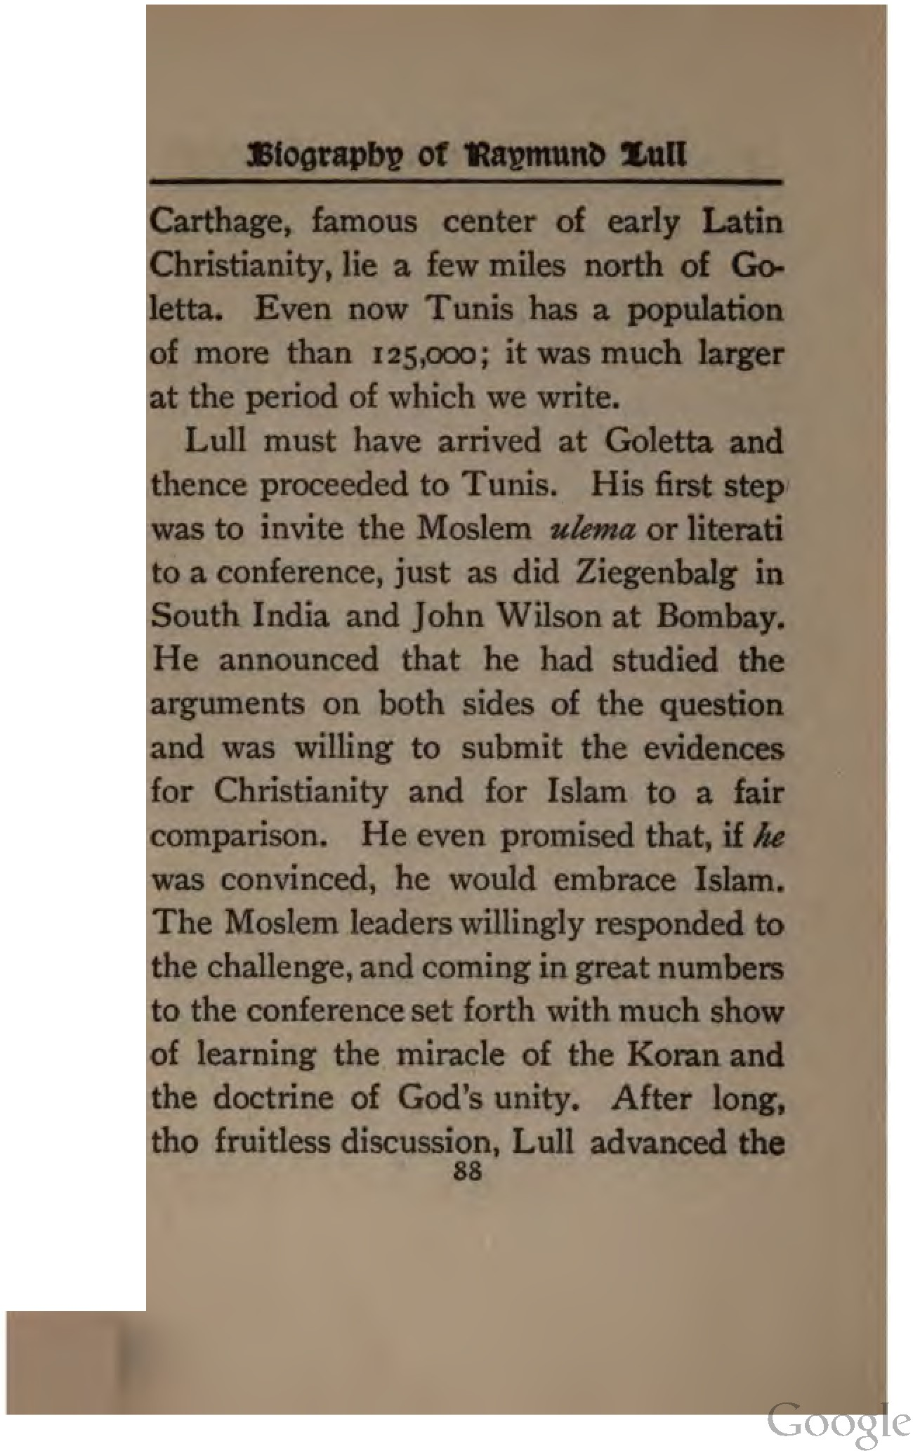

Digitized by

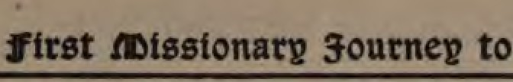
fol1owmc propositions,• which are well cal­ culated to trike the two weak points of MobanlJuedan monotheism· /Mj II.I low• 1M -,g o.f A/Id, 11111.1 ltd o.f ,,.,,,,,_, • Hu fllbvfllu. .,Every wise man m
acknowledge that to be the true religion, bich ascribed the greatest perfection to the Supreme Being, and not only conveyed the worthiest conception of all H" at­ tn"butes, His goodness, power, wisdom, and glory, but demonstrated the harmony and equality existing between them Now /Mi, religion was defective in acknowledging only two active pnnciples in the Deity H will and His wisdom, while it left H goodness and greatness inoperative as tho they were indolent qualities and not called forth mto active exercise. But the Chris­ tian faith could not be charged with this

... tllea ID fllll la "Vita Prima," p. 665, _. .. Uber Qwtapledall ta Dao." JIT.,
•5-91... ...........
...., pp. 561, '6J.
Ip

defect. In _{I} doctrine of the Tnmty it conveys the highest conception of the Deity, as the Father, the Son, and the Holy Spirit in one imple essence and na­ t\lre. In the Incarnation of the Son it evinces the harmony that exists between God's goodness and His greatness; and in
the person of Christ displays the true union of the Creator and the creature; while in His Passion which He underwent out of His great love for man, it sets forth the divine harmony of infinite goodness and condescension, even the condescension of Him who for us men, and our salvation, and restitution to our primeval state of perfection, underwent those sufferings and lived and died for man."
This style of argument, whatever else may be thought of it, i orthodox and evangelical to the core. It surprises one continually to see how little medieval theol­ ogy and how very few Romish ideas there
90

Ytrst .mtsstonar» journep to 1:tunts
are in Lull's writings. The offense of the cross is met everywhere in Lull's argu­ ment with Moslems. He never built a rickety bridge out of planks of compro­ mise. His early Parliament of Religions was not built on the Chicago platform. The result proved it when persecution fol­ lowed. There were some who accepted the truth• and others who turned fanatics. One Imam pointed out to the Sultan the danger likely to beset the law of Moham­ med if such a zealous teacher were allowed freely to expose the errors of Islam, and suggested that Lull be imprisoned and put to death. He was cast into a dungeon, and was only saved from a worse fate by the intercession of a less prejudiced leader. This man praised his intellectual ability and reminded the ruler that a Moslem who
- " Disponerat viros fam051e reputationis et alios quam­ plurimos ad baptismum quos toto animo affectabat deduc:ere ad perfectum lumen 6dei orthodoxre."-"Vita S. L#lli."
91

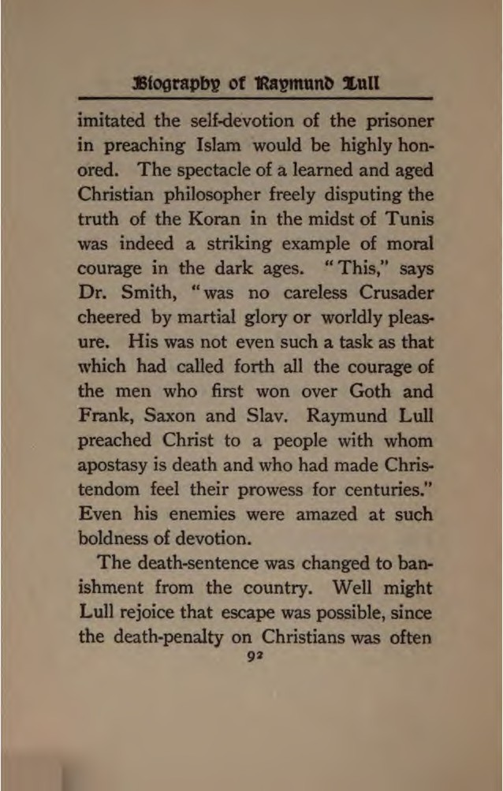

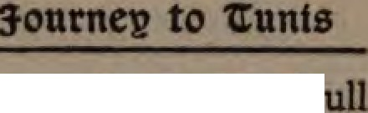

barbarous cnielty • Y. L
not rmdy to submit even to the
of. banisbmer.t, and 10 leave his little poup of converts to themsel wathout illltrUctioD or leadership.
The ship which had conveyed him to Tunis waa on the point of returning to
\.e!IIOIL; he was placed on baud and warnecl that if he ever made bis way into the couo- apin he would assuredly be stoned to death. Raymund Lull, however, felt that, th the apostles, it not for him to obey their "threatening that he should speak henceforth to no man in this Name." P ps also he felt that his cowardice at
-when setting out demanded atone­ ment At any rate he managed to escape flan the ship by strategy and to return unawares to the harbor town of Goletta in deia of the edict of banishment. For
...._. a"- la Kalr'a "'Jlamelaa DJwt,,
41,,s,-.

three long months the zealous missionary concealed himself like a wharf-rat and wit­ nessed quietly for his Master. Such was the character of his versatile genius that we read how at this time, even, he com­ posed a new scientific work I
But since his favorite missionary method of public discussion was entirely impos­ sible, he finally embarked for Naples, where for several years he taught and lectured on his New Method. And later, as we have already seen, he revisited Rome.
It is evident from all of Lull's writings, as well as from the writings of his biogra­ phers, that his preaching to the Moslems was not so much polemical as apologetic. He always speaks of their philosophy and learning with respect. The very titles of his controversial writings prove the tact and love of his method. It was weak only in that it placed philosophy ahead of re-
94

,trst mtsstona journep to 1tunts
velation, and therefore at times attempted to explain what must ever remain a mys­ tery of faith.
As a theologian, we should remember, Lull was not a schoolman, nor did he ever receive instruction from the great teachers of his time. He was a self-taught man. The speculative and the practical were blended in his character and also in his system. " His speculative turn entered even into his enthusiasm for the cause of missions and his zeal as an apologist. His contests with the school of Averroes, and with the sect of that school which affirmed the irreconcilable opposition between faith and knowledge, would naturally lead him to make the relation subsisting between these two a matter of special investiga­ tion."•
Lull did not go to Naples because he had given up the battle. He went to bur­
* Neader : " Church History," iY., p. ,426.
95

nish his weapons and to win recruits and to appeal to the popes to arm for a spiritual crusade against the strongest enemy of the kingdom of Christ. When, as we have seen in a previous chapter, these efforts proved nearly fruitless, he made other mis­ sionary journeys, and in 1307 was again on the shores of North Africa, fifteen years after his first banishment.

CHAPTER VII
OTHER MISSIONARY JOURNEYS
(A.D. 1301-1309)
11 In an age of violence and faithlessness he wu the apostle
of heavenly love."-G1twg1 S111itA.
" Yea, so have I strived to preach the Gospel not where Christ was named, lest I should build upon another man's foundation."-Pat1I.
FROM 1301 to 1309 Lull made several missionary journeys which are the more remarkable if we consider that he was now sixty-six years old and if we think of the conditions of travel in the Middle Ages. The Mediterranean was beset with pirates and the Catalan Grand Company were fighting the Byzantines, while Genoa and Venice waged a war of commercial rivalry. The Knights of St. John were fighting for Rhodes and the rival popes were quarreling.
97

J3tograpbp of 'l?apmun S.ull
Travel by sea was dangerous and by land was full of hardship. In the Middle Ages the use of carriages was prohibited as tend­ ing to render vassals less fit for military serv­ ice. As late as the sixteenth century it was accounted a reproach for men to ride in them, and only ladies of rank used such conveyances. Men of all grades and pro­ fessions rode on horses or mules, and some­ times the monks and women on she-asses. Highway robbers infested the forests, and the danger from wild animals had not yet ceased even in the south of Europe.
In spite of all obstacles, however, we read that Lull " resolved to travel from place to place and preach wherever he might have opportunity." His purpose seems to have been to reach Jews and Christian heretics as well as Saracens.• After laboring for
*" Accessit ad regem Cypri affectu multo supplicans ei, quatenus quosdam infideles atque schismaticos videlicet Jacobinos, Nestorinos, Maronites, ad suam prredicationem necnon disputationem coarctaret venire."-Made11r,J, j6,f. n,
98

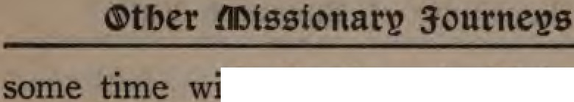

"th the Jews in Majon:a he eailed for Cyprus, landing at Famagosta, e chief port and fortress during the Gen- occupancy of the island. Cyprus at
that time had a large population of Jen as well as of Christians and Moslema. LuD's preaching probably did not meet with success, for he soon left the island and, attended only by a single companion, crossed over to Syria and penetrated into Armema, striving to reclaim the various­ Oriental sects to the orthodox faith.
Armenia, in the thirteenth century, wa& the name of a small principality to the north of Cilicia, under a native dynasty With Cyprus it formed the last bulwark of Christianity against Islam in the East. For fear of being crushed by th Moslem powers the Armenians formed alliances
th the Mongolian hordes that overran Asia and shared in the hostility and ven­ pance of the Mamelukes. Among this
''

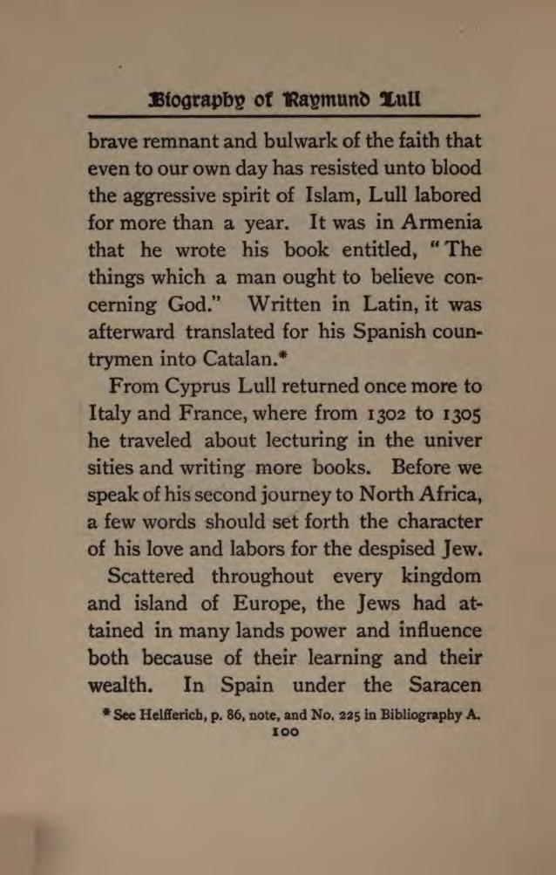

....₋..
11111111DeCY they enjoyed toleration, m proportion as the were clri'Ven out and the Christim:i. :Lacamc p,weriul, the Jews suffeied. As 0ekl'IJ-a8
uo8 a riot broke out m Toledo agaiMt
J and the streets treamecl with •• :·-·. blood All throup the twelfth and ·.. ·: teeath centuries dark ries were told of : ::•
hostility of the Jews. It was said that · .:.•·
they poisoned we11sw tole the consecrated wafers to pierce them with a needle, and crucified infants at their Passover festivals used their entrails for magic and
Clet rites I In 1253 the Jews were expelled
from France and in 1290 from England. Many were put to death by the Inquisi­
tion, and there were very few Christians who dared to defend a Jew in court. A cbiJd could not be missed without some foul play being suspected on the part of a
Jew. In vam a few pious monb pro­
tetted against such accusations and tried
IOI

Digitized by e

.·.... . .
to befrie..nd·· ·outcast race. The whole spirit of: t times was to class Jews and
Moslerhij0 ·as infidels and as worthy of
•

hatr d·
0
and contempt. · If possible, the

: d against the Jews was stronger in
:··.-' pain than elsewhere. During the closing
. ··:·.·."years of Lull's life there were already
._:.::.:· kindled in Spain the fires of bitter, cruel
··.·..· persecution which at last, under Torque­ mada, consumed the entire race of the Jews in that country.*
In the thirteenth century, in almost all lands, the Jews were compelled to wear an insulting badge, the so-called "Jew's hat," a yellow, funnel-shaped covering on the head, and a ring of red cloth on the breast. They were also compelled to herd together in the cities in the ghetto or Jewish quar­ ter, which was often surrounded by a spe­ cial wall.t
* Maclear, p. 381 ti seq.
t Kurtz: "Church History," vol. ii., p. 23.
102

This despised. nee however, was not outside the arcle of Lull's love and inter­ est. He wrote many books to prove to them the truth of the Christian religion.* H showed them that their expected Mes­ siah was none other than Jesus of Naza.­ reth. His great mission to the Saracens in Africa did not blind him to the needs of missions at home, and we read how, in 1305 and even earlier, he labored to convince the Jews in Majorca of their errors. In an age when violence and faithlessness were the only treatment 'ch Jews expected from Christians,
Raymund Lull was the apostle of love
to them also.
There is a story or legend to the effect that, about this time, Lull paid a short visit to England and wrote a work on alchemy
- Of tbao worn tbe foDowhtc are atarat: ' Uber a,atra
.,...,.." ..Uber de lleformatloae Hebralca.• ... HJ.a.,
.. .Ad"NDtalllllUI.
103

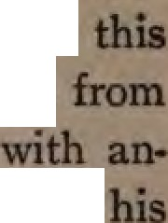
at S Catharine's ospital In LODI-.• But have no good testimon for event, a.pd the legend probably arose confounding Lull the onary
other Lull who was celebrated for knowledge of alchemy. In the "Acta Sanctorum" a special article JS devoted to prove that Lull never taught or practiaecl the arts of medieval alchemy.
We now come to his journey to North
.Africa, on which he set out in 130'/ prob­ ably from some port in France or from Genoa. This time he did not go to TUDJS, but to Bugia. Some say he visited H" pone and Algiers as well. A special 1ntel'­ est attaches to the town of Bugia in the story of Lull'slifeas it was here he preached to Moslems in his old age and here was the ecene of his death.
Bugia, or Bougiah, is a fortified seaport
... Kadllr, .. s67, --. wbo qlallaadaaldll ..
llpad.
104

Digitized by 008 e

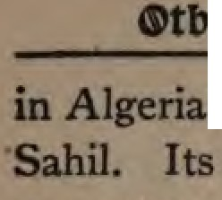

.n111..-nabetweenCape Carbon and Watly
moat important buildings at insent ue the French Roman Catholic ehwch, the hospital, the barracks, and the oldAbdul Kadir fort,now used as a pnson. At present 1t bas but a small population.
conducts a considerable trade in
pain, oranges, oil, and wine.
Bugia is a town of great antiquity it the Salda of the Romans and was first built by the Carthaginians. Genseric the
andal surrounded it with walls. In the
century it became the chief commu­ cial city of all North Africa under the Beni Hammad sultans. The Italian merchants the twelfth and thirteenth centuries had numerous buildings of their own in the city, as warehouses, baths, and churches.
In the fifteenth century Bugia became a haunt for p tes; after that time 1t lost its prosperity and importance.
Our photog,aph shows the ruins of the
105

Digitized by

or
old gateway from the harbor, which dates from the eleventh century, and through which Lull must have entered the town.•
Altho there were Christian merchants 1n Bugia, they were a small minority, and were able to secure commercial freedom and favor only by avoiding all religious con­ troversy and keeping the· light carefully under a bushel. One can read in the his,. tory of the Mameluke dynasty, which ruled Egypt at this period, how Christians were regarded and treated by the Saracens. So far as poss1"ble the odious edict of Omar
    - was reimposed and its intolerant rules enforced.
The Mameluke sultan Nasir," a jealous,
cruel, suspicious, and avaricious tyrant," extended his power over Tunis and Bugia from 1308-1320. He was fanatical as well as cruel, and one has only to read how
Christian churches were destroyed, Chris­ tians burned or mutilated, and their prop,
      - See page 140.
106

Digitized by 008 e

erl:y confiscated ill the capital, to know
DUJlt have been the tate of the
prow
:ymund Lull no sooner came to Bugia than he found his way to a public place, stood up boldly, and proclaimed in the Arabic language that Christianity was the only true faith, and expressed his willing- to prove this to the satisfaction of all know not what the exact nature of his argument was on this occasion, but it
touched the character of Mohammed A cemmotion ensued and many hands were lifted to do him violence.
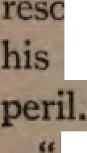
The mufti, or chief of the Moslem cleigy, ued him and expostulated with him on madness in thus exposing himself to

Death:' Lull replied, "has no terrors whaiever for a sincere servant of Christ who is laboring to bring souls to a knowl- wu.. llalr; " TIie Mamebdre J>ywtJ,"pp. 67-87.
IOf

edge of the truth." After this the mufti, who must have been well versed in Arabian philosophy, challenged Lull for proofs of the superiority of Christ's religion over that of Mohammed.
One of Lull's arguments, given in his controversial books, consists in presenting to the Saracens the Ten Commandments as the perfect law of God, and then show­ ing from their own books that Moham­ med violated every one of these divine precepts. Another favorite argument of Lull with Moslems was to portray the seven cardinal virtues and the seven deadly sins, only to show subsequently how hare Islam was of the former and how full of the latter I Such arguments are to be used with care even in the twentieth century; we can imagine their effect on the Moslems in the north of Africa in Lull's day.
Persecution followed. He was flung
108

4'tber ll)tsstonarp 3-ourneps

into a dungeon and for half a year remained a close prisoner, befriended only by some merchants of Genoa and Spain, who took pity on the aged champion of their com­ mon faith.
Meanwhile riches, wives, high place, and power were offered the Christian philos­ opher if only he would abjure his faith and turn Moslem. This was Lull's reply, from the depth of his dungeon, to all their enticements: "Ye have for me wives and all sorts of worldly pleasure if I accept the law of Mohammed? Alas! ye offer a poor prize, as all your earthly goods can not purchase eternal glory. I, however, prom­ ise you, if ye will forsake your false and devilish law, which was spread by sword and force alone, and if ye accept my belief, Eternal Life, for the Christian faith was propagated by preaching and by the blood of holy martyrs. Therefore I advise you to become Christians even now, and so
109

obtain everlasting glory and escape the pains of bell.ti• Such words, from the lips of a man seventy-three years old, in perfect command of the Arabic tongue, learned in the wisdom of the Arabian philosophy, and from whose eyes flashed earnest zeal for the truth, must have come with tremen­ dous force.
While he tarried in prison, Lull proposed that both parties should write a defense of their faith. He was busy fulfilling his part of the agreement when a sudden command of the governor of Bugia directed that he be deported. Whether the reason of this command was the results that followed Lull's preaching, we know not. His biog­ raphers indicate that Lull was visited in prison by Moslems who again and again urged him to apostatize. " During his im­ prisonment they plied him for six months
- KIIJer: "C"-elstebmpf _{1l.} z. Y,,n pp. SO. 6o. lladear,
p. SflS.
110

4'tber tsstonarv 3-ourneps

with all the sensual temptations of Is­
lam."*
This must have been a bitter experience for the missionary in recalling the sins of his youth and the vision of his early man­ hood.
" But I amid the torture and the taunting­
I have had Thee !
Thy hand was holding my hand fast and faster, Thy voice was close to me ;
And glorious eyes said, 'Follow Me, thy Master,
Smile, as I smile thy faithfulness to see.' "
Raymund Lull left Bugia practically a prisoner, since the Moslems did not wish to have repeated the incident that followed his embarking at Tunis. During the voy­ age, however, a storm arose and the vessel was almost wrecked off the Italian coast near Pisa. Here he was rescued and re­ ceived with all respect by those who had heard of his fame as a philosopher and
•" Promittehant el uxores, honores, domum, et pecuniam ClOpiosam."-" Vita Primo," chap. iv.
111

missionary. From Pisa, Lull went by way of Genoa to Paris ; of his work there and at the Council of Vienne we have already given an account.

The prologue of John's Gospel in Cata­ lan, the language of Lull:
LO EVANGELI DE JESU-CHRIST
PQOII
SANT JOAN.
lrloidMN.,_11'llioiloilllt id Y,r&:.., tenebru, y las tenebru no la com­
CAP, 1, 5 Y la 11nm reeplandeis • 1M
E Verb era ab Deo, J lo Verb 7 Eshiogn6 4 .. n,ir de teati­
ealulm., ha BaJ,tit- prengneren.
,a:-11c1u.,.,.......dcbo61u. 6 Hibagu6 an home enYiatde
N lo prlneipl era lo Verb, y lo Den qae s'1111omena,1 J-.
tra Deo. moni, pera te&tiflcar dela Uum, ,
I Ell era en lo principi ab Den. fl de quo tots cregoe-n per me­
,u, '1 -• ell ninguna eoso. fon 8 No era ell la 11am, aln6 -
feta de Jo qui ha edit ret. vial pen donar teatimoni de la
-& En ell era la -rid&, -, la ,icl& llum.
I Per ell roren fetu totaa las co- di d'ell.
I d bom-.
9.A lleral&,

112

CHAPTER VIII
RAYMUND LULL AS PHILOSOPHER AND AUTHOR
'' He was at once a philosophical systematizer and an analytic chemist, a skilful mariner and a successful propaga­ tor of Christianity,"-Hum6o/dt'.r "Co.rmo.r," ii., 6:29.
" Of making many books there is no end, and much study
is a weariness of the ftesh."-Ecclesia.rte.r.
IT will be difficult in one short chapter to crowd an account of Lull's philosophy, which for two centuries after his death per­ plexed the genius of Europe, and to enu­ merate even a small number of the vast library of books which have Lull for their author. One does not know which to ad­ mire most-the versatile character of the genius, or the prodigious industry of the· author.
Raymund Lull was from his youth a
IIJ

J3tograpbp of 'Ra11munt, Siull
master of Catalan and wrote in it long be­ fore his conversion. Of his works in that language there exists no complete cata­ log. One of Lull's biographers states that the books written by Lull number
\ four thousand I In the first published edi­
- tion of his works (1721), two hundred and eighty-two titles are given; yet only forty­ five of these, when printed, took up ten large folio volumes. To understand some­ thing of the scope and ambition of this genius-intellect, one must read the partial list of his books given in the bibliography at the close of this volume. Lull was a philosopher, a poet, a novelist, a writer of
.· proverbs, a keen logician, a deep theo­
.\ logian, and a fiery controversialist. There was not a science cultivated in his age to which he did not add. The critical histo­ rian Winsor states that in 1295 Lull wrote a handbook on navigation which was not superseded by a better until after Colwn·
114

l)btlosopber ant, !lntbor
bus. Dr. George Smith credits Lull with the independent invention of the mariner's compass; and not without reason, for we find repeated references to the magnetic needle in hisdevotional books.* He wrote a treatise on " the weight of the elements • and their shape; on the sense of smell ; on astronomy, astrology, arithmetic, and geom-! etry. One of his books is entitled, "On the squaring and triangulation of the cir­ cle." In medieval medicine, jurisprudence, and metaphysics he was equally at home. His seven volumes on medicine include one book on the use of the mind in curing the sick I And another on the effect of climate on diseases.
  - See " Liber de Miraculis Creli et Mundi," part vi., on Iman. Calamita.
•• As the needle naturally turns to the north when it is touched by the magnet so it is fitting," etc.-" Li6er Con­ te,nplationi1 in .Dto."
In his treatise "Fenix des les Maravillas del Orbes," pub­ lished in 1286, he again alludes to the use of the mariner's compass. See Humboldt : " Cosmos," ii., 630 n.
115

J3tograpb-g of 'Rapmunt, 2,uu
He was a dogmatic theologian, and wrote sixty-three volumes of theological discus­ sion, some of which are so abstruse as to produce doubt whether their author earned the title of "Doctor Illuminatus,'' given him by his contemporaries. Other titles among his theological writings there are which awaken curiosity, such as: "On the
\ Most Triune Trinity" ; "On the Form of
,; God" ; " On the Language of the Angels," etc.
Among the sixty-two books of medita­ tion and devotion which are preserved in the lists of Lull's writings, there are none
·on the saints, and only six treat of the Virgin Mary. This is one of the many proofs in Lull's books that he was more of a Catholic than a Romanist, and that he esteemed Christ more than all the saints of the papal calendar. One of his books of devotion is entitled, "On the One Hun­
dred Names of God,'' and was evidently
II6

    - btlosopbet anb Butbot
prepared for the use of Moslems who were seeking the light.•
Raymund Lull wrote or collected three books of proverbs, one of which contains • six thousand popular sayings and maxims. Here are a few out of many beautiful gems to be found in this collection:
- Deum dilige, ut ipsum timeas. " " Pax est participatio sine labore."
"Deus exemplum dedit de sua unitate in natura."
- Fortitudo est vigor cordis contra maliciam." " Divitlse sunt copiositates voluntatis."
- Prsedestinatio est' scire Dei qui scit homines."
"Deus adeo magnum habet recolere quod nihil obliviscitur."

Among Lull's works there are twenty on logic and metaphysics. One of the latter has the title, " On the Greatness and the Littleness of Man." Among his sermons and books on preaching there is only one commentary. That, in accord with Lull's

  - According to Moslem teaching, Allah has one hundred beautiful names. The Moslem's rosary has one hundred beads, and to connt these names is a devotional exercise.
111

J3tograpb)] of 'lbtvmun 2iull
mission and character, is a commentary on the prolog of John's Gospel.
Of making many controversial books there was no end in the days of Lull. His writings in this department, however, are not, as are those of his contemporaries, against heretics to condemn them, with their errors, to ecclesiastical perdition.
Even the titles of his controversial writings \f
show his irenic spirit and his desire to con­ vert rather than to convince.· All through his books there runs the spirit of earnest devotion; even his natural philosophy is . full of the world to come and its glories. At the end of one of his books he bursts out with this prayer: "0 Lord, my help I till this work is completed thy servant can not go to the land of the Saracens to glorify Thy glorious name, for I am so occupied with this book which I undertake for Thine honor that I can think of nothing else. For this reason I beseech Thee for that·
118

    - btlosopbet ant, Bntbor
grace, that Thou wouldst stand by me that I may soon finish it and speedily depart to die the death of a martyr out of love to Thee, if it shall please Thee to count me worthy of it."
In 1296 he concluded a work on the logic of Christianity with this seraph-song to the key of world-wide missions: " Let : Christians consumed with burning love for · the cause of faith only consider that since nothing has power to withstand truth, they can by God's help and His might bring infidels back to the faith; so that the precious name of Jesus, which in most regions is still unknown to most men, may be proclaimed and adored." And again: "As my book is finished on the vigils of John the Baptist, who was the herald of the light, and pointed to Him who is the true light, may it please our Lord to kindle
a new light of the world which may guide unbelievers to conversion, that with us they 119

:13tograpb)] of 'Ra)]munt, Siull
may meet Christ, to whom be honor and praise world without end." This is not the language of pious rhetoric, but the passion­ ate outcry of a soul hungry for the coming of the Kingdom.
Lull was a popular author. He wrote not only in learned Latin, but in the ver­ nacular of his native land. Noble calls him the Moody of the thirteenth century. He tried to reach the masses. His influ­ ence on popular religious ideas in Spain was so great, through his Catalan hymns and proverbs and catechisms, that Helf­ ferich compares him to Luther and calls him a reformer before the Reformation.• He made the study of theology popular by putting its commonplaces into verse, so that the laity could learn by heart the sum­ mary of the Catholic faith and meet Mos-
* " Der Protestantismus in Spanien zur Zeit der Reforma­ tion." Prot. Monatsblatter v. H. Gelzer, 1856, S. 133-168. Also his" Raymund Lull, u. z. w. ," pp. 152-154-
120

----l)btlosopber-ant, Bntbo-
r ·--

lems and Jews with ready-made arguments. Scholasticism was for the clergy; the " Lullian method" was intended for the laity as well. Raymund Lull had become discontented with the methods of scientific inquiry commonly in use, and so set himself to construct his " Ars Major," or Greater Art, which by a series of mechanical con­ trivances and a system of mnemonics was adapted to answer any question on any topic. This new philosophy is the key­ note of most of Lull's treatises. All his philosophical works are but different ex­ planations and phases of the "Ars Major." In his other books he seldom fails to
- call attention to this universal key of
knowledge which the great art sup­ plies.
What is the method of Lull's philoso­ phy? The most complete account and the most luminous explanation of its abstruse perplexities is given by Prantl in his " His-
1 :z 1

:13tograpb)? of 'Rapmunt> S.ull
tory of Logic" (vol. iii., 145-177). This is a summary of it:
The reasonableness and demonstrability of Christianity is the real basis of his great method. Nothing, Lull held, interfered more with the spread of Christian truth than the attempt of its advocates to rep­ resent its doctrines as undemonstrable mysteries. The very difference between Christ and Antichrist lies in the fact that the former can prove His truth by miracles, etc., while the latter can not. The glory of Christianity, Lull argues, is that it does not maintain the undemonstrable, but simply the supersensuous. It is not against rea­
son, but above unsanctified reason. The • demonstration, however, which Lull seeks
is not that of ordinary logic. He says, that we require a method which will reason not only from effect to cause, or from cause to effect, but per aqutparantt"am, that is, by showing that contrary attributes can exist
122

btlosopber ant> !lutbor

togetlter in one sub_ject. This method must be real, and not altogether formal or sub­ jective. It must deal with the things them• selves, and not merely with second inten• tions.
Lull's great art goes beyond logic and metaphysic: it provides a universal art of discovery, and contains the formulre to :. which every demonstration in every sci­ ence can be reduced-being, in fact, a sort of cyclopedia of c.ategories and syllogisms. Lull's "Ars Major" is a tabulation of the different points of view from which propo­ sitions may be framed about objects. It is a mnemonic, or, rather, a mechanical con• trivance for ascertaining all possible cate­ gories that apply to any possible proposi• tion. Just as by knowing the typical terminations or conjugations of Arabic grammar, for example, we can inflect and conjugate any word; so, Lull reasons, by a knowledge of the different types of exist-
123

ence and their possible relations and com­ binations we should possess knowledge of the whole of nature and of all truth as a system.
"The great art, accordingly, begins by laying down an alphabet according to which the nine letters from B to K stand for the different kinds of substances and attributes. Thus in the series of substances B stands for God, C, angel, D, heaven, E, man, and so on; in the series of absolute attributes B represents goodness, D, dura­ tion, C, greatness; or, again, in the nine questions of scholastic philosophy B stands for utrum, C, for quid, D, for de quo, etc." By manipulating these letters in such a way as will show the relationship of differ­ ent objects and predicates you exercise the " new art." This manipulation is effected by the help of certain so-called " :figures " or geometrical arrangements. Their con­ struction differs in various books of Lull's
u4

btlosopber ant, Butbor
philosophy, but their general character is the same. Circles and other figures are divided into sections by lines or colors, and then marked by Lull's symbolical letters so as to show all the possible combinations of which the letters are capable. For ex­ ample, one arrangement represents the possible combinations of the attributes of God; another, the possible conditions of the soul, and so on. These figures are further fenced about by various definitions and rules, and their use is further specified by various '' evacuati"ons " and " multtpli"ca­ tions" which show us how to exhaust all the possible combinations and sets of ques­ tions which the terms of our proposition admit. When so "multipli"ed," the "fourth figure" is, in Lull's language, that by which other sciences can be most readily and aptly acquired; and it may accordingly be taken as no unfair specimen of Lull's
method. This " fourth figure " is simply
125

JStograpbp of 'Rapmunl> 2'ull
an arrangement of three concentric circles each divided into nine sections, B, C, D, etc., and so constructed of pasteboard that
.when the upper and smaller circle remains fixed the two lower and outer revolve around it. Taking the letters in the sense of the series' e are then able, by revolving the outer circles, to find out the possible relationships between different conceptions and elucidate the agreement or disagree­ ment that exists between them. Mean­ while the middle circle, in similar fashion, gives us the intermediate terms by which they are to be connected or disconnected.
This Lullian method, of a wheel within a wheel, seems at first as perplexing as the visions of Ezekiel and as puerile as the automatic book-machine in " Gulliver's Travels." But it would be unfair to say . that Lull supposed" thinking could be re­ duced to a mere rotation of pasteboard cir­ cles," or that his art enabled men " to talk
126

btlosopber ant, Butbor
without judgment of that which we do not ; know." Lull sought to giv not a com-: pendium of knowledge but a method of in- \ vestigation. He sought a more scientific method for philosophy than the dialectic of his contemporaries. In his conception of a universal method and his application of the vernacular languages to philosophy he was the herald of Bacon himself. In his demand for a reasonable religion he was beyond his age. And, in applying this system, weak tho it was, to the conversion_ of infidels, he proved himself the first mis-. sionary philosopher. He perceived the possibilities (tho not the limitations) of com­ parative theology and the science of logic as weapons for the missionary.
Nothing will so clearly illustrate the ver­
satile and brilliant character of Lull's ge­ nius as to turn from his " Ars Major" to his religious novel," Blanquerna," the great
allegory of the Middle Ages, and the pred-
127

:Btograpbp of 'Rapmunt, 2iull
ecessor of Bunyan's" Pilgrim's Progress." * In fact, Raymund Lull was the first Euro­ pean who wrote a religious story in the vernacular. The romances of the days of chivalry were doubtless well known to him before his conversion, and what was more natural than that the missionary knight should write the romance of his new cru­ sade of love against the Saracens? " Blan­ querna" is an allegory in four books. Its
•· sub-title states that it is "a mirror of morals in all classes of society, and treats of matri­ mony, religion, prelates, the papacy, and the hermit's life." It is the story of the pilgrimage of Enast, the hero, who marries Aloma, the daughter of a wealthy widow. Their only child, Blanquerna, desires to be a monk, but falls in love with a beautiful and pious maiden, Dona Cana by name.
* Helfferich, pp. n1-122. He holds that the allegory was first written in Arabic and then put into Catalan. Several manuscripts of it are extant in the archives of Palma, etc. It was first printed In 1521.
128

l)btlosopber ant, Butbot
Both, however, decide to remain ascetics. Blanquerna enters a monastery and his fair sweetheart turns nun. The allegory re­ lates the experiences of these characters in their different surroundings-the pilgrim, the monk, and the abbess. To borrow words in another book from Lull himself, "we see the pilgrim traveling away in dis­ tant lands to seek Thee, tho Thou art so near that every man, if he would, might find Thee in his own house and chamber. The pilgrims are so deceived by false men, whom they meet in taverns and churches, that many of them when they return home show themselves to be far worse than they were when they set out." Dona Cana, the abbess, disputes with her sister nuns the authority of the priest to bind the con­ science, and even draws in question some of the doctrines of the Church! The va­ rious characters bear allegorical names. When Blanquerna reaches Rome the Pope
129

:Etograpbp of 'RapmunD 1ull
has a court-jester called "Raymund the Fool," who is none other than Lull him­ self, and who tells the cardinals some rare truths. The four cardinals bear the names, " We-give-thee-thanks," " Lord­ God-heavenly-King," "We-glorify-Thee," and "Thou-only-art-Holy" I Blanquerna finally becomes Pope and uses his author­ ity in sending out a vast army of monk­ missionaries to convert Jews and Moham­ medans.
In various parts of the book songs of· praise and devotion occur, while the mis­ sionary idea is never absent. This remark­ able allegory, as well as many other works of Lull, deserves to be rescued from oblivion. The arrival of Blanquerna before the door of the Enchanted Castle, over whose gate­ way the Ten Commandments are written, and, within, the solemn conclave of gray­ beards who discourse on the vanity of the world, are two scenes that show a genius
130

btlosopbet an Butbor

equal to that of John Bunyan. There are other resemblances between these two pil­ grims rescued from the City of Destruction and describing their own experiences in allegory; but to present them here would make this chapter too lengthy. Who would know more of Lull the philosopher and the author is referred to the bibliog­ raphy and to the writings themselves.

IJI

CHAPTER IX
HIS LAST MISSIONARY JOURNEY AND HIS MARTYRDOM
" As a hungry man makes despatch and takes large morsels on account of his great hunger, so Thy servant feels a great desire to die that he may glorify Thee. He hurries day and night to complete his work in order that he may give up his blood and his tears to be shed for Thee."-Lull's "Lil,er Contemplationis in Deo."
•• Is not devotion always blind? That a furrow be fecund it must have blood and tears such as Augustine called the blood of the soul."-&batier.

THE scholastics of the Middle Ages taught that there were five methods of ac­ quiring knowledge-observation, reading, listening, conversation, and meditation. But they left out the most important method, namely, that by suffering. Lull's philosophy had taught him much, but it was in the school of suffering that he grew
t32

into a saint Love, not learning, is the key to his character. The philosopher was absorbed in the missionary. The last seen of Lull's checkered life is not at Rome nor Paris nor Naples in the midst of J11s pupils, but in Africa, on the very shores
mm which he was twice banished.
At the council -0£ Vienne (as we saw in Chapter V.) Lull had rejoiced to see some portion of the labors of his life brought to fruition When the deliberations of the council were over and the battle for in­ struction in Oriental languages in the uni­ versities of Europe had been won, it might have been thought that he would have been willing to enjoy the rest he had so well de­ aerved. Raymund Lull was now seventy­ nine years old, and the last few years of his Hfe must have told heavily even on so strong a frame and so brave a spirit as he
possessed. His pupils and friends natu­
rally desired that he hould end his daya
133

in the peaceful pursuit of learning and the
comfort of companionship.
Such, however, was not Lull's wish. His ambition was to die as a missionary and not as a teacher of philosophy. Even his favorite " Ars Major" had to give way to that ars maxlma expressed in Lull's own motto," He that lives by the life can not die."
This language reminds one of Paul's Second Epistle to Timothy, where the Apostle tells us that he too was now"al­ ready being offered, and that the time of
. his departure was at hand." In Lull's" Con­ templations" we read: "As the needle nat­ urally turns to the north when it is touched by the magnet, so is it fitting, 0 Lord, that Thy servant should turn to love and praise and serve Thee ; seeing that out of love to him Thou wast willing to endure such grievous pangs and sufferings." And again: " Men are wont to die, 0 Lord,
134

from old age, the failure of natural warmth and exce.ss of cold; but thus, if it be Thy will, Thy servant would not wish to die; be would prefer to die in the glow of love,
even as Thou wast willing to die for
him,,
Other passages in Lull's writings of this period, uch as the words at the head of this chapter, show that he longed for the crown of martyrdom. If we consider the age in which Lull lived and the race from which he sprang, this is not surprising. Even before the thirteenth century, thou­ sands of Christians died as martyrs to the faith in Spain; many of them cruelly tor­ tured by the Moors for blaspheming Mo­ hammed.
Among the Franciscan order a mania
for martyrdom prevailed. Every friar who

*" Uber CoatemplatloaJI," cuiL, 19; "Vtta Secallda," cap. iv., ud "Uber ColatemplatloDls," _{CUE.,} s7. a. Kaclear, p. 367.
135

:Etograpbp of apmunt> Siull
was sent to a foreign shore craved to win the heavenly palm and wear the purple passion-flower. The spirit of the Crusades was in possession of the Church and its leaders, even after the sevenfold failure of its attempts to win by the sword. Bernard of Clairvaux wrote to the Templars: "The soldier of Christ is safe when he slays, safer when he dies. When he slays it profits Christ; when he dies it profits him­ self."
Much earlier than the end of the Middle Ages the doctrines of martyrdom had taken hold of the Church. Stories of the early martyrs were the popular literature to fan the flame of enthusiasm. A martyr's death was supposed, on the authority of many Scripture passages,* to cancel all sins of the past life, to supply the place of baptism,

*Luke xii. so; Mark x. 39; Matt. x. 39; Matt. v. 10-11. Compare the teachin of Roman Catholic commentaries OD these passages.

1ast Sournep ant, martprt)om
and to secure admittance at once to Para­ dise without a sojourn in Purgatory. One has only to read Dante, the graphic painter of society in the Middle Ages, to see this illustrated. Above all, it was taught that martyrs had the beatific vision of the Savior (even as did St. Stephen), and that their dying prayers were sure of hastening the coming of Christ's kingdom.
But the violent passions so prevalent and the universal hatred of Jews and infidels made men forget that " not the blood but the cause makes the martyr."
Raymund Lull was ahead of his age in his aims and in his methods, but he was not and could not be altogether uninflu­ enced by his environment. The spirit of chivalry was not yet dead in the knight who forty-eight years before had seen a vision of the Crucified and had been knighted by the pierced hands for a spiri­ tual crusade. Like Heber he felt:
137

J3tograpbp ot 'Rapmun 2,un
"The Son of God goes forth to war,
A kingly crown to gain ;
His blood-red banner streams afar
Who follows in His train?

•' Who best can drink His cup of wo
Triumphant over pain ;
Who patient bears His cross below He follows in His train.

" A glorious band, the chosen few
On whom the Spirit came ;
Twelve valiant saints, their hope they knew
And mocked the cross and flame.

" They climbed the steep ascent of heaven
Through peril, toll, and pain ;
0 God, to us may grace be given
To follow in their train."
The dangers and difficulties that made Lull shrink back from his journey at Genoa in ₁₂₉₁ only urged him forward to North Africa once more in _{1314.} His love had not grown cold, but burned the brighter "with the failure of natural warmth and the weakness of old age." He longed not only for the martyr's crown, but also once more to see his little band of believ-
138

2ast lourne» an ll)art)?r om

ers. Animated by these sentiments, he crossed over to Bugia on August 14, and for nearly a whole year labored secretly among a little circle of converts, whom on· his previous visits he had won over to the Christian faith.
Both to these converts, and to any others who had boldness to come and join them in religious conversation, Lull continued to expatiate on the one theme of which he never seemed to tire, the inherent superior­ ity of Christianity to Islam. He saw that the real strength of Islam is not in the second clause of its all too brief creed, but in its first clause. The Mohammedan conception of the unity and the attributes of God is a great half-truth. Their whole philosophy of religion finds its pivot in their wrong idea of absolute monism in the Deity. We do not find Lull wasting arguments to disprove Mohammed's mis­ sion, but presenting facts to show that Mo-
139

JJtograpbl] of 'Ra»munl) 1ull
hammed's conception of God was deficient and untrue. If for nothing else he de­ serves the honor, yet this great principle of apologetics in the controversy with Islam, as first stated by Lull, marks him the great missionary to Moslems.
" If Moslems," he argued, " according to their law affirm that God loved man be­ cause He created him, endowed him with noble faculties, and pours His benefits upon him, then the Christians according to their law affirm the same. But inas­ much as the Christians believe more than this, and affirm that God so loved man that He was willing to become man, to en­ dure poverty, ignominy, torture, and death for his sake, which the Jews and Saracens do not teach concerning Him; therefore is the religion of the Christians, which thus reveals a Love beyond all other love, superior to that of those which reveals it only in an inferior degree." Islam is a
140

sast ournq anb ll)artvroom

loveless religion. Raymund Lull believed and proved that Love could conquer it. The Koran denies the Incarnation, and so remains ignorant of the true character not only of the Godhead, but of God (Matt.
- 27).
At the time when Lull visited Bugia and was imprisoned, the Moslems were already replying to his treatises and were winning converts from _{ai} iong Christians. He says: " The Saracens write books for the destruc­ tion of Christianity; I have myself seen· such when I was in prison.... For one Saracen who becomes a Christian, ten Christians and more become Mohamme­ dans. It becomes those who are in power to consider what the end will be of such a
state of things. God will not be mocked." *
Lull did not think, apparently, that lack of speedy resu]ts was an argument for
  - Smith: "Short History of Christian Missioaa," pp. 107,
lo8.

abandoning the work of preaching to J4CJ9t
lems the unsearchable riches of Christ.
"Hip falhue. towerlnc far o'er low-,
Firm faith. aawarped bJ others' (aftbl. ,
WJucb, like a day brlptat at neodde,
Seemed _{Dflel'} ba1f IO deathlas, dJl be died."
For over ten months the aged missionary dwelt in hiding, talking and praying with his converts and trying to influence those who were not yet persuaded. His one weapon was the argument of God's love in Christ, and his " shield of faith " was that of medieval art which so aptly sym­ bolizes the doctrine of the Holy Trinity So lovingly and so unceasingly did Lull urge the importance of this doctrine that we have put the scuhl.m./ide,,' on the cover of this biography.•
Of the length, breadth, depth, and height of the love of Christ, all Lull's devotional writings are full.
    - Copied from u old woodcut of the '""""' >In ID tbl
IIDllth trauept of Tbame Cbun:h, Oxfordlhlre.
142

Digitized by 008 e

Ust ournep ant, martprt,om
At length, weary of seclusion, and long­ ing for martyrdom, he came forth into the open market and presented himself to the people as the same man whom they had once expelled from their town. It was Elijah showing himself to a mob of Ahabs I Lull stood before them and threatened them with divine wrath if they still per­ sisted in their errors. He pleaded with love, but spoke plainly the whole truth. The consequences can be easily anticipated. Filled with fanatic fury at his boldness, and unable to reply to his arguments, the popu­ lace seized him, and dragged him out of the town; there by the command, or at least the connivance, of the king, he was stoned on the 3oth·of June, 1315.
Whether Raymund Lull died on that
day or whether, still alive, he was rescued by a few of his friends, is disputed by his biographers. According to the latter idea his friends carried the wounded saint to
143

Digitized by Google

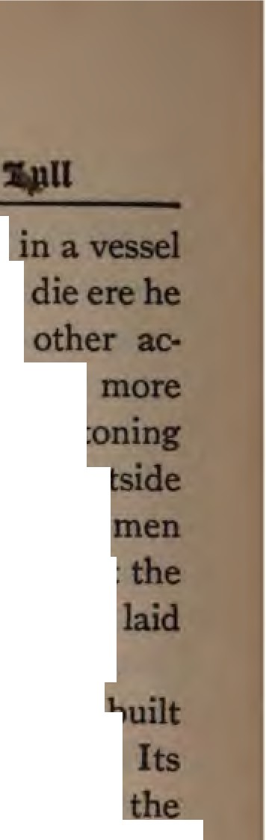

the beach and h conft}'ed to Majorca, hisbirthplace, only to reached Palma. According to
counts, which seem to me to carry
authority, Lull did not survive the
by the mob, but died, like Stephen, ou the city. Also in this case, devout earned Lull to his burial and brought body to Palma, Majorca, here it was to rest in the church of San Francisco.
An elaborate tomb was afterward - - ...
in th· church as a memorial to Lull. date is uncertain, but it is probably of fourteenth century. Above the elabomtely carved panels of marble are the shield& or coat-of-arms of Raymund Lull; on either side are brackets of metal work to hold candles. The upper horizontal panel shows Lull in repose, in the garb of a Franciscan, with a rosary on his girdle, and his hands in the attitude of prayer.
May we not believe that this was his
144

1ast journe» ant, .mar tt,om

attitude when the angry mob caught up stones, and crash followed crash against the body of the aged missionary? Per• haps not only the manner of his death but his last prayer was like that of Stephen the first martyr.
It was the teaching of the medieval Church that there are three kinds of mar­ tyrdom : The first both in will and in deed, which is the highest; the second, in will but not in deed; the third. in deed but not in will. St. Stephen and the whole army of those who were martyred by fire or sword for their testimony are examples of the first kind of martyrdom. St. John the Evangelist and others like him who died in exile or old age as witnesses to the truth but without violence, are examples of the second kind. The Holy Innocents, slain by Herod, are an example of the third kind. Lull verily was a martyr in will and in deed. Not only at Bugia, when he
145

J3tograpbp of 'Rapmun S.ull
fell asleep, but for all the years of his long life after his conversion, he was a witness to the Truth, ever ready "to fill up that which is behind of the afflictions of Christ " in his flesh "for His body's sake which is the Church."
To be stoned to death while preaching the love of Christ to Moslems-that was the fitting end for such a life. " Lull," says Noble, " was the greatest of medieval mis­ sionaries, perhaps the grandest of all mis­ sionaries from Paul to Carey and Living­ stone. His career suggests those of Jonah the prophet, Paul the missionary, and Stephen the martyr. Tho his death was virtually self-murder, its heinousness is lessened by his homesickness for heaven, his longing to be with Christ, and the sub­ limity of his character and career."

CHAPTER X
"WHO BEING DEAD YET SPEAKETH"
" He wAo loves not lives not; !,e wl,o /if/es y t!,e Li/1 ,an
not die."-Raym#nd L#II.
"One step farther, but some slight response from his church or bis age, and Raymund Lull would have anticipated William Carey by exactly seven centuries,"-Gtor.r, Smit!,.

N_{EANDER} does not hesitate to compare Raymund Lull with Anselm, whom he re­ sembled in possessing the threefold talents uncommon among men and so seldom found in one character: namely, a powerful intellect, a loving heart, and efficiency in practical things. If we acknowledge that Lull possessed these three divine gifts, we at once place him at the front as the true type of what a m1ss1onary to Moslems should be to-day..
147

He, whom Helfferich calls "the remarkable figure of the Midclle A being dead yet speaketh The task which he first undertook is still before the Ch unaccomplished. The modem missionary to Islam can see a reflection of his own trials of faith, difficulties, temptations, hopes, and aspirations in the story of L Only with his spirit of self-sacrifice and en,. thusiasm can one gird for the conflict with this Goliath of the Philistines, who for thirteen centuries has defied the armies of the Living God.
Lull's writings contain glorious watch­
words· for the spiritual crusade against Islam in the twentieth century. How up­ to-date is this prayer which we find at the close of one of his books: " Lord of heaven, Father of all times, when Thou didst send Thy Son to take upon Him human nature,
He and His apostles lived in outward peace
with Jews, Pharisees, and other men; for
148

Digitized by 008 e

"•bo lletnO l)aD »et 9fal&etb" never by outwani violence did they capture or slay any of the unbelievers, or of those
who penecuted them. Of this outward peace they availed themselves to bring the erring to the knowledge of the truth and to a communion of spirit with themselves. A.1lll so Tt,:, a:11111p/6 sAmdd CAru­
•f•
tia,u &t111411tl lorllanl Most.u; Ind si,,u tut a,-dor of dnotiola fllAul, glow«J m apostles a,uJ l,oly #le# of old ,u, longw i,upins ,u, low and tievotion 1/mn,gll tU#IOSI 1111 1M '11/0rld /,aw g,rnn eoltl, Md 1"6nfon do Clwistuuu aJ>n,d IMir ,/ftwb f• mll#nhlJanJllu,,,;.1/#s,;,;.
tu/ em,..f/ul."
England's war in the Sudan cost more in men and money a hundred times
all missions to Mat}ems in the past cen­
tury I Yet the former was only to put down a Moslem usurper by fire and wcml• the latter represents the effort of Ch• t­ endom to convert over two hundied mil-
1-49

lions of those who are in the dar1mes&
Islam.
There was a thousandfold more en siasm in the dark ages to wrest an em sepulcher from the Saracens than there in our day to bring them the knowledge of a living Savior. Six hundred years after Raymund Lull we are still "playing at missions" as far as Mohammedanism is concerned. For there are more mosqu in Jerusalem than there are missionaries in all Arabia; and more millions of Moslems unreached in China than the number of missionary societies that work for Moslem in the whole world I
In North Africa, where Lull witnessed to the truth, missions to Moslems were not begun again until 1884. Now there is again daybreak in Morocco, Tripoli, Tunis, Algiers, and Egypt. Yet how feeble are
the efforts in all Moslem lands compared with the glorious opportunities I How
150

"'llUlbo J3etng lDea met Speahetb "
vast is the work still before us, six hundred years after Lull I
According to recent and exhaustive statistics, the population of the Moham­ medan world is placed at 259,680,672.• Of these u,515,402 are in Europe, 171,278,ooS are in Asia, 19,446 are in Australasia, 76,- 818,253 are in Africa, and 49,563 are in North and South America. Three per cent. of Europe's population is Moslem; Asia has 18 per cent., and Africa 37 per cent. Out of every ₁₀₀ souls in the world
16 are followers of Mohammed. Islam's power extends in many lands, from Canton to Sierra Leone, and from Zanzibar to the Caspian Sea.
Islam is growing to-day even faster in some lands than it did in the days of Lull. And yet in other lands, such as European Turkey, Caucasia, Syria, Palestine, and
- Dr. Hubert Jansen's "Verbreitung des Islams," Berlin,
18g7 ; a marvel of research and accuracy.
151

Turkestan, the number of Moslems is de­ creasing. In Lull's day the empire of Moslem faith and Moslem politics nearly coincided. Nowhere was there real liberty, and all the doors of access seemed barred. Now five-sixths of the Moslem world are accessible to foreigners and missionaries; but not one-sixtieth has ever been occupied by missions. There are no missions to the Moslems of all Afghanistan, Western Turkestan, Western, Central, and South­ ern Arabia, Southern Versia, and vast re­ gions in North Central Africa. ·
Mission statistics of direct work for Mos­ lems are an apology for apathy rather than an index of enterprise. The Church for­ got its heritage of Lull's great example and was ages behind time. To Persia, one thousand years after Islam, the first mis­ sionary came; Arabia waited twelve cen­ turies; in China Islam has eleven hundred
years the start. This neglect appears the
15a

"11Ulbo :Betng !)eat> met Spealtetb "
more inexcusable if we consider the great opportunities of to-day. More than 125,- 000,000 Moslems are now under Christian rulers. The keys to every gateway in the Moslem world are to-day in the political grasp of Christian Powers, with the excep­ tion of Mecca and Constantinople. Think only, for example, of Gibraltar, Algiers, Cairo, Tunis, Khartum, Batoum, Aden, and Muskat, not to speak of India and the farther East. It is impossible to enforce the laws relating to renegades from Islam under the flag of the " infidel." One could almost visit Mecca as easily as Lull did Tunis were the same spirit of martyrdom alive among us that inspired the pioneer of Palma. The journey from London to Bagdad can now be accomplished with less hardship and in less time than it must have taken Lull to, go from Paris to Bugia.
How much more promising too is the
153

J3tograpbp or 'Rapmunt> 1ull
condition of Islam to-day I The philo­ sophical disintegration of the system began very early, but has grown more rapidly in the past century than in all the twelve that preceded. The strength of Islam is to sit still, to forbid thought, to gag reformers, to abominate progress. But the Wahabis "drew a bow at a venture " and smote their king " between the joints of the har­ ness." Their exposure of the unorthodoxy of Turkish Mohammedanism set all the world thinking. Abd-ul-Wahab meant to reform Islam by digging for the original foundations. The result was that they now must prop up the house I In India they are apologizing for Mohammed's morals and subjecting the Koran to higher criticism. In Egypt prominent Moslems advocate abolishing the veil. In Persia the Babi movement has undermined Islam everywhere. In Constantinople they are
trying to put new wine into the old skins
154

0 11Ulbo :Eetng E>eaD met Speaketb"
by carefully diluting the wine; the New Turkish party is making the rent of the old garment worse by its patchwork pol­ itics.
In addition to all this, the Bible now speaks the languages of Islam, and is everywhere preparing the way for the con­ quest of the cross. Even in the Moslem world, and in spite of all hindrances, "it is daybreak everywhere." The great lesson of Lull's life is that our weapons against Islam should never be carnal. Love, and love alone, will conquer. But it must be an all-sacrificing, an all-consuming love-a love that is faithful unto death.
"Taking him all in all," says Noble, "Lull's myriad gifts and graces make him the evening and the morning star of mis­ sions." He presaged the setting of medi­ eval missions and heralded the dawn of the Reformation. The story of his life and labors for Moslems in the dark ages is a
155

J3tograpbv or 'Rapmun 1ull
challenge of faith to us who live in the light of the twentieth century to follow in the footsteps of Raymund Lull and win the whole Mohammedan world for Christ.

BIBLIOGRAPHY
- Books Written by Raymund Lull
(One of Lull's biographers states that the works of Lull numbered four thousand. Many of these have been lost. Of his writings in Latin, Catalonian, and Arabic it is said that one thousand were extant in the fifteenth century. Only two hundred and eighty-two were known in ₁₇₂₁ to Salzinger of Mainz, and yet he included only forty-five of these in his collected edition of Lull's works in ten volumes, It is disputed whether volumes seven and eight actually appeared. Some of Lull's unpublished works are to be found in the Impe• rial Library, the libraries of the Arsenal and Ste. Gen­ evieve at Paris, also in the libraries of Angers, Amlens, the Escurial, etc. Most of his books were written in Latin; some first in Catalonian and then translated by his pupils, others only in the Catalonian or in Arabic.
In the "Acta Sauctorumn, vol. xxvii., page 640 II SIIJ,,
we find the following classified catalog of tAr11 Aun­ dr,d andtwenty-on, /Jooks by Raymund Lull]

§ I. Books 011 G1111ral Arts.
1. Arsgeneralis.
- Ars brevis
- Ars generalis ultimL
:157

4- Ars demonstrativa veritatis.
- Ars altera demonstrativa veritatis.
- Compendinm artis demonstrative.
- Lectura super artem demonstrativ&.
- Liber correlativorum innatorum.
g. Ars inventiva veritatis.
10. Tabula generalis ad omnes scientias applicabilis.
II. Ars expositiva.
12. Ars compendiosa invmiiendi veritatem.
13- Ars alia compendiosa.
14- Ars inquirendi particularia in universalibus.
- Liber propositionum secundum, etc.
- Liber de descensu intellectus.
- Ars penultima.
- Ars scientia, generalis.
- Lectura alia super artem inventivam veritatis.
  - De conditionibus artis inventive.
21. Liber de declaratione scientire inventive.
22. Practica brevis super artem brevem.
23. Liber de experientia realitatis artis.
24- Liber de mixtione principiorum.
- Liber de formatione tabularum.
- Lectura super tabulam generalem.
- Practica brevis super ecamdem.
- Lectura super tertiani figuram tabula, generalis.
- Liber facilis scientia,.
- De qua,stionibus super eo motis.
- Liber de significatione.
- Liber magnus demonstrationus.
- Liber de lumine.
- Liber de inquisitione veri et boni in omnia mate­
ria.
- Liber de punctis transcendentibus.
158

:13tbltograpbp
- Ars intellectus.
- De modo naturali intelligendi in omni scientia.
- De inventione intellectus.
- De refugio intellectus.
- Ars voluntatis.
- Ars amativa boni.
  - Ars alia amativa (it begins Ad recognoscendum).
43. Ars alia amativa (1t begins Deus benedictus). 44, Ars memorativa.
- De quaistionibus super ea motis.
- Ars alia memorativa.
- De principio, medio et fine.
- De differentia, concordantia, et contrarietate.
- De equalitate, majoritate, et minoritate.
- De fine et majoritate.
- Ars consilii.
- Liber alius de consilio.
- Liber de excusatione Raymundi.
- Liber ad intelligendum doctores antiquos.
5S, Ars infusa.
- Art de fer y soltar questions (Catalan).
- Fundamentum artis generalis.
- Supplicatio Raymundi ad Parienses.
- Liber ad memoriam confirmandam.
6o. Liber de potentia objecta et actu.
- Ars generalis rhythmica.

§ II. Books on Grammar and Rlletoric.
- Ars grammaticre speculativse completissima.
- Ars grammaticre brevis. 64, Ars rhetoricre.
- Rhetorica Lttlli.
159

§ III. Booles 011 LIJgic and Dia/ecti'cs.
- Liber qui vocatur logica de Grozell (versa vulgari).
- Logica parva.
- Logica nova.
6g. Dialecticam seu logicam novam.
- Liber de novo modo demonstrandi.
- Liber de fallaciis.
- Logica alia de quinque arboribus.
- Liber de subjecto et prsedicato.
- Liber de conversione subjecti et pr11edicati, etc.
- Liber de syllogismis.
- Liber de novis fallaciis.
- Liber de modo naturali et syllogistico.
- Liber de affirmatione et negatione et causa earwn.
- Liber de quinque prsedicabilibus.
So. Liber qui dicitura fallacia Raymundi.

§ IV. Books 011 Pltilosoplty.
- Liber lamentationes duodecim princip. philosoph.
- Liber de principiis philosophise.
- Liber di, ponderositate et levitate elementorum.
84- Liber de anima rationali.
85. Liber de reprobatione errorum Averrois.
116. Liber contra ponentes ieternitatem mundi.
- Liber de quiestionibus.
- Liber de actibus potentiarum, etc.
- Liber de anima vegetativa et sensitiva. go. Physica nova.
- De Natura.
- Ars philosophia,.
160

Stbltograpbp
- De consequentiis philosophise.
- Liber de generatione et corruptione.
95. Liber degraduatione elementorum.
g6. Liber super figura elementari.
- Liber cle qualitatibus, etc., elementorum.
- Liber de olfactu.
- Liber de possibili et impossibili.
100. Arscompendiosa principorium philosophle.
101. Liber de intensitate et extensitate.

§ V. Books on Metaphysics.
102. Metaphysica nova.
103. Liber de ente reali et rationis.
104. De proprietatibus rerum.
105. Liber de homine.
1o6. De magnitudine et parvitate hominis.

§ VI. Books on Various Arts and Seien&&
107. Arspolitica.
1o8. Liber militiee secularis.
109. Liber de militia clericali. no. Ars de Cavalleria.
111. Tractatus de astronomia.
112. Ars astrologiee.
113. Llber de planetis.
u4- Geometria nova.
115. Geometria magna.
116. De quadrangulatura et triangulatura ctrocdl.
u7. Ars cognoscendi Deum per gratiam.
118. Ars arithmetica.
119. Ars divina.

JJtogral)bp of 'Ra,zmunl> 1\111
§ VII. Books on Medi&in,.
Ho. Ara de principiis et gradibus medicine.
HI. Liber de regionibus infirmitatis et sanitatia.
1H. Liber de arte medicina, compendiosa.
123- Liber de pulsibus et urinis.
124- Liber de aquis et oleis.
125. Liber de medicina theorica et practica.
116. Liber de instrumento intellectus in medicina.

§ VIII. Books on Jur,iprudene,.
- Ara utriusque juris.
- Ars juris particularis.
- Ars principiorum juris.
- Ars de jure.

 | § IX. Books of Devotion and Cont,mplati'on,
131. | Liber natalis pueri Jesu.
132. | Liber de decem mod.is contemplandi Deum.
133. | Liber de raptu.
134, | Liber contemplationis in Deo.
135. | Lioer B/a,scl,erna (also written, Blanquerna).
136. | Liber de orationibus et contemplationibus.
137. | Liber de meditationibus, etc.
138. | Liber de laudibus B. Virginia Maria,.
139. | Liber appelatus clericus sive pro clericia.
140. | Phantasticum (an autobiography).
141. Liber de confessione.
142. Liber de orationibus. 143- Philosophia amoris. 144, Liber Proverbiorum.
16:z

J3tbltograpbp
- Liber de centum nominibus Dei.
- Orationes per regulas artis, etc.
- Horre Deiparre Virginis, etc.
- Elegiacus Virginis planctus.
- Lamentatio, seu querimonia Raymundi.
- Carmina Raymundi consolatoria.
- Mille proverbia vulgaria.
- Versus vulgares ad regem Balearium.
- Tractatus vulgaris metricus septem articulos fidei
demonstrans.
- Liber continens confessionem.
- Primum volumen contemplationum.
- Secundum volumen contemplationum.
- Tertium volumen contemplationum.
- Quartem volumen contemplationum.
- De centum signis Dei.
16o. De centum dignitatibus Dei.
- Liber de expositione rationis Dominicre.
- Liber alius de eodem.
- Liber de Ave Maria.
- Liber dictus, Parvum contemplatorium.
- Liber de prreceptis legis• .• et sacramentis, etc.
- Liber de virtutibus et peccatis.
- Liber de compendiosa contemplatione.
- Liber Orationum.
- Liber de Orationibus per decem regulas.
- Liber de viis Paradisi et viis lnferni.
- Liber de orationibus et contemplationibus.
- Liber dictus, Opus bonum.
- Liber de conscientia.
- Liber de gaudiis Virginis.
- Liber de septem horis officii Virginis.
- Liber alius ejusdem argumenti.
163

!Stograpbp of 'Rapmoul) 1ull
- Planctus dolorosus Domine nostne, etc.
- Ara philosophise deaideratae (ad suUDl fllium).
179- Ara contitendi.
18o. Liber de doctrina pnerili.
- Doctrina alia puerilis parva.
- Liber de prima et secunda intentionibu.
- Blancherna magnus.
184- Liber de placida visione.
185- Liber de consolatione eremitiCL
- Ara ut ad Deum cognoscendum, etc.
- Liber ducentorum carminum.
- Liber de vita divina.
- Liber de definitionibus Dei.
190- Primo libre el desconsuelo de Ramon (Catalan).
191. Liber hymnorum.
191. Liber sex mille proverbiorum in omnia materia.

§ X. Bools of Sermons, or"" Pr,aeAi•z.
193. Ara pnedicabilis.
194- Liber super quattlor sensus S. Scripture.
195- Ars pnedicandi major.
1g6. Ars pnedicandi minor.
197. Liber quinquaginta duorum sermonum, etc.
1g8. Commentaria in primordiale Evang. Joanni&.

§ XI. Boois "" Varitnls S"/Jje&ts (Lilwl
tales).
199- Liber prime et secundae intentioniL llOO. Liber de miraculis coeli et mundi. ao1. Arbor scienwe.
ma. Liber qnaestionum super artem, etc.
164

-,. Ltberclelae.
•
1Q4. Coutliam RaJlll1UIC1L
105- Llber de aeqailltioutarra .......
906. Llber de ADti..cJuuto.
-,. Llber de mirabillbaa orbls.
IOI. Llber de dvitate n:nmdL
109, LIiier varianun qmNl:icm11111.
HO. Liber de lftda aapedativo.
s11. Liber de TirtDta ftQla1I et martaU.
I XII. a_.'II D/llfllllliM .- o.tn,,wo.
s1a. Liller de pDtiliettribu upleadhal.
•1•.
Tractata■ de articaUa 84el.
114- De Deo lgDoto et de maDdo la-to-
- Liller de eflldente et effecta.
- Diapatatlo R.aymllllCli et A verrol■tl l de qtdaqae
qaeatioDibu.
- Liber contracUctione ■ Inter ltaym11D4 et Averrola-
tam, 4e myaterio trhaltati■• arl. Liller allu■ 4e eodem.
ai9- Liber de forma Del.
ua. Llber atnuD 8delia poutt IIDlffn objectioael. etc.
HI. Liber di■pata tioDi ■ ia te11ecta ■ et tlclel.
ua. Liber appellatae apo ■u op he.
ns. Liber de demoutratioae per aquiparutiam.
1a4- Liller de CODvellintla qaam laabeat &le■ et
1ectu.
115- Liber de U. qaa homo de Deo clebet cndaw.
n6. Liber de n b■t &ll tla et ucidellte.
•7• Liber de Tialtat. la Ullitate.
HI. Dispatatlo Raymlllldi LaJlJ et lloaMril 8an c■m.
199- Diapatatio qubaqae bomhaam ■aplea tam.
165

JHograpbp or 'Rapmunl:> 2.ull
230. | Liber de existentia et agentia Dei contra Averroem.
231. | Declaratio Raym11ndi Lalli, etc.
232. | De significatione fidei et intellectus.
233. | Ars theologi et philosophire contra Averroem.
234, | Liber de spiritu sancto contra Grsecos.
235. | Quod in Deo non sint plures quam tres personae.
236. | De non multitudine esse divini.
237. | Quid habeat homo credere.
238. | De ente simpliciter per se contra Averrois.
239. | De perversione entis removenda.
240. | De minori loco ad majorem ad probandam Trini•
tatem.
- De concordantia et contrarietate.
- De probatione unitatis Dei, Trinitatis, etc.
- De qurestione quadam valde alta et profunda.
- Disputatio trium sapientum.
- Liber de reprobatione errorem Averrois.
- Liber de meliore lege.
- Liber contra Judseos.
- Liber de reformatione Hebraica.
- Liber de participatione Christianorum et Saracen-
orum.
- De adventu Messire contra Judseos.
- Liber de vera credentia et falsa.
- Liber de probatione articulorum fidei.
- Disputatio Petri clerici et Raymund Phautastici.
- Liber dictus, Domine qure pars?
- De probatione fidei Catholicre.
- Tractatus de modo convertendi infideles.
- De duobus retibus finalibus.

166

J3tbltograpb,?

§ XIII. .Books on Tlteology.
- Liber qurest. super quatuor libros sententiarum.
- Qurestiones magistri Thomre, etc.
26o. Liber de Deo.
- Liber _de ente simpliciter absoluto.
- Liber de esse Dei.
- Liber de principiis Theologire.
- Liber de consequentiis Theologire.
- De investigatione divinarum dignitatum.
- Liber de Trinitate.
- Liber de Trinitate trinissima.
- De inventione Trinitatis.
26g. De unitate et pluralitate Dei.
- De investigatione vestigiorum, etc.
- De divinis dignitatibus.
- De propriis rationibus divinis.
- De potestate divinarum rationum. 274- De infinitate divinarum dignitatum.
- De actu majori, etc.
- De definitionibus Dei.
- De nomine Dei.
- De (-?) Dei.
- De natura Dei.
28o. De vita Dei.
- De est Dei.
- De esse Dei.
- De essentia et esse Dei.
284- De forma Dei.
- De inventione Dei.
- De memoria Dei.
- De unitate Dei.

J3fOQffll)bl? of 'Ral?munt, 2-ull
- De voluntate Dei absoluta et ordinaria.
28g. De potestate Dei.
- De1><>te1tate pura.
- De potestate Dei infinita et ordir.:uuia.
- De divina veritate.
- De bonitate pura.
294- De productione divina.
295. De scientia perfecta.
2g6. De majori agentia Def.
297. De infinito E11e.
298. De perfecto Eue. 299- De ente infinito.
- De ente absoluto.
- De objecto infinito.
- De inveniendo Deo.
- Liber de Deo.
304- De Deo majori et minori.
305. De Deo et mundo et convenienta eorum in Jesu Christo.
3()6. Liber de Deo et Jesu Christo.
307. De l ncaruatione.
3()11. Liber ad intelligendam Deum.
3og. Propter bene intelligere diligere et possificare.
- De pramestinatione et libero arbitrio.
- Liber alius de pramestinatione.
- Liber de natura angelica.
- Liber de locutione angelorum.
314- Liber de hierarchiis et ordinibus angelorum.
- Deangelis bonis et malis.
- Liber de conceptu virginali.
- Liber alius conceptu virginali.
- Liber de creatione.
319- Liber de justitia Del.
168

:Btbltograpbp
3:10. Liber de conceptione Virginis Marie.
321. Liber de angelis.
Jn addition to this long list of works on every con­ ceivable science the author of the "Acta Sanctorum" gives a list of forty-one books on magic and alchemy wrongly attributed to Lull or published under his name by others of his age.
The following of Lull's works were printed:
Collected works of Lull, 10 vols. Salzinger, Mains,
1721-42.
Collected works of Lull [?]. Rosse16, Palma, 1886.
Ars Magna generalis ultima. :Majorca, 1647.
Arbor Scientie. Barcelona, 1582.
Liber Qu2stionum super quatuor, etc. Lyons, 1451.
Qu2stiones Magistri, etc. Lyons, 1451.
De articulis fidei, etc. Majorca, 1578.
Controversia cum Homerio Sarraceno. Valencia, 1510.
De demonstratione Trinitatis, etc. Valencia, 1510.
Libri duodecem princip., etc. Strasbourg, 1517. Philosophi2 in Averrhoistas, etc. Paris, 1516. Phantasticus. Paris, 1499.
Lull's Catalonian poetry and proverbs can be found in collections of Provence literature ; see especially the life of Lull by Adolf Helfferich.

- Books about Raymund Lull
Bouvelles: Epistol. in Vit. R. Lull eremit2. AmieDL
15n
Pax: Elogium Lulli. Alcala, 1519.
169

:Etograpb)? of a»munb 1ull
Segni : Vie de R. Lulle. Majorca, 16o5. Colletet: Vie de R. Lulle. Paris, 1646.
Perroquet: Vie et .Martyre du docteur illumin6 R. Lulle.
Vendome, 1667.
Nicolas de Hauteville: Vie de R. Lulle. 1666. Vernon: Hist. del la saintet6 et de la doctrine de R.
Lulle. Paris, 1668.
Anon. : Dissertacion historica del rulto in memoril del beato R. Lulli. Majorca, 1700.
Wadding: Annales Franciscan, t. iv., p. 422, 1732. Antonio: Bibi. Hisp. Vetus, vol. ii., p. _{122.} .Madrid,
1788.
Loev: De Vita R. Lulli specimen. Halle, 1830. Delkluze: Vie de R. Lulle (in Revue des Deux Mondes,
November 15, 1840). Paris, 1840.
- Helfferich: Raymund Lull und die Anfange d. Cata­
lonischen Literature. Berlin, 1858.
- Neander: Church History, vol. iv. London, 1851.
- Maclear: History of Christian Missions in the Middle Ages. London, 1863.
- Tiemersma : De Geschiedenis der Zending tot op den tijd der Hervorming. Nijmegen, 1888.
*Keller: Geisteskampf des Christentums gegen d. Is­ lam bis zur zeit der Kreuzziige. Leipzig, 1896.
*Noble: The Redemption of Africa. vol. i. New York, 1899.
- [Encyclop. Brit., ninth edition, vol. xv., p. 63. .Mc­ Clintock and Strong's Cyclopedia, vol. v., p. 558. Church Histories. Short History of Missions by Dr.
George Smith, etc.]

*Consulted in the preparation of this biography.
170

J3tbltograpbp
*"Acta Sanctorum," vol. xxvii., pp. 581-676, 16g5- 1867.t

* Consulted in the preparation of this biography.
t Translation of the titles of the chief articles on Ray• mund Lull in "Acta Sanctorum." (On character and origin of this stupendous work see McClintock and
Strong , vol. i.,p. 57) :
1. Brief notice of the Saint .
2. The Cult sacred to Lull with ceremonies and mass.
- The remarkable mausoleum, epitaphs, etc.
- On those who wrote the Life of St. Raymund from an earlier one after the year _{1400.} (Waddington's is based on this, but it contains fables.)
- Letters of Custererius proving authenticity of the old "Life."
- On the lineage, birth, and wanderings of Lull up to the end of the Thirteenth Ceutury.
- Works and journeys of Lull in the Fourteenth Cen­
tury, with a <:hronology.
- On the office of Senescbal which Lull held.
- Some difficulties met in the acts of Lull which must be reconciled by authors in the future.
10. On the money presented by R. Jacobus to the en­ dowed missionary colleges which Lull founded and on leaves of the mastic tree marked with letters in Mt. Randa (Roda).
n. St. Raymund is shown to have investigated nothing by chemical experiment, i.e., he was not an alche­ mist.
12. "Life Num ber .One "-by ananonymous contempo­
rary while Lull was still alive. From a manuscript.
171

13. "Life Number Two"-by C&t'C?lns Bovillus Samaro­ brinus. Editiou Benedictus Gononus. Four chap­ ters.
14- Eulogy of the divine Raymund Lull, Doctor Illu­
minatus and martyr, by Nicholas de Pax; from Complutensian edition, 1519.
- Miracles selected from the ceremonies of canoniza­ tion described in the Majorcan tongue and trans­ lated into Latin. Five chapters.
- Historical dissertation on the orthodozy and the books genuine and suppositious of St. Raymund by Joannis Baptista, Sollerii.
- Conclusion of the acts of Lull giving uamples of
bis heroic courage by J. B. S.

3. "Life Number Two "-by Car«?las Bovillus Samaro­ brinus. Edition Benedictus Gononas. Four chap­ ters.
4- Eulogy of the divine Raymund Lull, Doctor Illa• minatas and martyr, by Nicholas de Pax; from Complutensian edition, 1519.
- Miracles selected from the ceremonies of canoniza­ tion described in the Majorcan tongue and trans­ lated into Latin. Five chapters.
- Historical dissertation on the orthodoxy and the books genuine and suppositious of St. Raymund by Joannis Baptista, Sollerii.
- Conclusion of the acts of Lull giving examples of his heroic courage by J. B. S.

_,_ --.---+-- ,,.- ...

I
3 1D5 D11 ? 03i
STANFORD UNIVERSITY LIBRARIES
STANFORD AUXILIARY LIBRARY STANFORD, CALIFORNIA 94305-6004
(650) 723-9201
salcirc@sulma i I.st an f ord . ed u All books are subject to recall.
DATE DUE
.,
M21•
Digitized by

