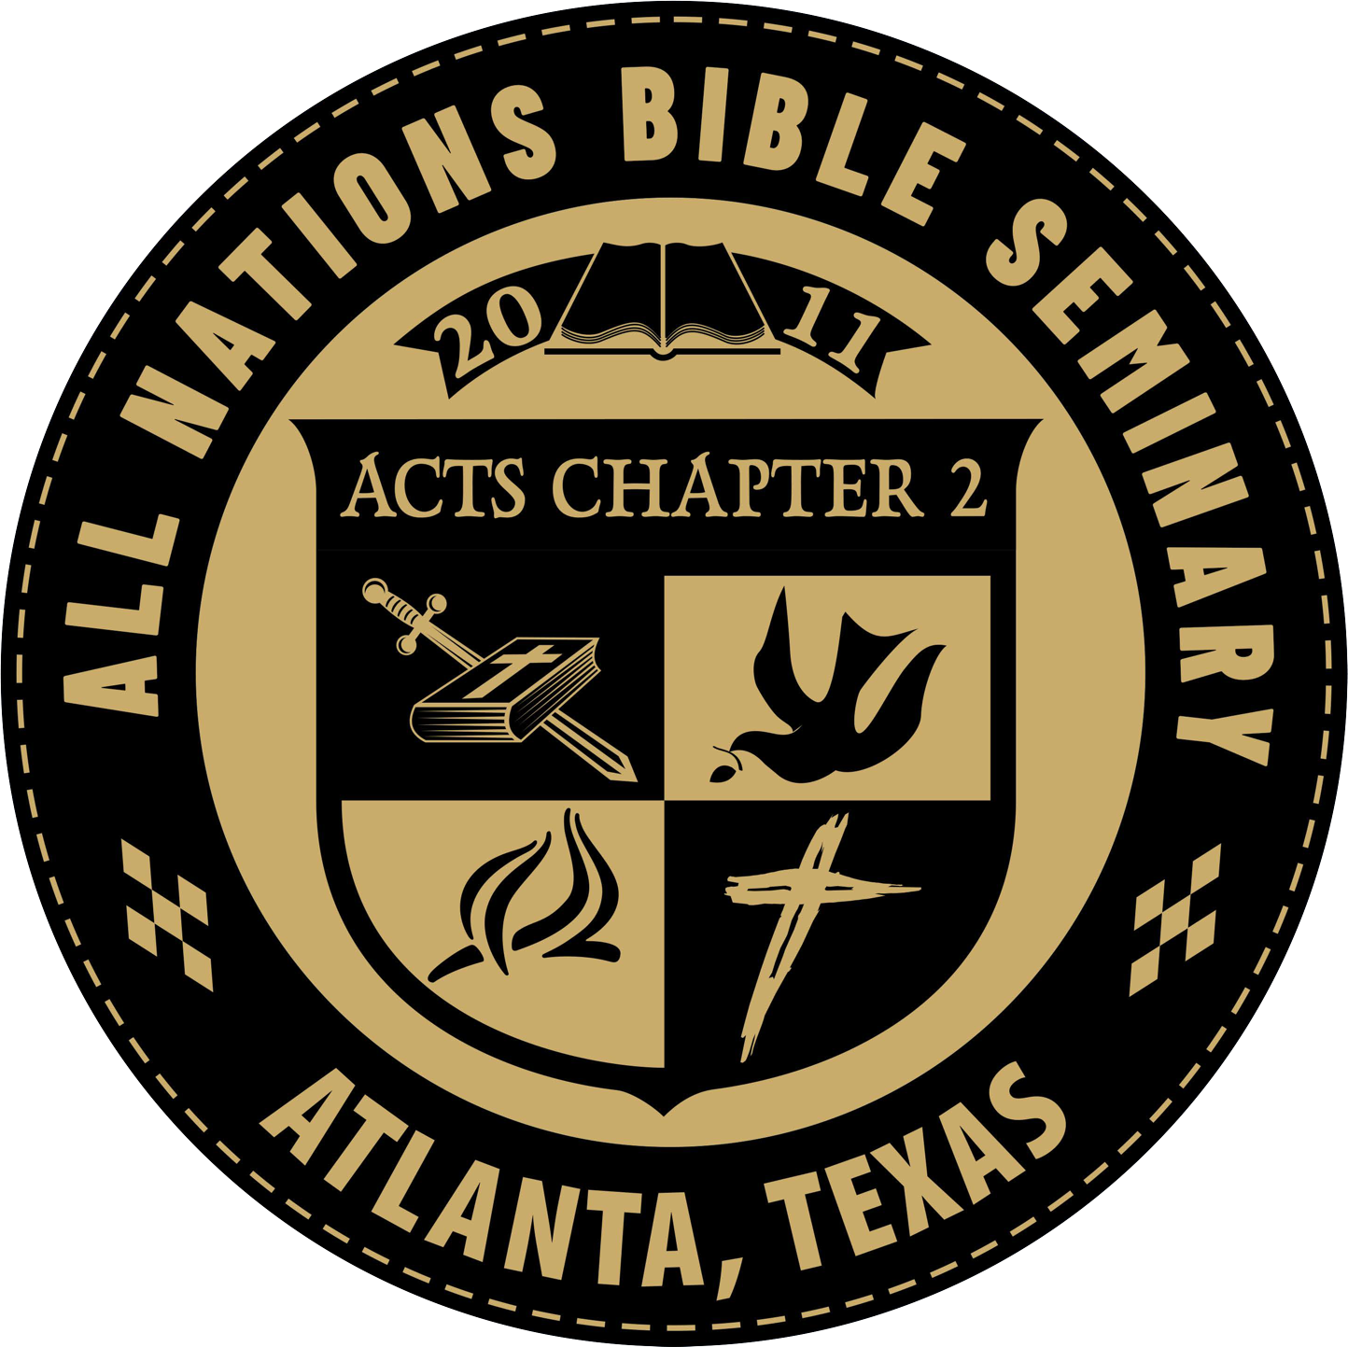
Course Syllabus

MIS 300 Missionary Marriage Issues
Instructor Information

Instructor: Office Location: Telephone:
E--‐mail: Office Hours:
Dr. Brad Gathright, Dean
702 Holly Street, Atlanta, TX 75551 Office – (903) 796--‐5308
info@anbseminary.org By appointment

Course Identification

Course Number: Course Name:

Course Hours:
MIS 300
Missionary Marriage Issues
3.0

Course Description/Overview
Missionary life can put much strain and stress upon a marriage. Why a course on mission life and marriage? The reason is that married couples living in cultures other than their passport country face some issues that make marriage more difficult than it is for people remaining at “home.” What about a spouse who doesn't want to go? Who is called? What about marrying a "national?" Relationship time between spouses. Should I stay single? Sexual stress? And
much more.

Course Resources
Required Course Text
- The Holy Bible
- Missionary Marriage
Textbook

Week 1

Lesson 1: Read the Missionary Marriage Textbook

Week 2

Write a five-page summary of the book including your thoughts on the material read and submit to the Seminary

