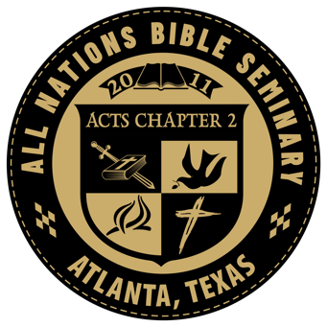
Course Syllabus
WOM-102
Dear Sister
Instructor Information
Instructor: N/A
Office Location: 702 Holly Street, Atlanta, TX 75551 Telephone: Office – (903) 796-5308
E-mail: info@anbseminary.org
Office Hours: By appointment

Course Identification
Course Number: WOM-102 Course Name: Dear Sister
Course Hours: 2.0
Prerequisites:

Course Description/Overview
Ladies will enjoy going through Gisela Johannan's book “Dear Sister” and gleaning strength from her words of wisdom. This work by Gisela is one that will encourage Christian ladies in their personal walk with the Lord and in their ministry.

Course Resources
Required Course Text
- The Holy Bible
- “Dear Sister” by Gisela Johannan

Course Assignment
The student will read the textbook and summarize each chapter. Each chapter summary must be at least 1 page in length, double-spaced, 1 inch margins, and using a TrueType font no larger than 12 point.

The student must demonstrate in these chapter summaries that the textbook has been read and studied.
Turn in your book summary when you are finished.
If there are videos, watch all the course videos from YouTube and take notes. Make photocopies of your notes and turn them in.

