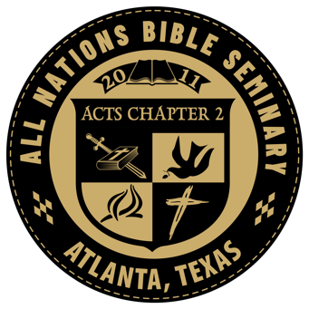
Course Syllabus

BIB-405 Ordinances of the Church
      - Information

Office Location: 702 Holly Street, Atlanta, TX 75551 Telephone: Office – (903) 796-5308
E-mail: info@anbseminary.org
Office Hours: By appointment

Course Identification
Course Number: BIB-405
Course Name: Ordinances of the Church
Course Hours: 3.0 Prerequisites:

Course Description/Overview
When the Lord calls us to serve Him, it is just like the start of a foot race. We are excited, full of strength and ready to run. However, a short while down the track, we discover that it takes more than our initial excitement if we want to last for the next 20, 30 or 50 years. And it takes even more to finally cross the finish line and win the prize. The purpose of this course and all our courses is to equip those whom God has called with solid biblical knowledge and doctrine. All must first consider and understand their calling and then find the courage and strength, through God’s grace, to endure until He has finished His purpose through us. Surely there will be no greater joy for us than one day to exclaim, like Paul: “I have fought a good fight, I have finished my course, I have kept the faith” (2 Timothy 4:7).

Course Learning Objectives
The major objective of this course is:

        - That the student will gain a greater understanding of the bible
        - That the student will learn sound biblical doctrine
        - That the student will learn how to help others with understanding the bible

Course Resources

Required Course Text
- The Holy Bible
- Textbook as provided by the seminary

Course Fees
None.

Assignments
In all of our classes you will be given bible reading assignments and then be assigned papers to write. We will not put a time limit on particular assignments however if the student tends to stop showing interest or turning in papers in
a reasonable length of time the said student will be dropped from our roles.
Proper Document Format must be typed and submitted as follows: (Use for all work in this seminary)
Set your margins for 1 inch on the top, bottom and sides of your paper. Select a simple font, such as Arial, Tahoma, Verdana or Times New Roman, in 11- or 12-point. Anything smaller will be difficult to read; anything larger will give the unfortunate impression that you are trying to force the words to take up space on the page.

Course Schedule

Assignment 1
Lesson 1: Read all the Gospel of Luke and Acts. Make notes of the themes and key verses, sayings, important teachings about The Lords’ Supper and baptism.
Assignment 2
Write a 5-6 page summary on the Ordinances of the Church. Summary should include the supporting scriptures, key verses, sayings, events and teachings.
Submit to the Seminary.

